***JFK vs. Nixon DBQ***

The United States presidential election of 1960 was the 34th American presidential election, held on November 8, 1960, for the term beginning January 20, 1961. The incumbent president, Republican Dwight D. Eisenhower, was not eligible to run again so there would be a new candidate from each party. The Republican Party nominated Richard Nixon, Eisenhower's Vice-President, while the Democrats nominated John F. Kennedy, a Senator from Massachusetts. At the time of the election, there was a bit of a recession, so the incumbent party, the Republicans were already at a slight disadvantage to begin.

Nixon was considered an early favorite due to the fact that he had much more experience in politics. He was thought to be steady, dependable, and tough. John F. Kennedy was thought of as new president for a new age. He was young and very charismatic but thought by many to be too inexperienced.

Both candidates knew the election would be a close one. In this DBQ, you will analyze some primary and secondary sources to determine your answer to the question:

***If you were voting in the 1960 presidential election, who would you vote for and why?***

***Instructions:***

***Part 1: Read the five documents.***

***Part 2: Fill out a document analysis sheet for each document to the best of your ability. Also answer the guiding questions for each document.***

***Part 3: When you are done, use the documents to write an essay answering the question If you were voting in the 1960 presidential election, who would you vote for and why?***

*Your final assignment you hand to me should include an essay, 5 document analysis worksheets, and one essay pre-planning sheet (a thinking map). (Outline, bullet points, etc.)

Sample essay outline:

Introduction Paragraph: State your claim with a few key points you’ll get to later.

Second Paragraph: One of your main points supporting your answer. Make sure to refer to the documents. Use them to your advantage. Think of it like a detective using evidence to solve a crime. “According to Document B…”

Third Paragraph: One of your main points supporting your answer. Make sure to refer to the documents. Use them to your advantage. Think of it like a detective using evidence to solve a crime. “According to Document B…”

Fourth Paragraph: One of your main points supporting your answer. Make sure to refer to the documents. Use them to your advantage. Think of it like a detective using evidence to solve a crime. “According to Document B…” OR use this paragraph to explain why the other side is wrong.

Fifth Paragraph: Conclusion. Restate your claim and key points.

**Document A**

**Campaign Commercials**

-<http://www.livingroomcandidate.org/commercials/1960>

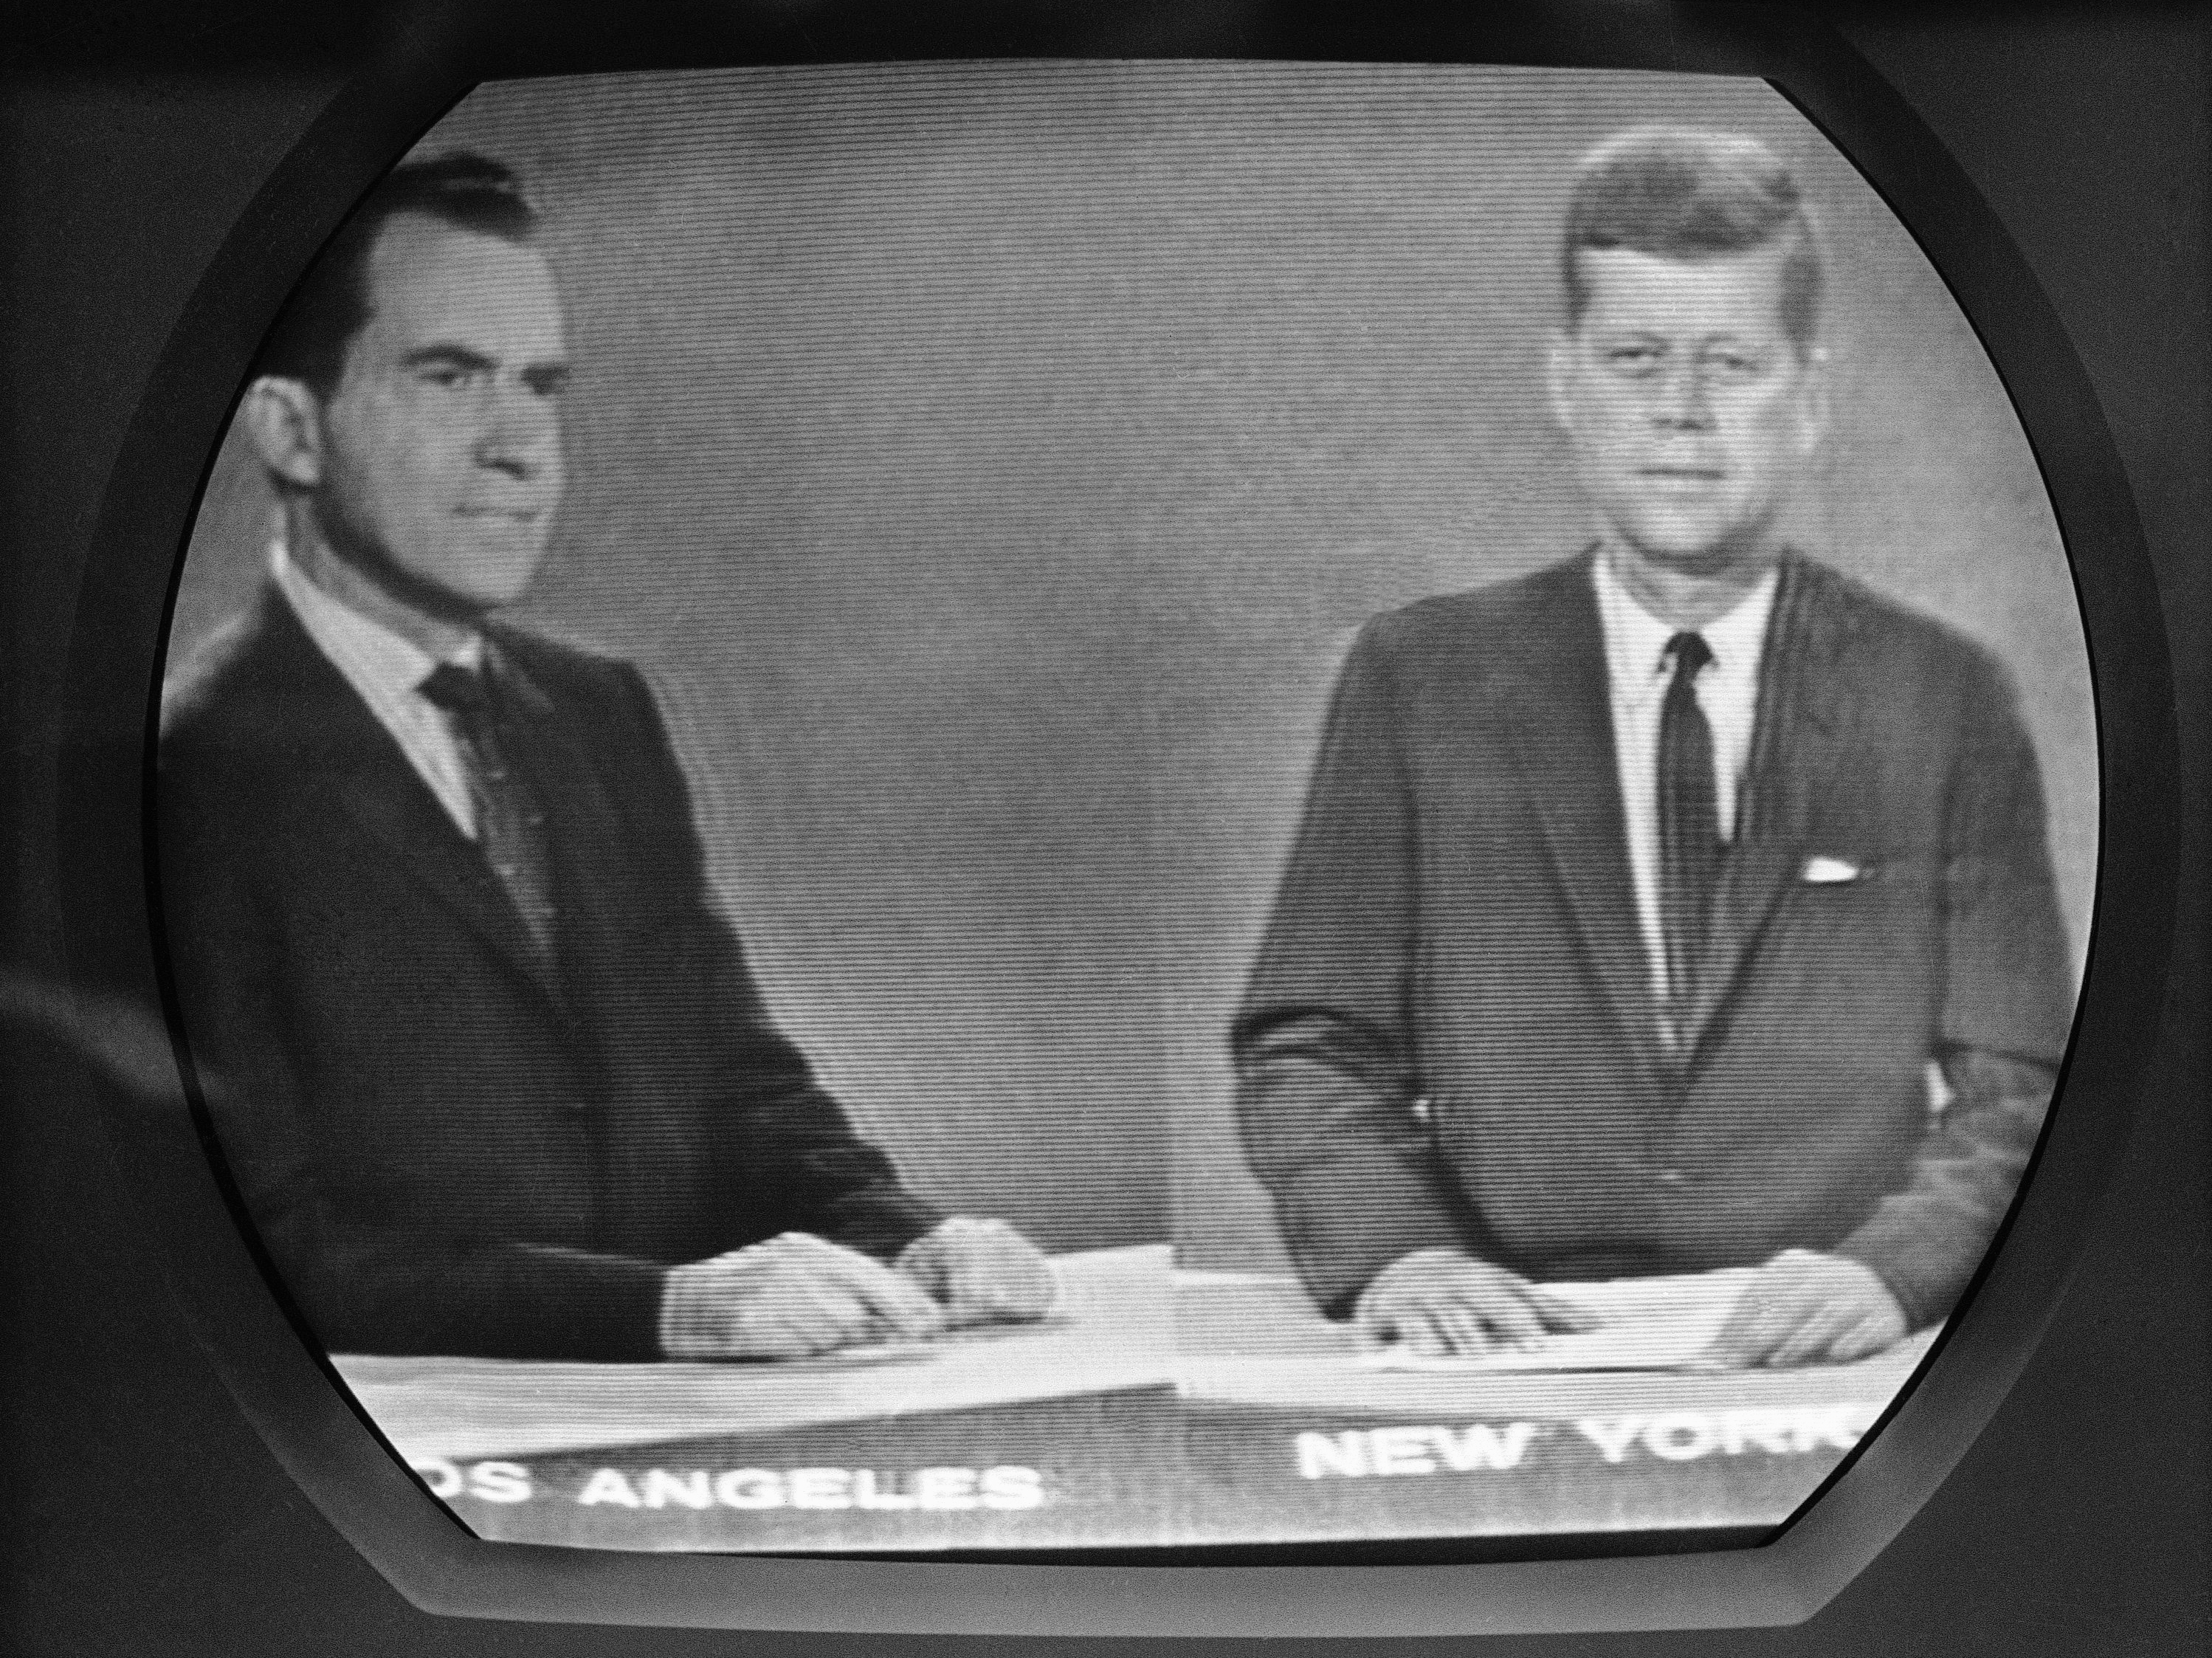

**After viewing a few of the commercials for each of the candidates, think about the following questions.**

1. How did the commercial describe America during the time of the election?
2. Did the candidate suggest we need peace and stability or change? Why do you think that?
3. Did the candidate talk about his own policies or did he talk about the other candidates?
4. What was the intended purpose of this commercial?

**Document B**

**Website Article:**

**THE KENNEDY-NIXON PRESIDENTIAL DEBATES, 1960**

On 26 September 1960, 70 million U.S. viewers tuned in to watch Senator John Kennedy of Massachusetts and Vice President Richard Nixon in the first-ever televised presidential debate. It was the first of four televised "Great Debates" between Kennedy and Nixon. The first debate centered on domestic issues. The high point of the second debate, on 7 October, was disagreement over U.S. involvement in two small islands off the coast of China, and on 13 October, Nixon and Kennedy continued this dispute. On 21 October, the final debate, the candidates focused on American relations with Cuba.

The Great Debates marked television's grand entrance into presidential politics. They afforded the first real opportunity for voters to see their candidates in competition, and the visual contrast was dramatic. In August, Nixon had seriously injured his knee and spent two weeks in the hospital. By the time of the first debate he was still twenty pounds underweight, his pallor still poor. He arrived at the debate in an ill-fitting shirt, and refused make-up to improve his color and lighten his perpetual "5:00 o'clock shadow." Kennedy, by contrast, had spent early September campaigning in California. He was tan and confident and well-rested. "I had never seen him looking so fit," Nixon later wrote.

In substance, the candidates were much more evenly matched. Indeed, those who heard the first debate on the radio pronounced Nixon the winner. But the 70 million who watched television saw a candidate still sickly and obviously discomforted by Kennedy's smooth delivery and charisma. Those television viewers focused on what they saw, not what they heard. Studies of the audience indicated that, among television viewers, Kennedy was perceived the winner of the first debate by a very large margin.

**Questions:**

1. What impact did the article suggest the televised debates had on the election?
2. Do you think looks matter in voting? Should they? Why or why not?
3. If a person talking is more energetic, and charismatic are you more or less likely to believe them if they say the same thing as someone else?
4. How did your opinion of each candidate change after reading about this debate?

**Document C**

**Campaign Buttons/Posters**

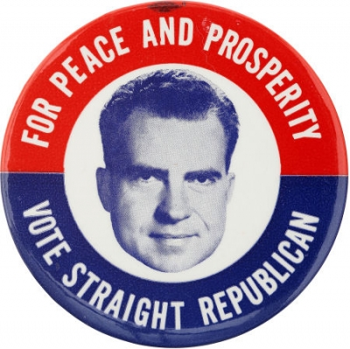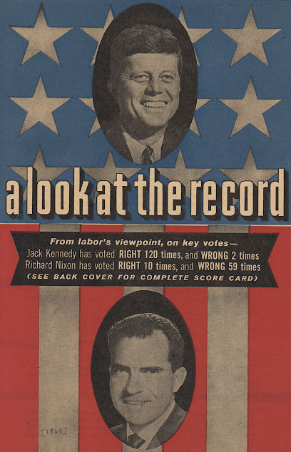

*Campaign Button 1 Poster 1*

**Questions:**

1. What message is each of the campaign pieces trying to show?
2. Do you think it is an effective strategy to talk about the poor job another candidate is doing?

**Document D:**

**TRANSCRIPT-The First Kennedy-Nixon Presidential Debate: September 26, 1960**

**Part 1:**

**MR. FLEMING:** Senator, the Vice President in his campaign has said that you were naive and at times immature. He has raised the question of leadership. On this issue, why do you think people should vote for you rather than the Vice President?

**MR. KENNEDY:** Well, the Vice President and I came to the Congress together 1946; we both served in the Labor Committee. I've been there now for fourteen years, the same period of time that he has, so that our experience in uh - government is comparable. Secondly, I think the question is uh - what are the programs that we advocate, what is the party record that we lead? I come out of the Democratic party, which in this century has produced Woodrow Wilson and Franklin Roosevelt and Harry Truman, and which supported and sustained these programs which I've discussed tonight. Mr. Nixon comes out of the Republican party. He was nominated by it. And it is a fact that through most of these last twenty-five years the Republican leadership has opposed federal aid for education, medical care for the aged, development of the Tennessee Valley, development of our natural resources. I think Mr. Nixon is an effective leader of his party. I hope he would grant me the same. The question before us is: which point of view and which party do we want to lead the United States?

**MR. SMITH:** Mr. Nixon, would you like to comment on that statement?

**Mr. NIXON:** I have no comment.

_____________________________________________________________________________________________

**Part 2:**

MR. NIXON; I of course disagree with Senator Kennedy insofar as his suggestions as to what should be done uh - with re- on the farm program. He has made the suggestion that what we need is to move in the direction of more government controls, a suggestion that would also mean raising prices uh - that the consumers pay for products and im- and imposing upon the farmers uh - controls on acreage even far more than they have today. I think this is the wrong direction. I don't think this has worked in the past; I do not think it will work in the future. The program that I have advocated is one which departs from the present program that we have in this respect. It recognizes that the government has a responsibility to get the farmer out of the trouble he presently is in because the government got him into it. And that's the fundamental reason why we can't let the farmer go by himself at the present time.

**Questions:**

1. What was the overall message of Part 1?
2. What was the overall message of Part 2?
3. If you only saw these pieces of the debate (there is much more), who would you say won the debate? Why?
4. What can a voter learn about during a debate?

**Document E:**

**Political Cartoons**

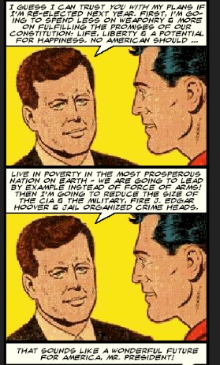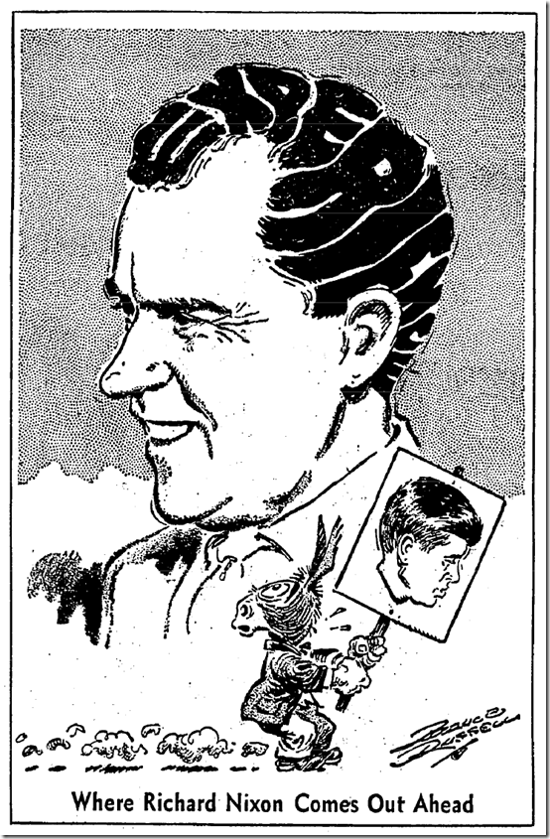  
 ***Cartoon 1******Cartoon 2***

1. In what way does cartoon 1 say Nixon is more prepared than John Kennedy?
2. Who appears to be scared in cartoon 1? What does he represent?
3. Who is Kennedy talking to in cartoon 2? Does the fact that Kennedy impresses him make you more or less likely to think he’s the right guy for the presidency?
4. What facial expression does Kennedy have in cartoon 2? Would it change the meaning of the cartoon if he had been doing something else?