Chapter 4-Federalism
Section One: Federalism: The Division of Power (pg. 94-102)

In 1787, the Framers wanted to create a new _______________ government that would be strong enough to meet the nation’s needs, but would also preserve the already existing __________. (pg. 94)

The Framers shared three convictions about limiting governmental powers: (pg. 94)
1.__________________________________________________________________________________
2.__________________________________________________________________________________
3.__________________________________________________________________________________

Federalism is a system of government that divides power on a ____________ basis between a ____________ government and several _________ governments. Each operates over the same people at the same time. (pg. 94)

This division of powers is spelled out in the __________ Amendment. (pg. 95)

Federalism’s major strength is that it allows ___________ action in matters of local concern and _________________ in matters of wider concern. (pg. 95)

Powers of the National Government (pg. 96-97)
Type of Power | Definition | Source in the Constitution | Examples
Expressed Powers (pg. 96)
Implied Powers
(pg.96-97)
Inherent Powers
(pg. 97)

Some powers are denied to the federal government for various reasons: (pg. 98)
1.__________________________________________________________________________________
2.__________________________________________________________________________________
3.__________________________________________________________________________________

____________ powers are those powers the Constitution does not grant to the national government and does not deny to the states. Examples include: _____________________________________________________ (pg. 99)

____________ powers are those powers that both the national and state governments share. Examples include: ________________________________________________________________________________ (pg. 100)

Each of the 50 states has a unitary form of government an arrangement in which a _____________ government can create ______________ of governments for its own convenience. (pg. 100)

Article VI, Section 2 (commonly called the ____________ Clause) means that the __________ stands above all other laws in the United States, and that ___________ and __________ stand immediately beneath it. (pg. 101)

The ____________ Court is the umpire in the federal system, and often settles clashes between national and state laws. It first did so in _____________________ v. ____________________, a case from 1819. (pg. 101)
Chapter 4-Federalism
Section Two: The National Government and the 50 States (pg. 103-109)

National Obligations to the States (pg. 103-104)
Obligation | What It Means | Example from History
Republican Form of Government (pg. 103)
Invasion and Internal Disorder (pg. 104)
Respect for Territorial Integrity (pg. 104)

Territorial Expansion of the U.S.

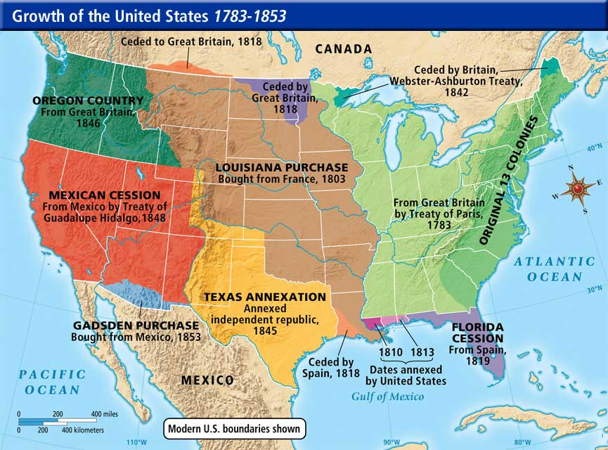

Only ____________ has the power to admit new states, but there is one restriction on this power: a state cannot be created out of a pre-existing state’s territory without the consent of ____________(s) of the State (s) involved. (pg. 106)

Congress has admitted ________ states since the original 13 formed the Union. (pg. 106)

Four states created from pre-existing states: ______________________________________________ (pg. 106)

__________________ and _______________ were independent republics before admission. (pg. 106)

_______________________ was admitted shortly after being ceded to the United States by Mexico. (pg. 106)

To become a state, the area desiring statehood must ask Congress for _______________, prepare a Constitution, and wait for Congress to pass an ______________ Act. If the __________________ signs the Act the new State enters the union. (pg. 106)

The two newest States _______________ and _______________, shortened the usual admission process. Each proposed a constitution without waiting for an enabling act. ________________ in 1950 and _______________ in 1956. Both became states in 1959. (pg. 106)

While Congress can set admission conditions, it can’t impose conditions of a __________ nature on the state. (pg. 107)

The American federal system also involves a broad area of ______________ powers. In addition to the two separate spheres of power ___________ and ____________ by the two basic levels of government, there are large growing areas of cooperation between them. (pg. 107)

The best example of intergovernmental cooperation are the many federal grant-in-aid programs. Which are grants of federal money or ___________________________________________________________________ _________________________________________________________________________________. (pg. 107)

Please explain how each type of federal grants-in aid work.
Types of Federal Grant-in-Aid (pg. 108-109)
Type of Grant | What It Means | Examples
Categorical Grants (pg. 108)
Block Grants (pg. 109)
Project Grants (pg. 109)

Chapter 4-Federalism
Section Three: Interstate Relations (pg. 111-114)

No state can enter into any ____________, __________________ or ____________________ but may, with the consent of __________________, enter into interstate compacts with foreign states. (pg. 111)

Some examples of interstate compacts include: _____________________________________________ (p 105)

While there were only 36 compacts approved by 1920 there are now more than __________ compacts enforced involving several States. (pg. 111)

All 50 States have joined in on two interstate compacts: The Compact for the ___________________________ and _________________________ along with the Compact on Juveniles. These two pacts allow the states to share important law enforcing data. (pg. 111)

Other pacts include the development and _____________________ of such resources as water, _________, wildlife and __________, while others work to counter the effects of global climate change and the cooperative use of public universities. (pg. 111)

Article IV, Section 1 of the Constitution states that ______________________ and Credit be given to every state to recognize as valid all of the public acts, records, and judicial proceedings of other states. (pg. 111-112)

Public Acts: _________________________________________________________________________

Records: ____________________________________________________________________________

Judicial Proceedings: __________________________________________________________________

The Full Faith and Credit Clause most often comes into play in _____________________ matters. (pg. 112)

There are two notable exceptions to the full faith and credit clause: First, it only applies to ___________, not ____________ matters so by law one state can’t enforce the criminal laws of another state. Second, was the person who obtained the _________________ a resident of the State in which it was granted? (pg. 112)

Extradition requires states to return _______________ from justice to the prosecuting jurisdictions. (pg. 113)

Under the _____________ and ________________ Clause, no state can draw _______________ distinctions between its own citizens and those of other states. (pg. 114)

Each State must recognize the right of any American to ______________ in or become a _________________ of that State. It must also allow any citizen no matter where he or she lives, to use its courts and make _____________; buy, __________, ___________ or sell property; or ___________ within its borders. (pg. 114)

Examples of unconstitutional distinctions: _________________________________________________
(pg. 114)

Examples of constitutional distinctions: ___________________________________________________
(pg. 114)

