The Lasting Effects of the Holocaust-DBQ

Directions: Examine the documents to see chronologically how the Nazis slowly changed life politically, economically and socially for many people. Once you have read through each document please answer the question or questions that accompany each document.

Kristallnacht Order

- How would The Kristallnact Order change life for the Jews?

- Were German citizens treated the same way as the Jews were?

Document B

Life in the Warsaw Ghetto
Life in the Warsaw Ghetto, Emanuel Ringelblum quoted in Yad Vashem Documents on the Holocaust, pp 228-229:
Smuggling began at the very moment that the Jewish area of residence was established; its inhabitants were forced to live on 180 grams of bread a day, 220 grams of sugar a month, 1 kg. of jam and 1 kg. of honey, etc. It was calculated that the officially supplied rations did not cover even 10 percent of the normal requirements. If one had wanted really to restrict oneself to the official rations then the entire population of the ghetto would have had to die of hunger in a very short time.... The German authorities did everything to seal off the ghetto hermetically and not to allow in a single gram of food. A wall was put up around the ghetto on all sides that did not leave a single millimeter of open space.... They fixed barbed wire and broken glass to the top of the wall.

- List three characteristics those living in the ghetto experienced.

Document C
Ghetto Ration Card
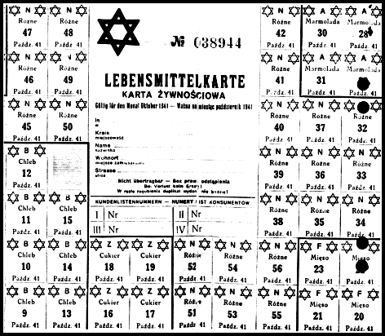
Ghetto ration card for October 1941. This card officially entitled the holder to 300 calories daily.
Photo credit: Meczenstwo Walka, Zaglada Zydów Polsce 1939-1945. Poland. No. 137.
- Why do you think the Nazis gave ration cards out to Jews in the ghetto?

- Do you think that it would be possible to survive with this amount of food?

Document D
Discriminatory Decrees Against the Jews
II. DISCRIMINATORY DECREES AGAINST JEWS
When the Nazi Party gained control of the German State, the conspirators used the means of official decrees as a weapon against the Jews. In this way the force of the state was applied against them.
- Jewish immigrants were denaturalized (1933 Reichsgesetzblatt, Part I, page 480, signed by Friank and Neurath).
- Native Jews were precluded from citizenship (1935 Reichsgesetzblatt, Part I, page 1146, signed by Frick).
- Jews were forbidden to live in marriage or to have extramarital relations with persons of German blood (1935 Reichsgesetzblatt, Part I, page 1146, signed by Frick and Hess).
- Jews were denied the right to vote (1936 Reichsgesetzblatt, Part I, page 133, signed by Frick).
- Jews were denied the right to hold public office or civil service positions (1933 Reichsgesetzblatt, Part I, page 277, signed by Frick).
- Jews were relegated to an inferior status by the denial of common privileges and freedoms.
  - Thus, they were denied access to certain city areas, sidewalks, transportation, places of amusement, restaurants (1938 Reichsgesetzblatt, Part I, page 1676).
- Progressively, more and more stringent measures were applied, even to the denial of private pursuits.
  - They were excluded from the practice of dentistry (1939 Reichsgesetzblatt, Part I, page 47, signed by Hess).
- The practice of law was denied to them (1938 Reichsgesetzblatt, Part I, page 1403, signed by Frick and Hess).
- The practice of medicine was forbidden them (1938 Reichsgesetzblatt, Part I, page 969, signed by Frick and Hess).
- They were denied employment by press and radio ( 1933 Reichsgesetzblatt, Part I, page 661).
- They were excluded from stock exchanges and stock brokerage 1934 Reichsgesetzblatt, Part I, page 661).
- They were excluded from farming ( 1933 Reichsgesetzblatt, , Part I, page 685).
Source: Nazi Conspiracy & Aggression, Volume I, Chapter XII, Office of the United States Chief Counsel for Prosecution of Axis Criminality, United States Government Printing Office, Washington, 1946, pp. 980-982.

- How did life change politically, economically, and socially for the Jews?

Document E
Testimonies of SS-Men from Various Camps
All of the documents on this Web page were retrieved from the archives of Shamash: The Jewish Internet Consortium. The comments inside the square [ . . . ] brackets were written by Daniel Keren for the Shamash archives.
Testimony of SS Scharführer Erich Fuchs, in the Sobibor-Bolender trial, Dusseldorf.
Quoted in "BELZEC, SOBIBOR, TREBLINKA - the Operation Reinhard Death Camps", Indiana University Press - Yitzhak Arad, 1987, p. 31-32:
If my memory serves me right, about thirty to forty women were gassed in one gas chamber. The Jewish women were forced to undress in an open place close to the gas chamber, and were driven into the gas chamber by the above mentioned SS members and the Ukrainian auxiliaries. when the women were shut up in the gas chamber I and Bolender set the motor in motion. The motor functioned first in neutral. Both of us stood by the motor and switched from "Neutral" (Freiauspuff) to "Cell" (Zelle), so that the gas was conveyed to the chamber. At the suggestion of the chemist, I fixed the motor on a definite speed so that it was unnecessary henceforth to press on the gas. About ten minutes later the thirty to forty women were dead.
Source: The testimony of SS-Unterscharfuehrer Wilhelm Bahr in his trial at Hamburg.
Quoted in "Truth Prevails", ISBN 1-879437

- Based on the testimony of this SS officer, what happened to the women prisoners of the Sobibor Concentration camp?

Document F
Nazi Boycotts of Jewish businesses
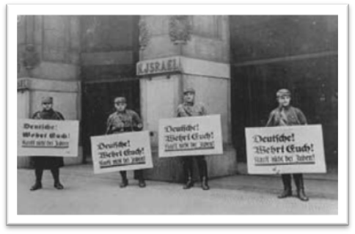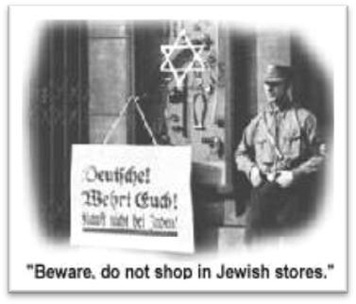
1.) How would the boycott of Jewish businesses help the Nazis?
2.) How would the boycott of the businesses change the economic livelihood of the Jews?
Document G
Identification badges
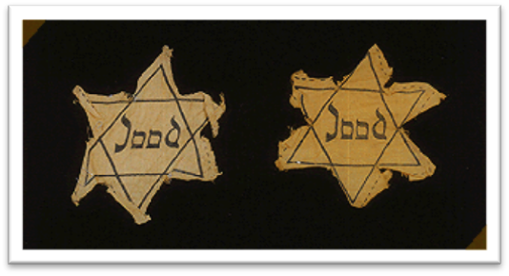
In May 1942, all Jews aged six and older are required to wear a yellow Star of David on their clothes to set them apart from non-Jews.

1.) What was the purpose of Identification badges?

Document H
A photo of Anne Frank in school
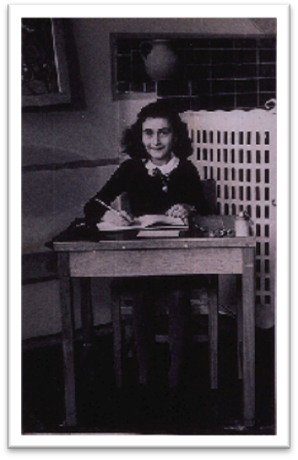

Anne Frank attends a local Montessori school until the summer of 1941 when she (a Jew) could no longer legally attend school with non-Jewish students.
- How did education change for Anne Frank and other children after the Nazis came to power?
Document I
Diary Excerpt

"Fine specimens of humanity, those Germans, and to think I'm actually one of them! No, that's not true, Hitler took away our nationality long ago. And besides, there are no greater enemies on earth than the Germans and Jews." - October 9, 1942

Source: The Diary of Anne Frank. Passage regarding her old home country, Germany.

1.) According to this diary entry, why did Anne Frank feel that the Germans were the enemy?

Document J
Photo of a Camp Prisoner
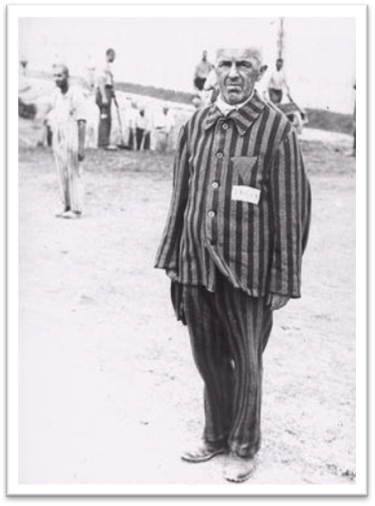
A prisoner in Dachau is forced to stand without moving for endless hours as a punishment. He is wearing a triangle patch identification on his chest.

1.) What was life like for prisoners in the Concentration Camp?

Document K
Photo of Jewish Children
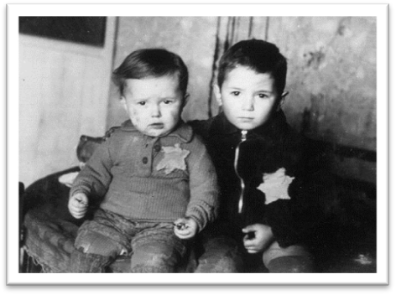
- Based on this picture, what do you think the future of these two children would be like?

Part B: Essay
Directions:
- • Write a well-organized essay that includes an introduction, several paragraphs, and a conclusion.
- • Use evidence from the documents to support your response
- • Do not simply repeat the contents of the documents
- • Include specific, related outside information.
Task: Using information from the documents your knowledge of global history, and the Daniel Story Exhibit, write an essay that shows how the rise of the Nazis caused life to change politically, economically and socially for people. Make sure to include how life changed for children as a result of the Nazis coming to power in 1933. Be sure to include specific historical detail.

