Name ___________________________Date _______________________ Hour ______

WWI-DBQ

Part A
Short-Answer Questions

Directions: Analyze the documents and answer the short-answer questions that follow each document in the space provided.

Document 1
The effect of the war upon the United States will depend upon what American citizens say and do. Every man who really loves America will act and speak in the true spirit of neutrality…The spirit of the nation in this critical matter will be determined largely by what individuals…do and say, upon what newspapers and magazines contain, upon what ministers utter in their pulpits…The United States must be neutral in fact as well as in name during these days that are to try men’s souls. We must be impartial in thought as well as in action…

Source: President Woodrow Wilson From a speech to the U.S. Senate, 1914

1a.) What policy is Wilson promoting about the war in Europe?
________________________________________________________________________
________________________________________________________________________
________________________________________________________________________

1b.) According to Wilson, who is responsible for the success of that policy?
________________________________________________________________________
________________________________________________________________________
________________________________________________________________________

Document 2

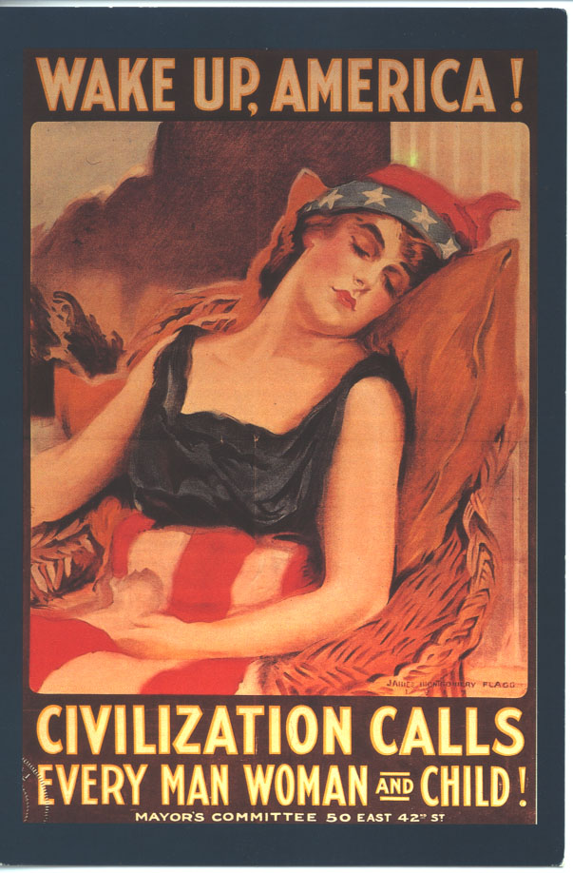
-James Montgomery Flagg, 1917

2a.) What year was this poster created?
________________________________________________________________________
________________________________________________________________________
________________________________________________________________________

2b.) What does the woman in the poster symbolize?
________________________________________________________________________
________________________________________________________________________
________________________________________________________________________

2c.) What is the main message of the poster?
________________________________________________________________________
________________________________________________________________________
________________________________________________________________________
Document 3
Neutrality is no longer feasible or desirable where the peace of the world is involved and the freedom of its peoples…
We have no quarrel with the German people. We have no feelings toward them but one of sympathy and friendship. It was not upon their impulse that their government acted in entering this war…We are accepting this challenge…to fight thus for the ultimate peace of the world and for the liberation of its people, the German people included…The world must be made safe for democracy…

Source: President Woodrow Wilson-From a speech to Congress, April 2, 1917

3a.) What does Wilson believe about the people of Germany?
________________________________________________________________________
________________________________________________________________________
________________________________________________________________________

3b.) What reason does Wilson give for going to war?
________________________________________________________________________
________________________________________________________________________
________________________________________________________________________

Document 4

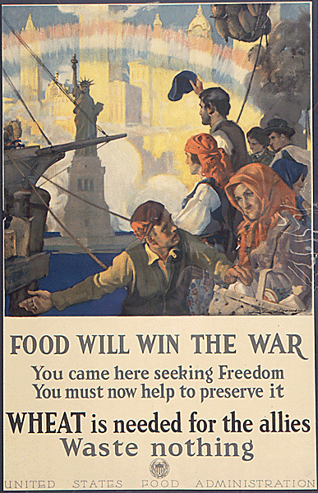

4a.) What audience is this WWI poster targeting?
________________________________________________________________________
________________________________________________________________________
________________________________________________________________________

4b.) What did the U.S. Food Administration want people to do after seeing this poster?
________________________________________________________________________
________________________________________________________________________
________________________________________________________________________

Document 5
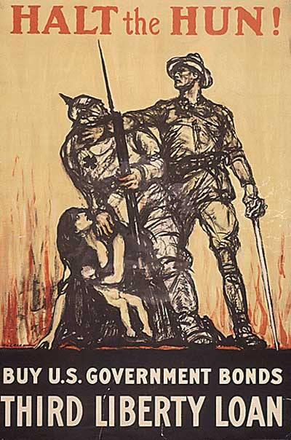

5a.) How is the American portrayed in this poster?
________________________________________________________________________________
________________________________________________________________________________
________________________________________________________________________________

5b.) How is the German portrayed in this poster?
_______________________________________________________________________________
_______________________________________________________________________________
_______________________________________________________________________________

5c.) How might the poster have influenced the people who saw it?
______________________________________________________________________________
______________________________________________________________________________
______________________________________________________________________________

Document 6

…whoever, when the United States is at war, shall willfully utter, print, write, or publish…abusive language about the form of government of the United States, or the Constitution of the United States…or the flag of the United States…shall be punished by a fine of not more than $10,000 or imprisonment for not more than twenty years, or both…

Source: The Sedition Act-Passed by Congress, May 16, 1918

6a.) What freedoms are suspended by the Sedition Act?
________________________________________________________________________
________________________________________________________________________
________________________________________________________________________

6b.) Why did Congress pass the Sedition Act in 1918?
________________________________________________________________________
________________________________________________________________________
________________________________________________________________________

Document 7

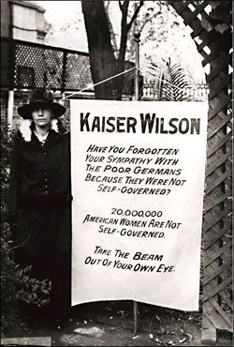

7a.) What cause does this woman support?
________________________________________________________________________
________________________________________________________________________
________________________________________________________________________

7b.) How is the banner critical of Woodrow Wilson?
________________________________________________________________________
________________________________________________________________________
________________________________________________________________________

