**Chapter 5-Political Parties**

**Key Vocabulary**

**Section 1-Parties and What They Do**

Political Party

Partisanship

Single Member District

Bipartisan

Consensus

Coalition

**Section 2-Two-Party System in American History**

Incumbent

Faction

Electorate

**Section 3-The Minor Parties**

Ideological Parties

Single Issue Party

Economic Protest Party

Splinter Party

**Section 4-Party Organization**

Ward

Precinct

**Use the following website to complete the activity:** http://www.diffen.com/difference/Democrat_vs_Republican

**Democrats**

|  |  |
| --- | --- |
| **Philosophy** |  |
| **Economic Ideas** |  |
| **Social and Human Ideas** |  |
| **Stance on Military Issues** |  |
| **Stance on Same Sex Marriage** |  |
| **Stance on Abortion** |  |
| **Stance on the Death Penalty** |  |
| **Stance on Taxes** |  |
| **Stance on Government Regulations** |  |
| **Healthcare Policy** |  |

**Democrats**

|  |  |  |
| --- | --- | --- |
| **Stance on Immigration** |  | |
| **States in which the Democrats are Traditionally Strong** |  | |
| **Symbol and Color** | **Symbol** | **Color** |
| **Year in Which the Democratic Party Was Founded** |  | |
| **Democratic Party Website** |  | |
| **Senate Leader** |  | |
| **Chairperson** |  | |
| **Famous Democratic Presidents** |  | |
| **Number of Seats in the Senate** |  | |
| **Number of Seats in the House** |  | |
| **Governorships** |  | |
| **Memberships** |  | |

**Republicans**

|  |  |
| --- | --- |
| **Philosophy** |  |
| **Economic Ideas** |  |
| **Social and Human Ideas** |  |
| **Stance on Military Issues** |  |
| **Stance on Same Sex Marriage** |  |
| **Stance on Abortion** |  |
| **Stance on the Death Penalty** |  |
| **Stance on Taxes** |  |
| **Stance on Government Regulations** |  |
| **Healthcare Policy** |  |

**Republicans**

|  |  |  |
| --- | --- | --- |
| **Stance on Immigration** |  | |
| **States in which the Republicans are Traditionally Strong** |  | |
| **Symbol and Color** | **Symbol** | **Color** |
| **Year in Which the Republican Party Was Founded** |  | |
| **Republican Party Website** |  | |
| **Senate Leader** |  | |
| **Chairperson** |  | |
| **Famous Republican Presidents** |  | |
| **Number of Seats in the Senate** |  | |
| **Number of Seats in the House** |  | |
| **Governorships** |  | |
| **Memberships** |  | |

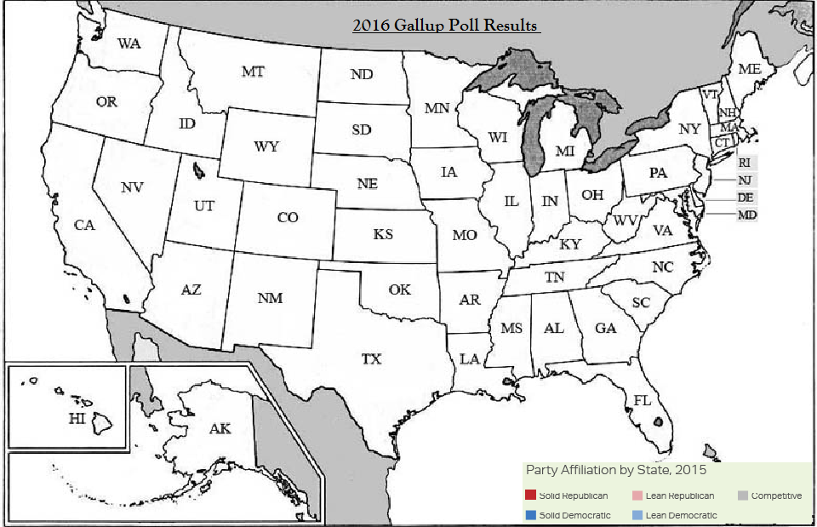

**Presidential Biography: Democratic Presidents**

**Presidential Bio #1:** __________________________________

* When and where was he born?
* What did he do in his early years as a child and a young adult?
* Who did he marry and how many children did he have?
* What was his occupation before he was elected President?
* When was he elected President of the United States?
* When was his term of office?
* Who was his vice president?
* What was one major event that took place during his term? (Include the results)
* What are two interesting or little known facts about this president?

**Presidential Bio #2:** __________________________________

* When and where was he born?
* What did he do in his early years as a child and a young adult?
* Who did he marry and how many children did he have?
* What was his occupation before he was elected President?
* When was he elected President of the United States?
* When was his term of office?
* Who was his vice president?
* What was one major event that took place during his term? (Include the results)
* What are two interesting or little known facts about this president?

**Presidential Biography: Republican Presidents**

**Presidential Bio #1:** __________________________________

* When and where was he born?
* What did he do in his early years as a child and a young adult?
* Who did he marry and how many children did he have?
* What was his occupation before he was elected President?
* When was he elected President of the United States?
* When was his term of office?
* Who was his vice president?
* What was one major event that took place during his term? (Include the results)
* What are two interesting or little known facts about this president?

**Presidential Bio #2:** __________________________________

* When and where was he born?
* What did he do in his early years as a child and a young adult?
* Who did he marry and how many children did he have?
* What was his occupation before he was elected President?
* When was he elected President of the United States?
* When was his term of office?
* Who was his vice president?
* What was one major event that took place during his term? (Include the results)
* What are two interesting or little known facts about this president?

**Minor Parties**

|  |  |  |
| --- | --- | --- |
|  | **Definition** | **Examples** |
| **Ideological Parties** |  |  |
| **Single-Issue Parties** |  |  |
| **Economic Protest Parties** |  |  |
| **Splinter Parties** |  |  |

**Decide whether the following scenarios would be an example of an Ideological Party, Single-Issues Party, Economic Protest Party or Splinter Party then write the correct term in the space provided.**

_________________________________ The “Free Choice Party” is formed by people intent on legalizing the use of marijuana for medical purposes.

_________________________________ A group of Democrats dissatisfied with the parties moderate nominee, decided to form a new “People’s Rights” party to block their more liberal leader, Henry J. Smith.

_________________________________ A group of angry Midwestern farmers and laborers form the “Working Peoples” party calling for higher tariffs, higher farm subsidies and congressional term limits

_________________________________ The “Socialist Justice Party” calls for a complete overhaul of the American political, economic and legal systems

_________________________________ The “Equality” party works for an end to affirmative action programs

**Campaign Spending-Pie Chart**

**Go to the following website to fill in the pie chart:** <http://a.abcnews.com/images/Politics/abc_begich_spending_chart_SIZED_kb_141103.jpg>

**Trump and Clinton**

**Comparing the Candidates**

**Use the following website to complete the activity: http://www.diffen.com/difference/Donald-Trump-vs-Hillary-Clinton**

|  |  |  |
| --- | --- | --- |
| **Topics** | **Donald J. Trump** | **Hillary Clinton** |
| **Political Party** |  |  |
| **Alma Mater** |  |  |
| **Date and Place of Birth** |  |  |
| **Current Position of Employment** |  |  |
| **Campaign Website** |  |  |
| **Position on Immigration** |  |  |
| **Position on Healthcare** |  |  |
| **Position on Abortion** |  |  |
| **Tax Policies** |  |  |

**Trump and Clinton**

**Comparing the Candidates**

|  |  |  |
| --- | --- | --- |
| **Economic Policies** |  |  |
| **Position on Minimum Wage** |  |  |
| **Position on Government Regulation** |  |  |
| **Position on Global Warming** |  |  |
| **Position on Gun Rights** |  |  |
| **Position on Marijuana Legalization** |  |  |
| **Position on Syria and ISIS** |  |  |
| **Spouse(s)** |  |  |
| **Religion** |  |  |
| **Running Mate** |  |  |