**Unit 1: The Mongols**

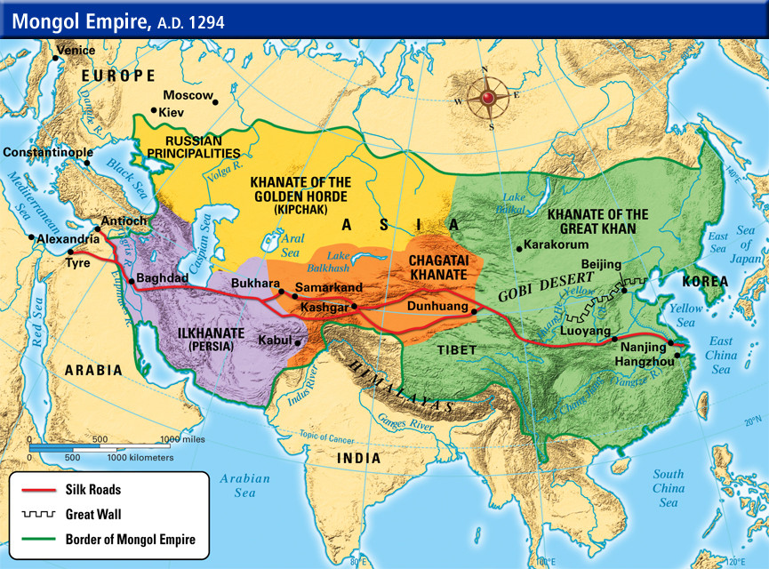

**Important terms:**

* Genghis Khan
* Kublai Khan
* Conquest
* Largest unified land empire in history: China to the Middle East
* Pax Mongolica= Peace of Mongolia

**Practice Questions:**

1. How did Genghis Khan succeed as a conqueror?

1. through the brilliant military strategy and organization
2. through conquering only empires that became weak
3. through use of clever tricks
4. Through offering people the Mongol Peace if they surrendered.

2. What was true of the Mongol Empire?

1. The Mongols treated all people humanely.
2. Mongols refused to assimilate with the cultures they conquered.
3. It was the largest unified land empire in history.
4. Mongols forced the conquered to practice their religion.

3. What happened during the Pax Mongolica?

1. Irrigation systems in the Tigris and Euphrates valleys were rebuilt.
2. A cure for bubonic plague was developed in China.
3. Ideas and innovations spread between Europe and Asia.
4. Moveable type, Gunpowder and the Magnetic compass were invented.

**Unit 2: Islam**

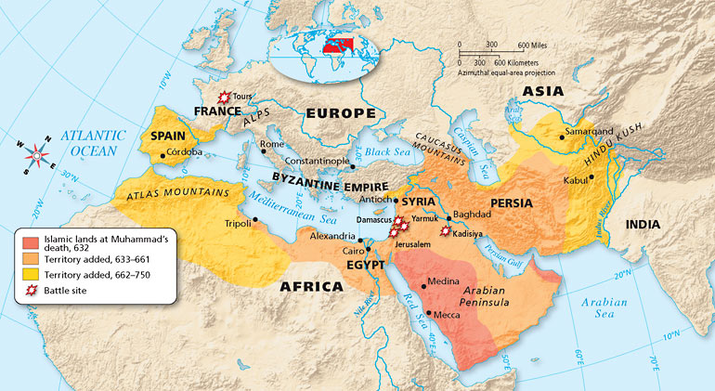

**Important terms:**

* Monotheistic
* Prophet Muhammad
* Five Pillars
* Bedouins
* Sunni
* Shia
* Expansion

**Practice Questions:**

1. What are the Five Pillars of Islam?

1. the various divisions in Islam
2. the major duties required of all Muslims
3. the times of the day when Muslims must pray
4. the first revelations given to Muhammad

2. How were conquered people’s treated by the Muslim Empire?

1. They were forced to give up their religions and convert to Islam.
2. They were treated as equal citizens with Muslims.
3. They were allowed to become first-class citizens upon converting to Islam.
4. Their religions were tolerated, but restrictions and taxes were imposed.

3. What is the main difference between Sunni and Shi’a branches of Islam?

1. The Shi’a did not outwardly oppose Umayyad rule.
2. Sunni named their caliphate after Muhammad’s daughter.
3. Shi’a believed that the caliph needed to be a relative of Muhammad.
4. Sunni wanted to return to the elective system of choosing a caliph.

**Unit 3: Ancient China**

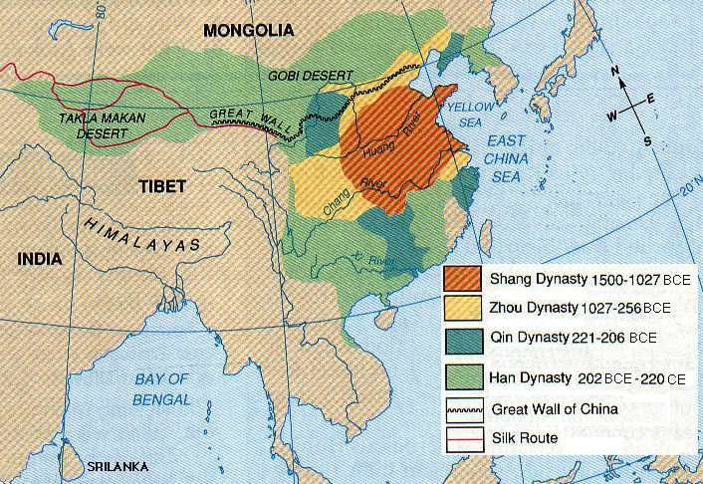

In China, history was divided into a series of dynasties. The most famous of these, the Han Dynasty, existed from 206 BCE to 220 CE. Accomplishments of the Chinese Empires included:

* Building the Great Wall of China
* Inventions= paper, paper money, printing and gunpowder, magnetic compass
* High level of artistic development
* Silk Production
* The Silk Road= major trade route.

**Practice Questions:**

1. What was not true of women during the Tang and Song periods?
   1. Wu Zhou declared herself emperor for the first time in Chinese History
   2. Foot-binding crippled women but enhanced their husband's status.
   3. Women were encouraged to become writers, poets and painters.
   4. Women were considered subservient to men.
2. What helped China to become a great sea power under Song leadership?
   1. the invention of the magnetic compass
   2. new ship building techniques
   3. the invention of gunpowder
   4. battle tactics learned from Mongolian rulers.
3. All of the following were inventions of the Tang and Song Dynasties EXCEPT
   1. porcelain
   2. the microscope
   3. paper money
   4. the magnetic compass

**Unit 4: Age of Exploration**

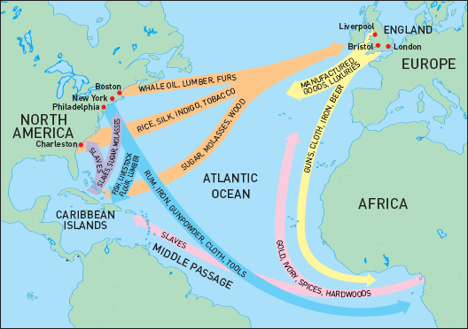

**Important terms:**

* Columbian Exchange
* Triangular Trade

**Practice Questions:**

1. What were Europeans’ main motives for making voyages of exploration?
   * 1. to test their new technology
     2. to grow wealthy and spread Christianity
     3. to break the Portuguese monopoly on trade.
     4. to gain extra land for a growing population.
2. As part of the Columbian exchange, which of the following was carried west across the Atlantic?
   1. livestock
   2. tobacco
   3. potatoes
   4. tomatoes
3. How was Africa affected by the Atlantic Slave trade?
4. Many cultures lost their strongest members, and families were torn apart.
5. All African countries prospered and grew to be world powers.
6. Kings were able to stop rebellions with the firearms they received through the trade.
7. African empires became safer because they traded away their criminals.

**Unit 5: Japanese Government**

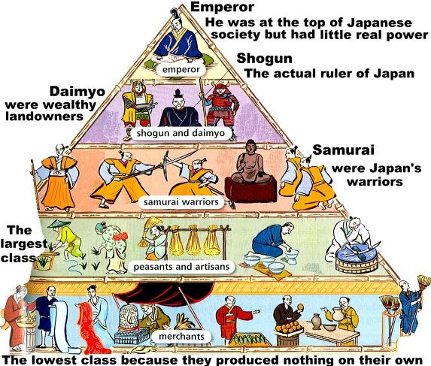

**Important terms:**

* Feudalism
* Daimyo
* Samurai
* Shogun
* Peasant
* Artisan
* Isolationism

**Practice Questions:**

1. What did the kamikaze, or divine wind, do for Japan?
   1. It stopped a Korean invasion.
   2. It brought the shoguns safely back home.
   3. It brought rain after a long drought.
   4. It stopped the Mongolian invasion.
2. What type of policy did Japan institute to limit foreign ideas in their nation?
   1. a closed country policy
   2. a policy of persecution
   3. a policy of colonization
   4. a Zen Buddhist policy
3. What major barrier hindered effective centralized government in Japan?
   1. the power of the daimyo
   2. the difficulties in collecting taxes
   3. the dissatisfaction of the peasant class
   4. the interference from Christian missionaries

**Unit 6: Enlightenment and Political Revolutions**

**Important terms:**

* Enlightenment
* Scientific Revolution
* Reason
* absolute monarch
* divine right
* social contract

**Practice Questions:**

1. What was Montesquieu's influence on the U.S. Constitution?
   1. public relations
   2. branches of government
   3. the Bill of Rights
   4. representatives
2. Which of the following did the Enlightenment promote?
3. a belief in progress
4. a more secular outlook
5. faith in science
6. all of the above
7. Which of the following were caused by the Scientific Revolution
8. belief that the earth was unmoving and at the center of the universe.
9. reliance on ancient authorities to explain the physical world
10. improvements in medicine and scientific instruments.
11. the assumption that the human body was similar to the anatomy of other animals.

**Unit 7: Transformations in Russia**

**Important terms:**

* Czar
* Serfs
* Communism
* Revolution
* Bolshevik
* Lenin
* Stalin

**Practice Questions:**

1. Who were the Bolsheviks?
   1. soldiers of the white army
   2. radical Russian Marxist revolutionaries
   3. 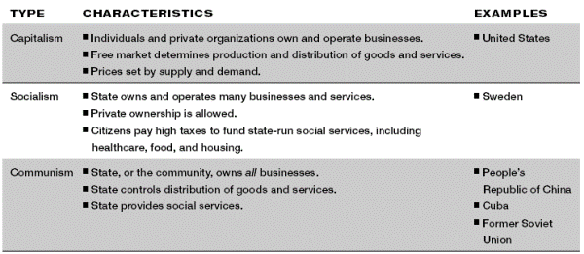members of the Duma, Russia’s parliament.
   4. supporters of Rasputin.
2. What is a totalitarian state?
   1. a state in which the people have a direct say in their government.
   2. a state in which the people elect representatives to the legislature.
   3. a state in which the government controls every aspect of public and private life.
   4. a state in which the working class have the greatest voice in government.
3. Between 1934 and 1939, the Great Purge was a campaign to eliminate
4. opposition to Stalin’s power
5. opposition to communist rule
6. shortages in housing, food and trade goods
7. traditional beliefs

**Unit 8: Industrialization**

**Important terms:**

* Machinery
* steam engine
* factory
* raw materials
* natural resources
* urbanization
* factors of production
* 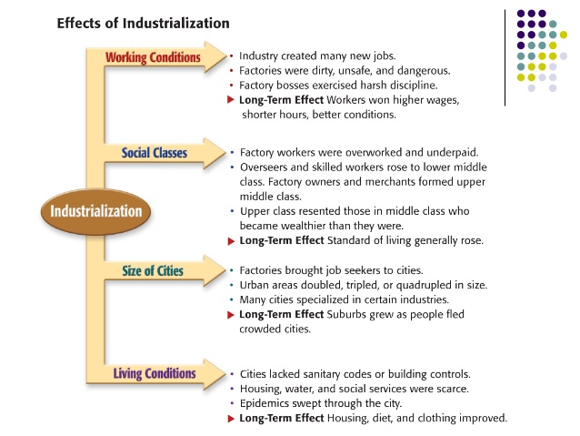union

**Unit 9: Imperialism**

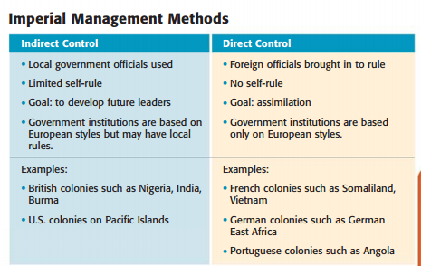

**Important terms:**

* Colony
* Annexation
* assimilation
* “white man’s burden”

**Practice Questions:**

1. What happened at the Berlin Conference of 1884-1885?
   1. France and Great Britain agreed to govern their colonies jointly.
   2. There was less fighting between African leaders and European powers.
   3. African leaders voiced their suggestions for better relations with Europe.
   4. European leaders divided Africa into colonies without consulting African leaders.
2. What was the main cause of inadequate food supplies in Africa during European colonization?
   1. Most of the farmland was used for mining.
   2. Native farmers were drafted into colonial armies.
   3. Europeans used too much farmland for building cities.
   4. Europeans insisted on the growth of cash crops, such as cotton.
3. How did Europeans use paternalism to govern people in colonies?
   1. They allowed them to assimilate into European society.
   2. They provided for colonial people’s needs but did not give them full rights.
   3. They trained colonial people to govern themselves.
   4. They trained them in advanced European farming and mining techniques.

**Unit 10: World War I**

**Important terms:**

* Nationalism
* Alliances
* Assassination
* Trench warfare
* Treaty of Versailles
* economic depression
* fascism

**Practice Questions:**

1. Which of the following was true of nationalism?
   1. one’s greatest loyalty should not be to king.
   2. one’s greatest loyalty should be to a nation of people.
   3. The nation of people should have a common culture.
   4. All of the above.
2. What is the probable link between militarism and imperialism?
   1. As a country gains colonies, its military grows to protect/control them.
   2. As a country’s military expands, the country wants colonies for recruits.
   3. As a country’s colonies grow, the military trains there.
   4. As the military expands, a country seeks colonies to stop problems at home.
3. What did the policy of unrestricted submarine warfare refer to?
4. Britain’s policy to sink any German ship without warning.
5. Germany’s policy to sink any ship approaching Britain without warning
6. The U.S. navy’s warning to sink German ships without warning.
7. Germany’s decision to ask Mexico for help in the war.

**Unit 10: World War I**

**More Practice Questions:**

1. How did the Treaty of Versailles affect postwar Germany?
2. It left a legacy of bitterness and hatred in the hearts of the German people.
3. It stabilized Germany’s economy and gave economic aid to the nation.
4. It left Germany in much the same state it was before the war.
5. It helped the Germans to rebuild their nation on a stronger foundation.
6. What was the American public’s opinion about joining the League of Nations?
7. The public thought that America should lead the League of Nations.
8. The public supported the idea but with a smaller role for America.
9. It supported the president and wanted to be an active member in the league.
10. It believed the United States should stay out of European affairs.
11. What caused Germans to start taking Adolf Hitler and his message seriously?
    1. the threat of invasion by the Soviet Union
    2. his skill at making speeches.
    3. the example of Mussolini in Italy
    4. the economic crisis brought on by the Depression

**Unit 11: World War II**

**Important terms:**

* aggression, appeasement
* Nazi
* Hitler
* Blitzkrieg
* Kamikaze
* Imperial Japan atomic bomb

**Practice Questions:**

1.) What was the policy of appeasement?

1. The treaty between Russia and Germany not to attack each other.
2. The British and French decision to give into aggression to keep the peace.
3. The desire of the U.S. to stay out of foreign affairs.
4. The alliance between Mussolini and Hitler
5. Which of the following does fascism stress?
6. nationalism
7. isolationism
8. individual rights
9. a classless society
10. The German blitzkrieg was a military strategy that depended on what advantage?
11. a system of well armed fortifications.
12. “out waiting” the opponent.
13. surprise and overwhelming force.
14. the ability to make a long, steady advance.

**Unit 11: World War II**

**More Practice Questions:**

1. What was the goal of Hitler’s “Final Solution”?
   1. It was a process to divide up his territories among his generals.
   2. It was a system for winning the war before the Americans entered.
   3. It was a way to draft more soldiers for the invasion of Russia.
   4. It was the genocide of the people the Nazis considered inferior.
2. What does the use of kamikaze pilots show about Japanese culture?
3. They hated Americans enough to die killing them.
4. They did not mind dying because they expected to lose the war.
5. They valued national honor more than individual life.
6. They were full of despair after the atomic bombs fell on Japan.
7. Which of the following is NOT a basic practice needed for democracy to work?
8. Free elections
9. Constitutional government
10. Citizen participation
11. A presidency

**Unit 12: Genocides**

**Important terms:**

* Armenian Genocide
* Holocaust
* ethnic cleansing
* concentration camps
* crimes against humanity

**Practice Questions:**

1. What was it called when Bosnian Serbs used violence to rid Bosnia of its Muslims?
   1. Revolution
   2. Militarism
   3. Shock and awe
   4. Ethnic cleansing
2. What effect did the end of Communist rule have on Yugoslavia?
3. Without communism as a unifier, ethnic hatred tore the country apart.
4. Without communism acting to repress free speech, art began to flourish.
5. Communists began using ethnic cleansing against democratic leaders.
6. They separated peacefully into 4 republics.
7. Which of the following reflects the leader who was responsible for the Great Purge and the main group that was victimized by it?

a. Lenin ---> the Mensheviks

b. Jiang ---> the Kuomintang

c. Jiang ---> members of the Communist Party

d. Stalin ---> members of the Communist Party

**Unit 13: Decolonization in Asia**

**Important terms:**

* Gandhi
* third world

**Practice Questions:**

1. How did European colonists cause later conflicts in African nations?
   1. They manufactured goods that were useful only to the home country.
   2. They set up unbalanced economies based on one or two cash crops.
   3. They established boundaries that ignored ethnic and cultural divisions.
   4. They left the newly independent nations without any governments.
2. The dividing of India into two nations was referred to as
3. The civil war
4. The partition
5. The separation
6. All of the above
7. What influenced the independence movement of colonial countries?
8. The spread of democratic ideas
9. During WWII, the occasional defeat of Western powers by the Japanese
10. The expense of maintaining and governing distant colonies
11. All of the above.

**Unit 14: The Cold War**

**Important terms:**

* Soviet Union
* Berlin Wall
* Mao Zedong
* Oppression
* Korean War
* Vietnem War
* nuclear arms race

**Practice Questions:**

1. What were Third World countries?
   1. Countries aligned with the United States and its allies
   2. Countries aligned with the Soviet Union and its allies
   3. Countries with a gross national product higher than First or Second World Countries.
   4. Developing countries not aligned with the United States or the Soviet Union.
2. What was the Strategic Defense Initiative?
3. A council created to develop defense measures.
4. A failed satellite of the Soviet Union
5. A system designed to protect the U.S. against enemy missiles.
6. A program to weed out terrorism in the U.S.
7. How did the Bay of Pigs failure lead to the Cuban Missile Crisis?
   1. Khrushchev believed the U.S. was too weak to oppose Soviet expansion into Cuba.
   2. Communism remained the ruling force in Vietnam.
   3. American expanded its trade embargo against Vietnam.
   4. Kennedy believed the Soviet Union was too strong to fight against.

**Unit 15: Globalization**

**Important terms:**

* United Nations
* Globalization:
* Interdependence:

**Practice Questions:**

1. What is meant by global interdependence?

1. the elimination of international borders through use of the Internet and the sharing of information worldwide
2. the idea that nations are dependent on other nations and affected by the actions of others far away
3. the existence of multinational corporations that have branch offices worldwide and utilize native laborers
4. the central influence of one nation on the world and the amount of change forced on other

2. What is the difference between developed and emerging

nations?

1. Developed nations are industrialized, while emerging are in the process of industrializing.
2. Emerging nations are industrialized, while developed are in the process of industrializing.
3. Both are industrialized, but in emerging nations only one language is spoken and understood.
4. Both are in the process of industrializing, but developed nations are further along.

3. NATO, SEATO, and the Warsaw Pact are all examples of  
a. regional trade associations.  
b. nuclear non-proliferation treaties.  
c. military alliances.  
d. peace treaties.