United States Office of Price Administration  War Ration Book  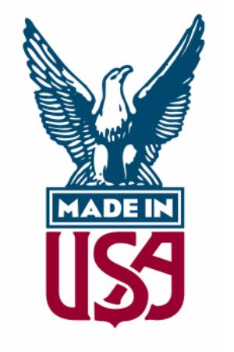  Issued To: _____________ | Ration Coupon  Item: _________________  NO. 1
Ration Coupon  Item: _________________  NO. 2 | Ration Coupon  Item: _________________  NO. 3
Ration Coupon  Item: _________________  NO. 4 | Ration Coupon  Item: _________________  NO. 5
Ration Coupon

Item: _________________
NO. 6

