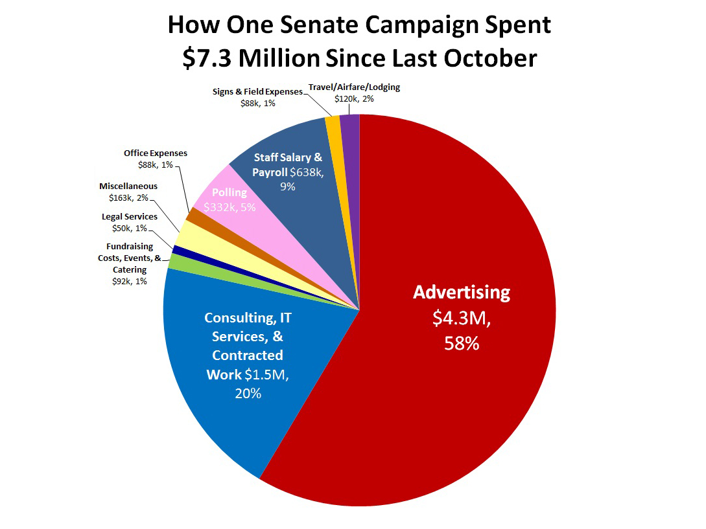

**http://a.abcnews.com/images/Politics/abc_begich_spending_chart_SIZED_kb_141103.jpg**