Chapter 4-Federalism
Section Two: The National Government and the 50 States (pg. 103-109)

National Obligations to the States (pg. 103-104)
Obligation | What It Means | Example from History
Republican Form of Government (pg. 103)
Invasion and Internal Disorder (pg. 104)
Respect for Territorial Integrity (pg. 104)

Territorial Expansion of the U.S.

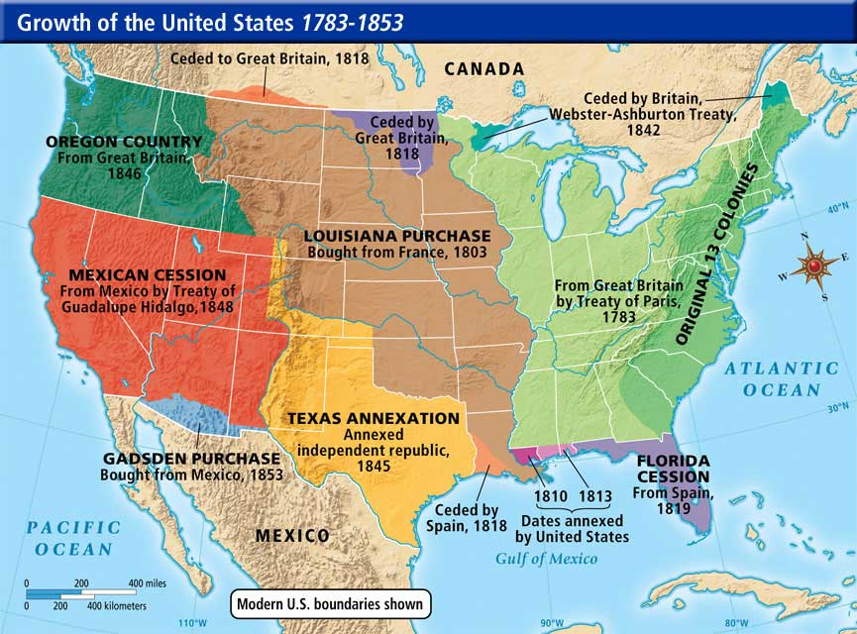

Only ____________ has the power to admit new states, but there is one restriction on this power: a state cannot be created out of a pre-existing state’s territory without the consent of ____________(s) of the State (s) involved. (pg. 106)

Congress has admitted ________ states since the original 13 formed the Union. (pg. 106)

Four states created from pre-existing states: ______________________________________________ (pg. 106)

__________________ and _______________ were independent republics before admission. (pg. 106)

_______________________ was admitted shortly after being ceded to the United States by Mexico. (pg. 106)

To become a state, the area desiring statehood must ask Congress for _______________, prepare a Constitution, and wait for Congress to pass an ______________ Act. If the __________________ signs the Act the new State enters the union. (pg. 106)

The two newest States _______________ and _______________, shortened the usual admission process. Each proposed a constitution without waiting for an enabling act. ________________ in 1950 and _______________ in 1956. Both became states in 1959. (pg. 106)

While Congress can set admission conditions, it can’t impose conditions of a __________ nature on the state. (pg. 107)

The American federal system also involves a broad area of ______________ powers. In addition to the two separate spheres of power ___________ and ____________ by the two basic levels of government, there are large growing areas of cooperation between them. (pg. 107)

The best example of intergovernmental cooperation are the many federal grant-in-aid programs. Which are grants of federal money or ___________________________________________________________________ _________________________________________________________________________________. (pg. 107)

Please explain how each type of federal grants-in aid work.
Types of Federal Grant-in-Aid (pg. 108-109)
Type of Grant | What It Means | Examples
Categorical Grants (pg. 108)
Block Grants (pg. 109)
Project Grants (pg. 109)

