Name:__________________________________
Date:________________________
Hour:________

Part 1: Political Dictionary-Vocabulary Words: Define each of the following words.
- Suffrage
- Franchise
- Electorate
- Disenfranchised
- Poll tax
- Alien
- Registration
- Gerrymandering
- Injunction
- Preclearance
- Off-year election
- Political efficacy
- Political socialization
- Party identification
- Straight-ticket voting
- Split-ticket voting
- Independent

Part 2: Chapter 6-Section 1 [pages 152-155]: TM#1: For this section, you are studying how suffrage, or the right to vote has been expanded from the 1800s to present-day. You will be doing a flow map [sequencing] and putting the five stages in order. For each stage, you will first put the time period in the big box and then the details/explanation in the sub-boxes.

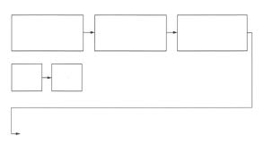
Part 3: Chapter 6-Section 2 [pages 156-159]: TM#2: For this section, you are studying the universal requirements to be able to vote (citizenship, residence and age). You are to do a tree map where you organize your notes on the three qualifications.

Name:__________________________________
Date:________________________
Hour:________

Part 1: Political Dictionary-Vocabulary Words: Define each of the following words.
- Suffrage
- Franchise
- Electorate
- Disenfranchised
- Poll tax
- Alien
- Registration
- Gerrymandering
- Injunction
- Preclearance
- Off-year election
- Political efficacy
- Political socialization
- Party identification
- Straight-ticket voting
- Split-ticket voting
- Independent

Part 2: Chapter 6-Section 1 [pages 152-155]: TM#1: For this section, you are studying how suffrage, or the right to vote has been expanded from the 1800s to present-day. You will be doing a flow map [sequencing] and putting the five stages in order. For each stage, you will first put the time period in the big box and then the details/explanation in the sub-boxes.

Part 3: Chapter 6-Section 2 [pages 156-159]: TM#2: For this section, you are studying the universal requirements to be able to vote (citizenship, residence and age). You are to do a tree map where you organize your notes on the three qualifications.

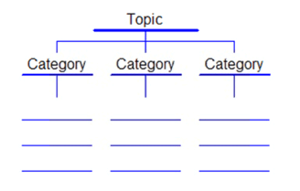

Part 4: Chapter 6-Section 3 [pages 164-168]: TM#3: For this section, you are studying the history of suffrage, or the right to vote, in America. You will be doing a tree map where you organize your notes on the following categories:
- 15th Amendment
- Methods used by Southern whites to stop blacks from voting [under history]
- Civil Rights Legislations [make sure you define each one]

Part 5: Chapter 6-Section 4 For this section, you are doing THREE of the following four thinking maps:
- TM#4 [pages 170-173]: You will be doing a bubble map where your topic is “Why people don’t vote” and then you will include all the reasons [plus their definitions] on why people choose not to cast a ballot.
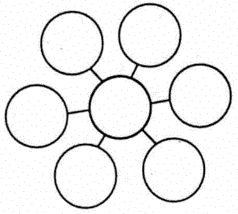
- TM#5 [pages 173-174]: A tree map that organizes the three ways in which we study voting behavior
- TM#6 [pages 174-177]: A bubble map that shows all of the sociological factors that determine voter preferences. Each must be explained.
- TM #7 [pages 177-178]: A bubble map showing all of the psychological factors that affect voter preferences. Each must be explained.

Part 4: Chapter 6-Section 3 [pages 164-168]: TM#3: For this section, you are studying the history of suffrage, or the right to vote, in America. You will be doing a tree map where you organize your notes on the following categories:
- 15th Amendment
- Methods used by Southern whites to stop blacks from voting [under history]
- Civil Rights Legislations [make sure you define each one]

Part 5: Chapter 6-Section 4 For this section, you are doing THREE of the following four thinking maps:
- TM#4 [pages 170-173]: You will be doing a bubble map where your topic is “Why people don’t vote” and then you will include all the reasons [plus their definitions] on why people choose not to cast a ballot.
- TM #5 [pages 173-174]: A tree map that organizes the three ways in which we study voting behavior
- TM#6 [pages 174-177]: A bubble map that shows all of the sociological factors that determine voter preferences. Each must be explained.
- TM#7 [pages 177-178]: A bubble map showing all of the psychological factors that affect voter preferences. Each must be explained.

