World War One-DBQ Activity

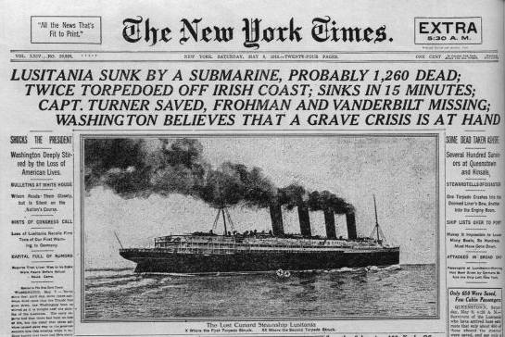

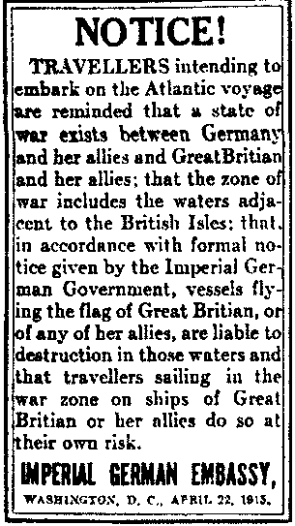
DOCUMENT 1 - Front page of the NY Times, May 8, 1915, reports that a German submarine torpedoed and sank an unarmed passenger ship carrying American citizens.

1. What was the purpose of the notice from the Imperial German Embassy?

2. What effect do you think that the incident described in the NY Times might have had on American public opinion about involvement in the war?

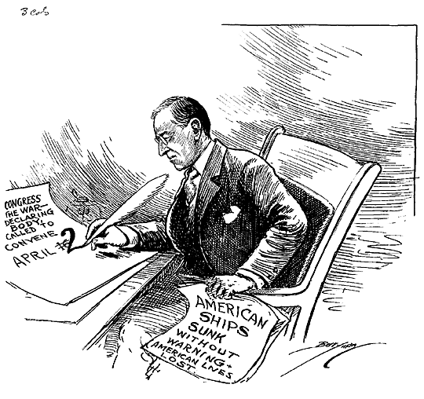

DOCUMENT 2 - Cartoon in response to German U-boat attacks on American ships at sea (1917).

3. What is President Wilson doing in the cartoon above?

4. What is the reason for his actions in the cartoon above?

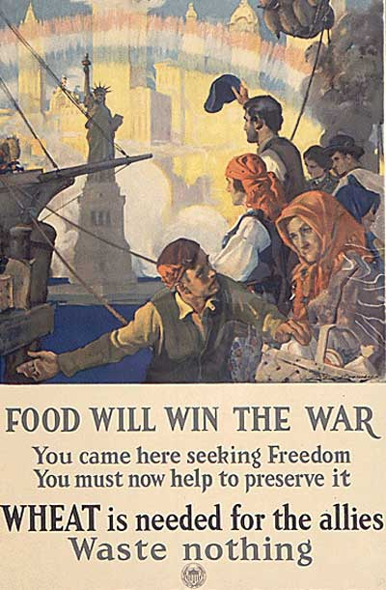

DOCUMENT 3 –
A 1917 Poster from the United States Food Administration

5. Who is the target audience for this poster?

6. What is the purpose of the poster?

It is a fearful thing to lead this great peaceful people into war, into the most terrible and disastrous of all wars…But the right is more precious than peace, and we shall fight for things which we have always carried nearest to our hearts --- for democracy; for the right of those who submit to authority to have a voice in their own Governments; for the rights and liberties of small nations; for universal dominion of right by such a concert of free peoples as shall bring peace and safety to all nations and make the world itself at last free.
- Woodrow Wilson, speech asking Congress to declare war on Germany (April 2, 1917)

DOCUMENT 4

7. What are two reasons that Wilson says we must go to war against Germany?

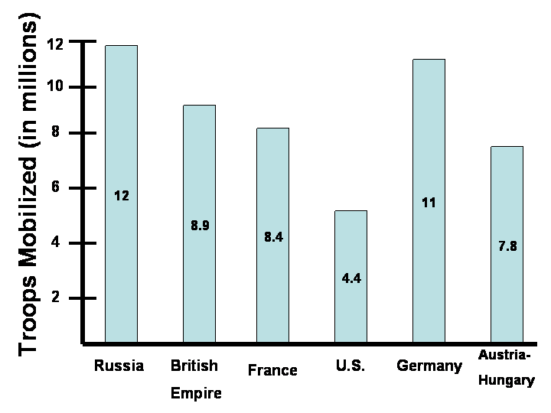

DOCUMENT 5

8. According to the bar graph, what was one way the U.S. involvement in WWI helped the Allies?

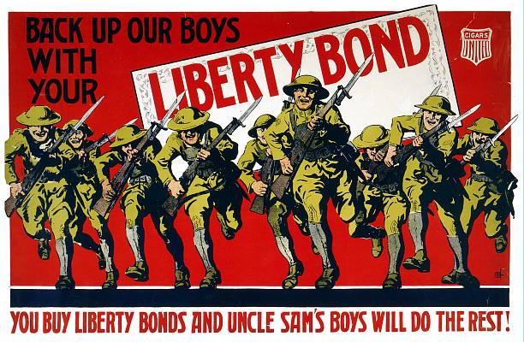

DOCUMENT 6

9. What is the poster in document 6 asking Americans to do to help the war effort?

10. How would this help America with the war effort?

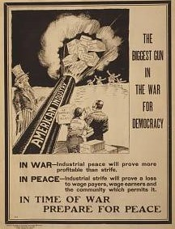

Document 7

11. What is the “Biggest Gun” in the war for democracy?

12. How did this “Gun” help the Allies win the war?

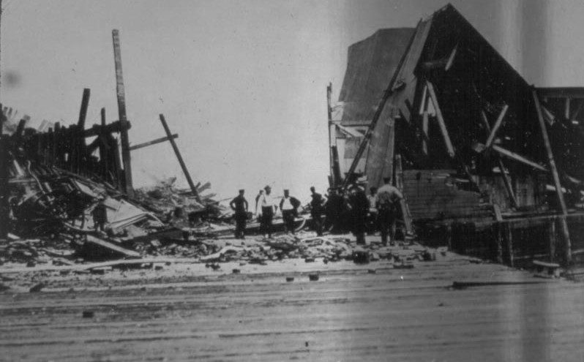

DOCUMENT 8 – A Jersey City, New Jersey munitions factory lay in ruins after it was blown up by German spies (saboteurs) on July 30, 1916.

13. What is significant about the date of this disaster?

14. How might the events at this munitions factory have swayed American public opinion about the war?

