**Chapter 3-Section 3: Informal Amendment**

* Many changes and interpretations have been made to the Constitution that have not involved any changed in its written words

**Informal Amendment Processes**

* **_______________________________** is the process by which over time many changes have been made in the Constitution which have not involved _________________________________
* The informal amendment process can take place by:

(1) __________________________________________

(2) __________________________________________

(3) __________________________________________

(4) __________________________________________

(5) __________________________________________

**I. Basic Legislation by Congress: 2 Ways**

**1. ) ___________________________________________________________________________**

C:\Users\Fatmeh Reda\AppData\Local\Microsoft\Windows\Temporary Internet Files\Content.IE5\UROBIBTA\MC900149508[1].wmfEx: Article III, Section I only talks about having a Supreme Court and “such inferior courts a the Congress may from time to time ordain and establish”…. Congress passed the Judiciary Act in 1789 ad since then, has created all the federal courts….

**2) _______________________________________________________________**

Ex: Constitution says that Congress has the power to “regulate foreign and interstate commerce.”…Congress has passed thousands of laws about this so that they expanded the words of the Constitution

**C:\Users\Fatmeh Reda\AppData\Local\Microsoft\Windows\Temporary Internet Files\Content.IE5\QSRTVS04\MC900440036[1].wmfII. Executive Action**

* Presidential actions such as the use of the military under the power of commander in chief.
* Presidents add on to “_______________________” based on what they think it means….
* An **__________________________**is a pact made by the President directly with the _______________________ and they do not need to be approved by Senate…
* A **___________________**is a formal agreement between two or more sovereign states that needs to be approved by Senate

**#3 Court Decision**

* C:\Users\Fatmeh Reda\AppData\Local\Microsoft\Windows\Temporary Internet Files\Content.IE5\UROBIBTA\MC900054685[1].wmfThe nation’s courts, most importantly the United States Supreme Court, ___________ and ____________ the Constitution in many cases they hear.

**#4 Party Practices**

* No mention of ________________ in the Constitution
* Ex: No method for nominating a person for the __________________
  + Since 1830s, parties have held national conventions to do that
  + Changed the purpose of the ____________________
  + Congress conducts its business on the basis of parties
  + President makes _________________ to office based on parties

**#5 Custom and Usage**

* Custom: A traditional and widely accepted way of behaving or doing something that is specific to a particular society, place, or time.
* Examples:
  + 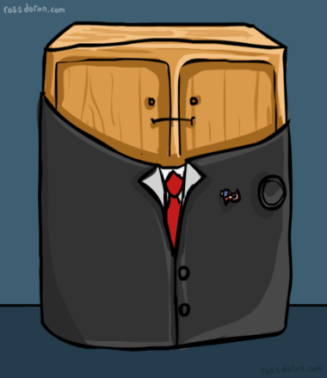Heads of the 15 executive departments make up the

_________________________

* + Senate approves the ____________________________________ who are

acceptable to the senator or senators of the President’s party from the State

involved

* + “_____________________________” was started by

____________________________ and followed for over _____ years until

1940 and 1944 when __________________________ won a third and

fourth term…so they added the __________________________ limiting

the President to two terms only