**Chapter 3-Section 2: Formal Amendment**

**Durability of the Constitution**: **(pg. 78)**

How has the Constitution, written in 1789, endure and kept pace with these changes and growth?

* **Answer:**
  + Constitution of today is the same as that of 1789…. Same words, same meanings…. Just some new words have been added………..
  + The process of constitutional change, of __________________ and ____________, happens in one of two ways:

1**. _______________________________**

**2. _______________________________**

**Amending the Constitution (pg. 78)**

* The Constitution provides for its own amendment—that is, for changes in its written words…it explain how to make changes to itself.
* __________________ sets out two methods _____________________ and two methods ________________________ of constitutional amendments, creating four possible methods of formal amendment.
* **_________________________** is the changes or additions that become part of the written language of the Constitution itself
* Framers didn’t want to make it easy to change the constitution- So they came up with four hard ways to do it.

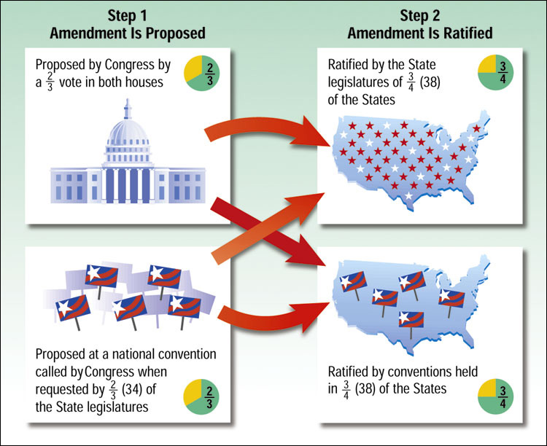

**METHOD #1 (pg. 79)**

* Proposed by two-thirds vote of each house of Congress
* Ratified by ____________________________________________________

**METHOD #2 (pg. 79)**

* Proposed by two-thirds vote of each house of Congress in ¾ of the states.
* __________________________________________ was adopted this way.

**METHOD #3 (pg. 79)**

* Proposed by national convention called by Congress at request of two thirds of state legislatures.
* ______________________________________________________________

**METHOD #4 (pg. 80)**

* Proposed by national convention called by Congress at request of two thirds of state legislature.
* ______________________________________________________________

**Formal Amendment Process Highlights Constitutional Principles (pg. 80)**

* Formal Amendment process works on two basic principles of the Constitution:

**1. ­­­­­­­­­­­­­­­­_____________________________**

* + Proposal always takes place at the ______________________
  + Ratification always takes place at the _______________________

**2. _____________________________**

* + When an amendment is proposed, it’s voted on by the people… so the action represents the expression of the people’s sovereign will!

**Some were a FLOP! (pg. 80-82)**

* Since 1789, _______ resolutions for amendments have been sent to Congress…. Only ____ passed votes in the two houses and made it to State legislatures… of those, only _______________!
* Some that were proposed, and didn’t pass….

1. **1789:** Distribution of seats in the House of Representatives
2. **1861:** Prohibited forever any amendment relating to slavery
3. **1810:** Voided citizenship of anyone who had any ______________________________
4. **1924:** _____________________________________________________
5. **1978:** Give _________________________________ seats in Congress
6. **1972:** _____________________________ [ERA] to give equality of rights under the law to women

