**Government-Chapter 1-Principals of Government- (pg. 4) Packet Check List #1**

**(The Entire Packet is due at the End of the Hour)**

Chapter 1-Essential Questions



Chapter 1-Section 1- Brace Map



Chapter 1-Names and Terms



Chapter 1-Political Cartoon Actvity (Examples 1-4)



--------------------------------------------------------------------------------------------

**Essential Question-Chapter 1: Principals of Government**

1. As citizens, what should we expect the major roles /functions of government to be (Analysis)?
2. What are the most important services do governments provide to their citizens? (Evaluate)?
3. What kinds of government are best? (Evaluate)
4. How does the United States define democracy? (Analysis)

**Use the Brace Map below to define the three basic powers of government (pg. 5)**

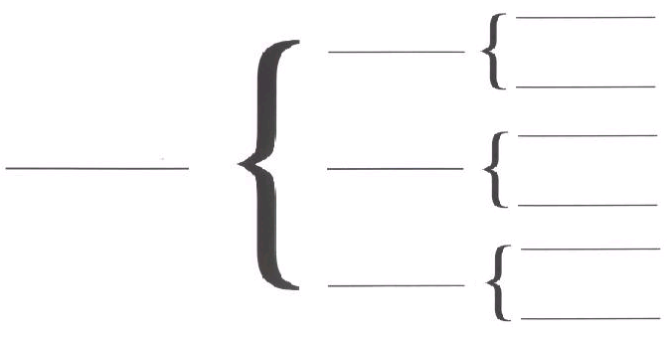

**Reflection Questions:**

1. Why do you think the Framers of the Consitiution seperated these powers?
2. What problems may arise if these powers are not seperated and lie in the hands of a single person?

**Chapter 1-Principals of Government**

**Names and Terms**

**Section 1: Government and the State-**

1. Government-
2. Public Policies-
3. Legislative Power-
4. Executive Power-
5. Judicial Power-
6. Constitution-
7. Dictatorship-
8. Democracy-
9. State-
10. Sovereign-

**Section 2: Forms of Government-**

1. Autocracy-
2. Oligarchy-
3. Unitary Government-
4. Federal Government-
5. Division of Powers-
6. Confederation-
7. Presidential Government-
8. Parliamentary Government-

**Section 3: Basic Concepts of Democracy-**

1. Majority Rule-
2. Compromise-
3. Citizen-
4. Free Enterprise System-

**Political Cartoon Activity-Chapter 1 (Examples 1-4)**

**Directions:** Write the vocabulary term from Chapter One that you best associate with the political cartoon or the picture shown below. State a specific piece of evidence from the picture as support your rational.

**Political Cartoon #1:**

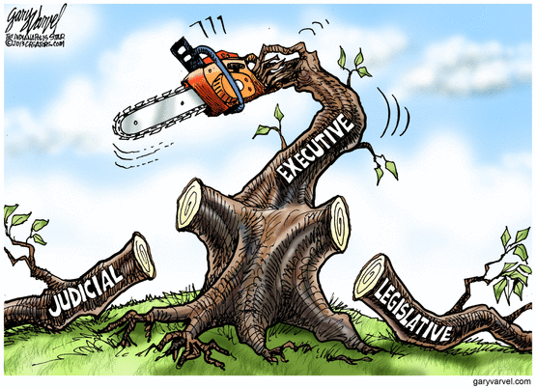

1. ____________________________ is the vocabulary term I associate with this political cartoon.
2. My rational for selecting _______________________ as my vocabulary term is ...

**Political Cartoon #2:**

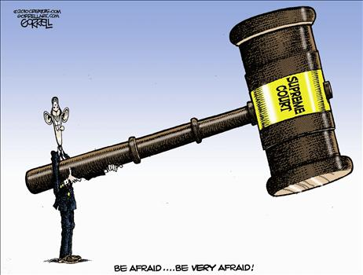

1. ____________________________ is the vocabulary term I associate with this political cartoon.
2. My rational for selecting _______________________ as my vocabulary term is ...

**Political Cartoon #3:**

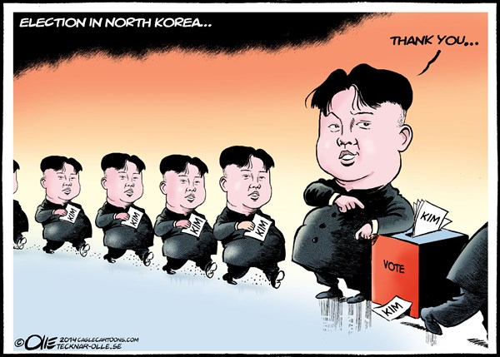

1. ____________________________ is the vocabulary term I associate with this political cartoon.
2. My rational for selecting _______________________ as my vocabulary term is ...

**Political Cartoon #4:**

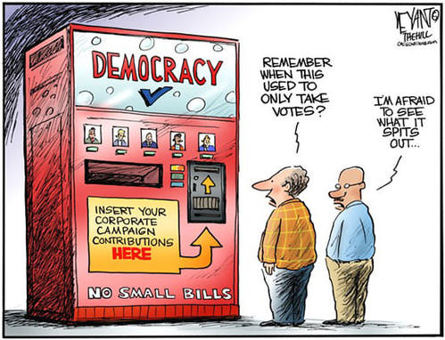

1. ____________________________ is the vocabulary term I associate with this political cartoon.
2. My rational for selecting _______________________ as my vocabulary term is ...