Chapter 27-The Age of Imperialism-Guided Notes
Section 1-The Scramble for Africa

Setting the Stage (pg. 773)

- Describe Imperialism using the vocabulary match up activity we conducted in class:

Africa Before European Domination (pg. 773)

- Before the arrival of Europeans how were African tribes divided up?

- How many languages were spoken in Africa?

- What type of religious practices existed in Africa prior to mass colonization?

- What percentage of Africa had been colonized by Europeans by 1880?

- Before the arrival of Europeans who controlled the trade networks and supply of goods in Africa?

- What were two of the luxury goods collected by the Chokwe?

- Who were some of the original groups to settle in Africa?

- Prior to European colonization how did most people learn about Africa?

Driving Forces Behind Imperialism (pg. 774-775)

- The race for African colonies grew out of a strong sense of _________________.
  - European nations were determined to plant their flag on as much land as possible

- Describe Racism using the vocabulary match up activity we conducted in class:

- Describe Social Darwinism using the vocabulary match up activity we conducted in class:

Driving Forces Behind Imperialism (pg. 774-775) continued…

*Understanding that Europe’s technological superiority helped promote Imperialism in Africa let’s look at some other factors that contributed….

- What was the name of the world’s first automatic machine that European’s used to mow down attacking African tribes?

- What invention allowed Europeans to travel deep into the jungles of Africa?

- What were some of the factors that discouraged unity among African tribes?

The Division of Africa (pg. 775-776)

- Although colonization really didn’t begin until 1880 which precious gem was discovered in Africa in 1867?

- Once __________________ was discovered in 1886 all remaining European powers tried to get a foothold in Africa so they wouldn’t be left out of the new found wealth.

- Describe Berlin Conference using the vocabulary match up activity we conducted in class:

- How would a European country go about claiming African land?

Three Groups Clash Over South Africa (pg.776-777)

- Which three groups clashed over African resources?

- Under the leadership of Shaka the Zulu’s nearly defeated the British in 1816 by using which simple weapons?

  - The Zulu’s fell under British following their loss in the Battle of _____________ in 1879.

- Who were the Boers (include where they came from and what they took over) and where did they relocate to in an attempt to escape the British?

Three Groups Clash Over South Africa (pg.776-777)

- The Boer War

- While fighting the English for control of their land the Boer’s were also fighting to keep foreigners away from which valuable resources?

- How many South Africans died in European ran concentration camps?

- In what year did the Boer republics joined a self-governing Union of South Africa?

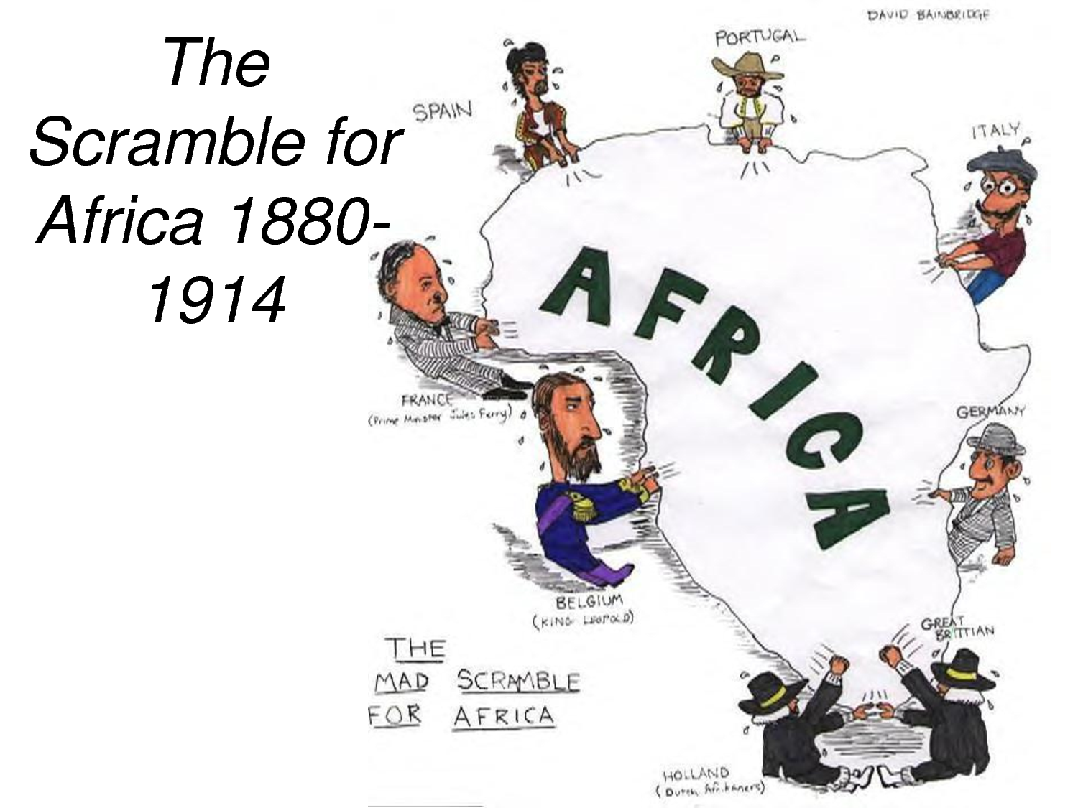

Chapter 27-The Age of Imperialism-Guided Notes
Section 1-The Scramble for Africa

Setting the Stage (pg. 773)

- Imperialism-The seizure of a country or territory by a stronger country

Africa Before European Domination (pg. 773)

Africa Before European Domination
- Africa Before Europeans Arrived  - African’s were divided into hundreds of ethnic and linguistic groups  - Spoke over 1,000 different languages  - Followed either traditional beliefs, Christianity or Islam | - Nations Compete for Overseas Empires  - By 1880 European’s only controlled 10% of Africa  - African’s controlled their own trade networks and supplied the goods  - The Chokwe collected ivory and beeswax  - Original settlers were missionaries, explorers and humanitarians  - They learned about Africa through travel books and newspapers

Driving Forces Behind Imperialism (pg. 774-775)

- The race for African colonies grew out of a strong sense of nationalism
  - European nations were determined to plant their flag on as much land as possible

Driving Forces Behind Imperialism (pg. 774-775) continued…

Belief in European Superiority | Forces Promoting Imperialism in Africa
- Racism-The belief that one race is superior to another  - Social Darwinism-The belief that the races “fittest for survival” would enjoy wealth and success b/c they were superior to others | - Forces Promoting Imperialism in Africa  - Europe’s technological superiority  - The Maxim Gun  - Worlds 1st automatic machine gun  - The Steam engine  - Allowed European’s to travel deeply into the jungles  - A variety of languages and cultures discouraged unity among the tribes

The Division of Africa (pg. 775-776)

Berlin Conference Divide’s Africa
- Colonization began around 1880  - Diamonds were discovered in 1867 and gold in 1886 so, no European powers wanted to be left out | - Berlin Conference-With the goal of preventing future wars, 14 European Nations met to lay down the rules for dividing up Africa  - A country could claim land by notifying other nations and showing they were in control

Three Groups Clash Over South Africa (pg.776-777)

Zulus Fight the British | Boers and British Settle in the Cape
- Africans, Dutch and English clashed over African resources  - Zulus Fight the British  - 1816 Zulu chief Shaka and his men used spears and shields nearly defeats the British  - After losing the Battle of Ulundi in 1879 the Zulu nation fell under British control | - Boers and British Settle in the Cape  - Boers were Dutch farmers who gradually took more African land  - To escape the British the Boers headed north from the Cape of Good Hope and soon found themselves fighting the Zulus

- The Boer War
  - Boers tried to keep foreigners out and away from diamonds and gold began to fight with the English for control of land
    - Over 14,000 South African died in concentration camps
  - In 1910, the Boer republics joined a self-governing Union of South Africa

