Chapter 25-The Industrial Revolution -Guided Notes
Section 1-The Beginnings of Industrialization

Industrial Revolution Begins in Britain (pg. 717-718)

- Describe the Industrial Revolution and be sure to include where and when it began.

- Explain the purpose of enclosures?

- Describe the seed drill. Include who invented it and its purpose?

- Describe industrialization using the vocabulary match up activity we conducted in class.

  - List the natural resources used during industrialization.

- Define the factors of production based on the vocabulary match up activity we conducted in class.

- List the three factors of production:

Improvements in Transportation (pg.721)

- What is an entrepreneur?

- Describe why the steam engine was such a significant invention.

  - Who modified the steam engine for maximum efficiency?

  - Robert Fulton’s ship the Clermont ferried passengers up and down which river?

The Railway Age Begins (pg. 721-722)

- What invention was the driving force behind English industry after 1820?

- Describe the bet made by Richard Trevithick made in 1804.
(Be sure to include what he bet he could haul, how far he would haul it and the transportation source he used.)

- In order to connect the cities of Liverpool and Manchester in England entrepreneurs decided to build a rail line called the Liverpool-Manchester Railroad. Discuss the purpose of the contest they held and whose invention won. Don’t forget to tell us how they won.

- List and describe the four major effects of the locomotive on the lives of British citizens.

Chapter 25-The Industrial Revolution -Guided Notes
Section 1-The Beginnings of Industrialization

Industrial Revolution Begins in Britain (pg. 717-718)

The Agricultural; Revolution-Paves the Way
- The Industrial Revolution-  - The increased output of machine-made goods beginning in England in the mid 1700’s | - Enclosures-  - Large fenced in fields in which landowners experimented with productive seeding and harvesting methods to boost crop harvests

Rotating Crops
- Seed Drill-  - Invented by Jethro Tull in 1701 that allowed farmers to plant seeds in well-spaced rows at specific depths. | - Crop Rotation-  - Designed to rotate crops that drained nutrients from the soil (ex. Wheat) with crops that replenish them (ex. Turnips)

Why the Industrial Revolution Began in England
- Industrialization- The process of developing the machine production of goods through the use of natural resources.  - Natural Resources used for Industrialization  - Water and coal power  - Iron Ore to construct tools, machines and buildings  - Rivers for inland transportation  - Harbors for the ships to set sail | - Factors of Production-The resources needed to produce goods and services that the Industrial Revolution required.  - Ex. Land, labor and capital (a.k.a wealth)  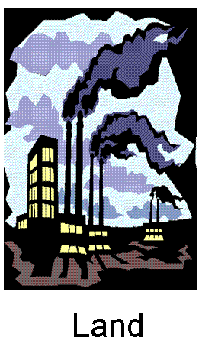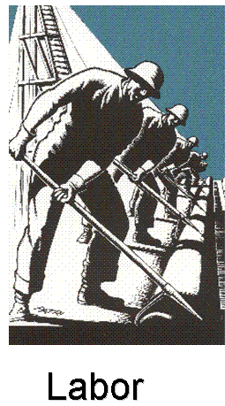
Improvements in Transportation (pg.721)

Watt’s Steam Engine
- Entrepreneur-Someone who organizes, manages, and takes on the risks of a business. | - The steam engine was modified by James Watt for increased efficiency.  - Ex. Robert Fulton's Clermont was a steam ship that ferried passengers up and down the Hudson River

The Railway Age Begins (pg. 721-722)

- The steam powered railroad locomotive was the driving force behind English industry after 1820

- Steam-Driven Locomotives-
  - 1804 Richard Trevithick won several thousand dollars on a bet that he could haul 10 tons of iron ore nearly 10 miles with a steam engine

- The Liverpool-Manchester Railroad-  - English entrepreneurs wanted a rail line to connect the cities of Liverpool and Manchester.  - A contest was held to see which train would run on the line  - George Stephenson’s Rocket won by hauling 13 tons at nearly 24 miles per hour | - Railroads Revolutionize Life in Britain-  - The Four Major Effects of the Locomotive-  - Materials and finished products were cheap to transport  - The new rail lines created thousands of new jobs  - Agricultural and fishing industries saw a boost b/c of new transportation opportunities  - Travel became easier and people could now live farther from their jobs

