Chapter 24-Nationalist Revolutions Sweep the West-Guided Notes
Section 1-Latin American Peoples Win Independence
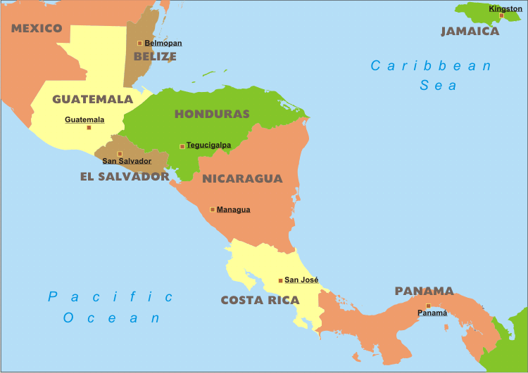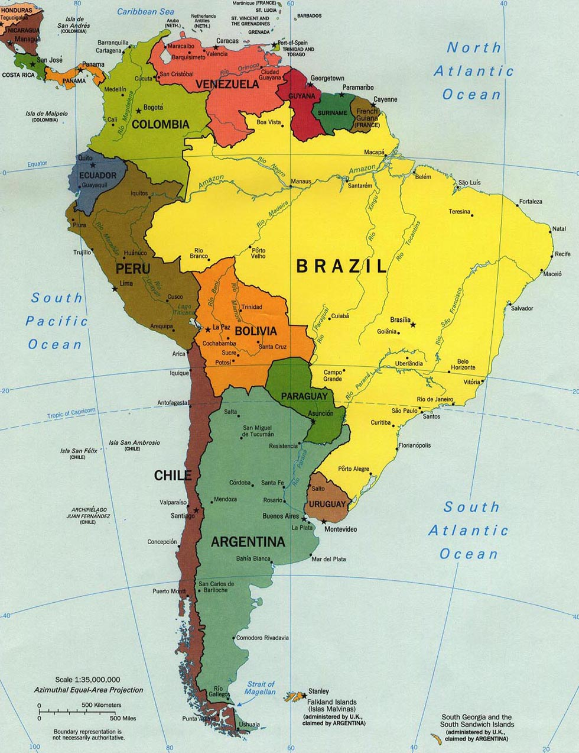
Central America South America

Colonial Society Divided (pg. 681-682)

In Latin American Society, Class Dictated People’s Place in Society
- Peninsulares–  - Creoles-Spaniards born _____________  - Could not hold high-level office but could rise in rank in the army | - Mestizos-People of mixed _________ and _________ ancestry  - Mulattos-People of __________ and ____________ ancestry

Revolutions in America (pg. 682)

- What was the 1st Latin American territory to free itself from European rule?

- Until his incarceration at the hands of the French who led the revolution in Saint-Domingue?

- Which leader declared Saint-Domingue independent?

- What does Haiti (the new name for half of Saint-Domingue) mean?

Creoles Lead Independence (pg. 682-683)
- Creoles-
  - _________ oppressed of those in Latin American and the _________ educated
    - Brought ideas of the _______________back from Europe

Creoles Lead Independence (pg. 682-683) (continued…)

- The South American Wars of independence rested on the achievements of which two military leaders?

- What major military accomplishment occurred under Simon Bolivar in August 1819?

- What major military accomplishment occurred under Simon Bolivar in 1821?

- What Latin American nation did Jose de San Martin help free in 1817?

- What four Latin American nations came together to form Grand Colombia?

Mexico Ends Spanish Rule (pg. 685-686)

- Which poor but educated religious leader from the city of Delores helped Mexico take the first steps towards independence?

- What major event was he involved in on September 16th 1810?

  - What was the end result?

- During the 1820’s what did Mexican creoles fear they might lose?

  - What did they do as a result

- When Central America declared their independence from Mexico in 1823 what new title did they adopt?

Brazil’s Royal Liberator (pg. 686)

- What was so unique about Brazil’s quest for independence? (Hint: Were there any bloody battles involved?)

- How many Brazilians signed the petition in 1822 that allowed Dom Pedro to rule Brazil?

- Did he accept their nomination?

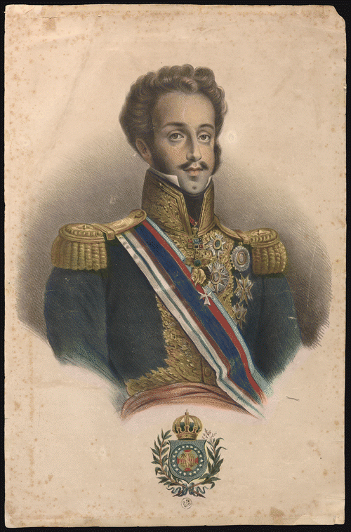

Chapter 24-Nationalist Revolutions Sweep the West-Guided Notes
Section 1-Latin American Peoples Win Independence
Central America South America

Colonial Society Divided (pg. 681-682)

In Latin American Society, Class Dictated People’s Place in Society
- Peninsulares –Spaniards born on the Iberian peninsula, they were the only ones able to hold high office in the colonial government  - Creoles-Spaniards born in Latin America  - Could not hold high-level office but could rise in rank in the army | - Mestizos-People of mixed European and Italian ancestry  - Mulattos-People of European and African ancestry

Revolutions in America (pg. 682)

Revolution in Haiti
- Saint Domingue (Haiti) was the 1st Latin territory to free itself from European rule
  - Toussaint L’Ouverture led the revolution until he was sent to a French prison
  - Jean-Jacques Dessalines declared them independent on January 1, 1804
    - Haiti means “mountainous land”

Creoles Lead Independence (pg. 682-683)

- Creoles-  - Least oppressed of those in Latin American and the best educated  - Brought ideas of the enlightenment back from Europe  - The South American Wars of independence rested on the achievements of Simon Bolivar and Jose de San Martin | - Simon Bolivar-  - August 1819-Bolivar led 2,000 soldiers through the Andes and won a surprise victory  - 1821-Bolivar won Venezuela’s independence and marched into Ecuador where he met San Martin  - Jose de San Martin-  - 1817-San Martin helped free Chile

- Grand Colombia-The future countries of Venezuela, Colombia, Panama, and Ecuador united to form one country

Mexico Ends Spanish Rule (pg. 685-686)

A Cry for Freedom | Mexico’s Independence
- Miguel Hidalgo-  - A priest from Dolores who took the first step towards Mexico’s independence  - Poor but well educated man who supported the enlightenment  - Sept. 16th, 1810-Hidalgo rang the bells from his church and called for the rebellion  - He and his 80,000 man army were defeated | - Mexico’s Independence-  - 1820-Mexico’s creoles feared the loss of their privileges  - They united in their support of Mexico’s independence and in 1821 gained it  - Central America’s Independence-  - 1823-Central America declared their independence from Mexico, taking the name the United Provinces of Central America

Brazil’s Royal Liberator (pg. 686)

- Brazil’s Quest for Independence-
  - Brazil declared their independence without blood shed
    - They also had help from Portugal's royal family
  - 1822-8,000 Brazilians signed a petition to have Dom Pedro rule Brazil
    - He agreed and Brazil received their independence

