Chapter 23-The French Revolution and Napoleon-Guided Notes
Section 3-Napoleon Forges an Empire

Napoleon Seizes Power (pg. 663-664)

- When and where was Napoleon born?

- What type of school did Napoleon attend at age 9?

- What military ranking did he reach in the French artillery by the time he was 16?

- Following Napoleons return from his military campaign in Egypt what revolutionary action did he lead?

- Once he took the title of first consul and assumed the powers of a dictator what was his first goal for France?

Napoleon Rules France (pg. 664-665)

- What was the Plebiscite?

- How did Napoleon feel about the French Revolution?

- What type of laws was Napoleon in favor of?

- In addition to setting up an effective banking system Napoleon took this approach in an attempt to clean up the government?

- What are the Lycees?

  - What type of students attended the Lycees?

  - How were jobs assigned after leaving the Lycees?

- Describe what the Napoleonic Code was and its focus on order and individual rights?

Napoleon Creates an Empire (pg.665-667)

- When Napoleon crowned himself emperor in 1804 what did that symbolize?

- What territory was Napoleon interested in conquering?

- How did Napoleon treat Frances presence in the Americas?

- What product and colony did he think was the key to France’s success in the Americas?

Loss of American Territories

- What was going on in Saint Domingue that mirrored the French Revolution?

  - Who was their leader and how did Napoleon fare in this conflict?

- With a desire to finance other battles and a belief that the American territories were more of a nuisance that an asset how much does he sell the Louisiana Territory to the U.S for in 1803?

Conquering Europe

- How would you describe Napoleon’s battle history early on in his reign?

- Which four countries joined together to fight him nut were ultimately unsuccessful?

- What did his victories allow him to build?

- Which military group presented the only real challenge to Napoleon’s troops?

- What was the name of the only major battle (besides Waterloo) that Napoleon lost?

- What were the two lasting effects of that defeat:

Napoleon Creates an Empire (pg.667) continued

- By 1812, what were the only major nations/empires not controlled by Napoleon?

- During what time period did Napoleon’s empire exist at its greatest heights?

- What ultimately became Napoleons undoing?

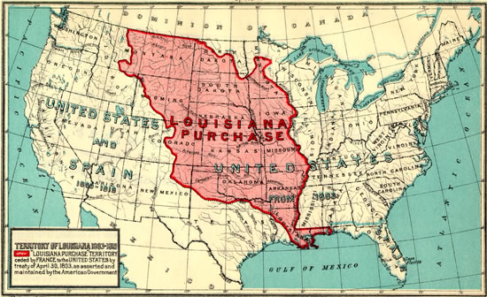

Chapter 23-The French Revolution and Napoleon-Guided Notes
Section 3-Napoleon Forges an Empire

Napoleon Seizes Power (pg. 663-664)

Napoleon Bonaparte (1769 A.D. to A.D.)
- Born in 1769  - Sent to military school at 9 years old  - He became a lieutenant in the French artillery at 16  - Upon his return from Egypt he led a coup d’ etat  - When the council dissolved he named himself dictator  - His first goal was to restore order in France | 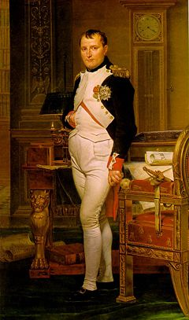

Napoleon Rules France (pg. 664-665)

Restoring Order at Home
- The Plebiscite-  - A vote of the people that gave Napoleon all real power  - Napoleon Supported  - Changes from the revolution  - Laws that would strengthen the central gov. and achieve the goals of the revolution | - Napoleon also:  - Set up an effective banking system  - Tried to end to gov. corruption  - Set up Lycees-Gov. ran public schools  - Students came from all backgrounds  - Relived jobs based on performance  - Napoleonic Code-A uniform set of laws that ended many injustices  - Promoted order over individual rights

Napoleon Creates an Empire (pg.665-666)

- 1804-Napoleon crowned himself emperor
  - This symbolized his power over the church

Napoleon Creates an Empire (pg.666-667) continued

Loss of American Territories
- Napoleon's Goals-  - Wanted to control all of Europe  - Re-establish French dominance in the Americas  - He thought the key was the sugar producing colony of Saint Domingue | - Napoleon Supported  - Changes from the revolution  - Laws that would strengthen the central gov. and achieve the goals of the revolution

Loss of American Territories
- The people of Saint Domingue led by Toussaint L’Ouverture demanded the same rights as French citizens
  - Napoleon failed to overtake them

- 1803-Napoleon offers to sell the Louisiana Territory for $15 million

Conquering Europe
- Napoleon was extremely successful in battle during the early part of his reign  - Britain, Russia, Austria, and Sweden joined forces against France but could not beat them  - His victories allowed him to build the largest empire since the Romans  - His only real challenge was Britain's navy | 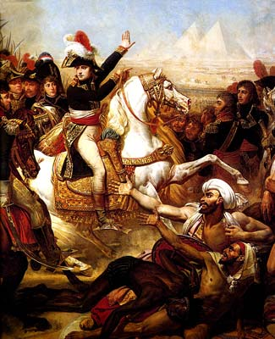

Napoleon Creates an Empire (pg.667) continued

The Battle of Trafalgar | The French Empire
- The only major battle Napoleon lost  - This naval defeat had two lasting effects:  - It assured Britain naval supremacy for the next 100 years  - Napoleon abandoned his plans of invading Britain | - By 1812 the only countries in Europe not controlled by Napoleon were:  - Britain, Portugal, Sweden and the Ottoman Empire  - His empire existed at it’s greatest extent from 1807 to 1812  - Napoleon’s grand ambitions became his undoing

