Chapter 22-Enlightenment and Revolution-Guided Notes
Section 1-The Scientific Revolution

The Roots of Modern Science (pg. 623-624)

The Medieval View
- Geocentric Theory-The theory that the __________ was the center of the universe  - Originally the idea came from _____________  - The Greek astronomer _____________ expanded _______________________________________ | 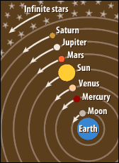

A Revolutionary Model of the Universe (pg. 624-625)

The Heliocentric Theory
- Heliocentric Theory-Copernicus’s theory that the ______, _____ and the other planets revolved ___________ ___________________  - He published this theory in his book: __________________ __________________ in 1543 and received a copy on his death bed | 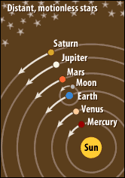

A New Way of Thinking
- ____________________ - A new way of thinking about the natural world by replacing old assumptions with new theories

Galileo’s Discoveries
- Galileo Galilei-Italian Astronomer
  - Published _________________ in 1610
  - Wrote that Jupiter had ______________ moons
  - The Sun ______________
  - The moon had a ________ _____________________
  - Disproved that the moon and _____ were not made of a _____________________

The Scientific Method (pg. 625)

- The Scientific Method-A logical _____________________________ ________________________________________________________
- Step 1: Begins with a ______________ or question
- Step 2: Form a _____________________
- Step 3: _________ the hypothesis
- Step 4: Analyze and __________________________
    - Data (conclusion) _______________ or ______________________the hypothesis

Newton Explains the Law of Gravity (pg. 626-627)

Isaac Newton (1642 A.D. to 1727 A.D.)
- Isaac Newton- English scientist who developed the law of gravity  - Theorized that the same ___________________ of motion governed both the planets and objects on Earth | 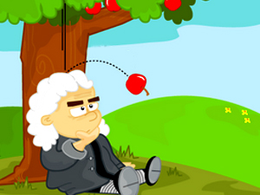

The Scientific Revolution Spreads (pg. 627-628)

Scientific Instruments | Medicine and the Human Body
- Important scientific inventions and discoveries  - Microscope (_______)  - First _________________ are examined (1670)  - _____________ was invented (1643)  - Measures ___________ pressure and predicted _________________  - First thermometer is invented (1714) | - Other important scientific inventions and discoveries  - Studying human remains advances the study of anatomy  - Late 1700’s a vaccine is created to prevent _________________  - ____________________ (1661) by Boyle identified the worlds four main elements  - _________, ________, _________, ________

