Chapter 21-Absolute Monarchs in Europe-Guided Notes
Section 2-The Reign of Louis XIV

Religious Wars and Power Struggles (pg. 596-597)

Henry IV (1367 A.D. to 1413 A.D.)
- In 1589 became the _____ king of the ______________________  - He was ________, fearless in battle and a _______________  - Converted to __________ to make the people of _________ happy | 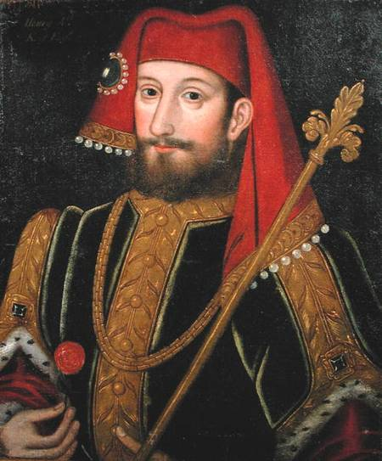

- Edict of Nantes-

Cardinal Richelieu (1585 A.D. to 1642 A.D.)
- Took two steps to increase the power of the Bourbon monarchy
  - Moved against ______________
    - Felt _____________ was an excuse for conspiracies against the ____________ Church

Writers Turn towards Skepticism (pg. 597)

- Skepticism-
  - _______________________________________________
    - To doubt was viewed as the first step to discovering the truth

Louis XIV Comes to Power (pg. 598-599)

Louis XIV (1638 A.D. to 1715 A.D.)
- Viewed the state and himself as one and the same  - His goal was | 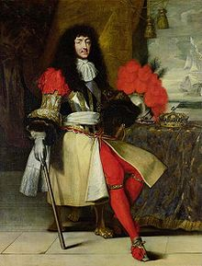

Louis Weakens the Noble’s Authority | Economic Growth
- Intendants- | - Jean Baptiste Colbert-Minister of France who believed they should be self sufficient  - Fan of _________________  - Gave ________________ to French companies  - Recognized how vital France’s _________ were in terms of receiving ________ materials

Louis Fights Disastrous Wars (pg. 601)

France Under Louis
- By 1660 France had a population of _____________ people | - France’s army was superior to the other European Countries in:  - _________________________  - _________________________  - _________________________

Louis Fights Disastrous Wars (pg. 601) continued…

The War of Spanish Succession ( 1701 to 1714 A.D.)
- Lasted from 1701 to 1714  - __________, Austria, Dutch Republic, Portugal and several German and Italian states joined forces to prevent ___________________ and _______________________ | - Treaty of Utrecht-  - England emerges as the big winner  - They captured ___________ _______________________  - Received permission to send _________ to Spain’s _______________________  - __________________ Nova Scotia and _____________ (In modern day Canada)

Louis’ Death and His Legacy
Positive Effects:  - France ranked as the best European country in terms of _____, __________, and _____________ | Negative Effects:  - The ________________ plunged France into debt  - There was resentment over ___________ and Louis’ _____________

Chapter 21-Absolute Monarchs in Europe-Guided Notes
Section 2-The Reign of Louis XIV

Religious Wars and Power Struggles (pg. 596-597)

Henry IV (1367 A.D. to 1413 A.D.)
- In 1589 became the 1st king of the Bourbon dynasty in France

- He was decisive, fearless in battle and a clever politician

- Converted to Catholicism to make the people of France happy

- Edict of Nantes-
  - Declaration of religious tolerance that allowed the Huguenots to set up their own place of worship

Cardinal Richelieu (1585 A.D. to 1642 A.D.)
- A strong minister appointed by Louis XIII to compensate for his weakness | - Took two steps to increase the power of the Bourbon monarchy  - Moved against the Huguenots  - Felt Protestantism was an excuse for conspiracies against the Catholic Church  - Sought to weaken the power of nobles

Writers Turn towards Skepticism (pg. 597)

- Skepticism-
  - The idea that nothing can ever be known for certain
    - To doubt was viewed as the first step to discovering the truth
Louis XIV Comes to Power (pg. 598-599)

Louis XIV (1638 A.D. to 1715 A.D.)
- Most powerful ruler in French History

- Viewed the state and himself as one and the same

- His goal was to become so strong that the nobles could never threaten him

Louis Weakens the Noble’s Authority | Economic Growth
- Intendants-Government agents who collected taxes and administered justice in France under Louis XIV | - Jean Baptiste Colbert-Minister of France who believed they should be self sufficient  - Fan of mercantilism  - Gave tax breaks to French companies  - Recognized how vital France’s colonies were in terms of receiving raw materials

Louis Fights Disastrous Wars (pg. 601)

France Under Louis
- By 1660 France had a population of 20 million people | - France’s army was superior to the other European Countries in:  - The size of their army  - Their training  - Their weaponry

Louis Fights Disastrous Wars (pg. 601) continued…

The War of Spanish Succession ( 1701 to 1714 A.D.)
- Lasted from 1701 to 1714  - Charles II of Spain had promised the throne to France’s Philip of Anjou  - England, Austria, Dutch Republic, Portugal and several German and Italian states joined forces to prevent the union of the France and Spain thrones | - Treaty of Utrecht-Stated that Philip could remain king of Spain as long as both thrones remained separate  - England emerges as the big winner  - They captured the fort at Gibraltar  - Received permission to send slaves to Spain’s American colonies  - England also received Nova Scotia and Newfoundland (In modern day Canada)

Louis’ Death and His Legacy
Positive Effects:  - France ranked as the best European country in terms of art, literature, and statesmanship  - Strongest military power in Europe | Negative Effects:  - The Palace of Versailles plunged France into debt  - There was resentment over high taxes and Louis’ abuse of power

