Middle Ages 100
Point Quest

Your Middle Ages Project is worth 100 Points to your grade. How you get those 100 points is going to be up to you. Below you will find different tasks to complete. Each task is assigned a starting point value. If you do the task and do it well you can earn those points. If you do the task, but do not put all your effort into it you may not earn all of the points assigned to that task. The goal is to complete enough tasks to earn 100 points and an A+ grade.

There are many topics that you can explore within the Middle Ages. You may want to focus on a single topic and do several activities related to it. Alternatively, you may want to learn about different aspects of the Middle Ages by picking different topics for each activity. It’s all up to you. If you have an idea for a project that I didn’t think of, come bounce it off me and I’m likely to ok it and assign it a point value.
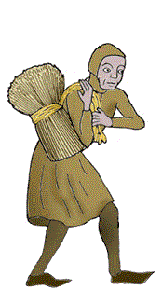

Peasant (10 Point) TASKS
- Design a Middle Ages Quiz of 20 multiple choice questions. Include an answer key!
- Design a stained glass window depicting a medieval scene. Use tissue paper or colored wax paper to create a translucent effect.
- Write a poem that tells about life in the Middle Ages.
- Take a time machine trip back to the Middle Ages and bring back a souvenir of your trip. Include a description of the item and its significance.

Knight (20 Point) TASKS
- Write and perform a TV commercial (1 minute long) to sell a trip in a time machine to the Middle Ages. Use detail. A written copy of your script must be handed in.
- Write a letter to someone from the Middle Ages telling why you admire (or object to) him/her. Letter should be at least 200 words.
- Draw a family tree of a royal family from the Middle Ages. Include at least 20 people, dates of birth, death, and years of reign.
- Create a collage using magazine pictures and words that describe life in the Middle Ages. Fill the space well. Write a brief explanation of your collage.

Duchess (30 Point) TASKS
- Design a front and back cover for a book that someone from the Middle Ages might have written. It can be someone famous or not, and it may need to have been transcribed by someone literate. Include all the important information about the book; a summary, information about the author, quotes from people who read the book, Illustration, etc.
- Write a Gregorian Chant or Madrigal (both types of music from the Middle Ages) about a topic that would have been important to someone in the Middle Ages
- Write a “Dear Abbey” type of advice column for Middle Ages people. Write letters from the people famous or unknown that ask for advice based on the problems they would have faced. Respond back with advice that you would give them to help with the problem. You must have at least 4 letters asking for advice and 4 responses.
- Visit the Detroit Institute of Arts (D.I.A). Take at least 4 pictures of yourself showing armor from 4 different time periods and/or places in the world. Make sure you get a photo pass from the front desk before you take pictures. You can also check out the website for the Higgins Armory Museum in Worcester, MA– they have some fun stuff and you can do a virtual tour! http://www.higgins.org/
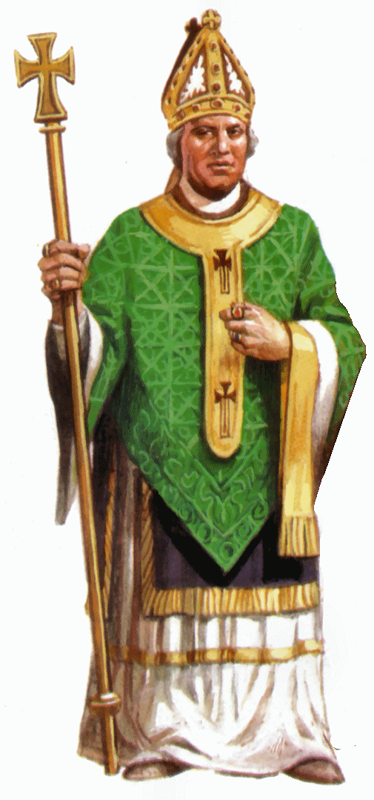
Bishop (40 Point) TASKS
- Create a timeline of the Middle Ages from 450 – 1450 and include 20 events that you feel are critical to understanding the middle ages. Include a brief description (1-2 sentences for each event) and an illustration. Be sure you timeline visually represents the relative passage of time.
- Research a site in Europe that people visit today to learn about the Middle Ages. Create a travel poster or brochure inviting people to come visit. Be sure to include what there is to see and do there and what visitor should expect to learn.
- Create a boardgame that incorporates themes, ideas, and/or events from the Midde Ages.
- With a partner or two, create a news broadcast of a specific event (like a battle, coronation, death, etc.). Your broadcast should describe the event, interview participants and perhaps include a map or other visual. You can present your broadcast live or record it. It should be at least 5 minutes long. A written copy of your script must be handed in.

King (50 Point) TASKS
- Chose a specific person and write a diary for him/her. Research the person and base your diary on real events. Write in the first person. Include what happens as well as how they felt during this time. You must have at least 8 diary entries. Each entry must be at least 2 paragraphs long.
- Write a short story (3-5 pages) set in the Middle Ages. Although it can be fictional, it should be realistic.
- Create a diagram (2-D) or model (3-D) of something from the Middle Ages – perhaps a castle, a suit of armor, or a Viking boat. Label at least 10-15 parts or point out 10-15 distinguishing characteristics. For each label, include 2-3 sentences that provide a short written explanation of what its purpose or importance is.
- Chose a historical movie or novel set in the Middle Ages. Research the true story behind the story. Create a study guide featuring your own analysis of the historical accuracy and inaccuracy of the film/novel. The guide should contain a synopsis of the movie/film, the historical background of the topic, a comparison of any real people to characters in the movie/novel, and any other pertinent information to help guide someone judge the historical value of the work.

Some possible topics to consider:
Chivalry
Feudalism (peasants, serfs, nobles)
Castles (design and function; life within a castle)
Knights
Vikings (Viking culture, exploration, boat building)
The Crusades
Bubonic Plague
Marco Polo
Architecture (especially the great Cathedrals)
Armor/Weapons
stained glass
Guild System
the Medieval Church (abbots, bishops, the papacy)
development of languages
well-known figures
Joan of Arc
Charlemagne
Richard the Lionhearted
Eleanor of Aquitaine
William the Conqueror
Charles Martel
The Princes in the Tower
Military Action
Battle of Tours
Hundred Years War
Wars of the Roses
Battle of Stirling Bridge
Battle of Vouille
Monastic life (monks, nuns, Benedictine rule)
Avignon Papacy
Saints
Medieval Town life
Magna Carta
Bayeux Tapestry
Domesday Book
Holy relics
Illuminated Manuscripts
Gregorian Chant
Literature (possibly Song of Roland, Robin Hood)
The Inquisition (Nobody expects the Spanish Inquisition!)
Celts, Anglo-Saxons, Goths, or another tribe – just stick with our time frame

