Chapter 17-European Renaissance and Reformation-Guided Notes
Section 1-Italy: Birthplace of the Renaissance

Italy’s Advantage (pg. 471-472)

- Renaissance-Term meaning “____________ or _______________” of the arts and learning (1300 A.D. to 1600 A.D.)
  - Italians wanted to revive the _____________ of classical Greeks and _____________.

Italy the Birthplace of the Renaissance
Three advantages that made Italy the birthplace of the Renaissance: | - _______________  - Wealthy _______ __________  - Classical _______ of Greece and Rome | 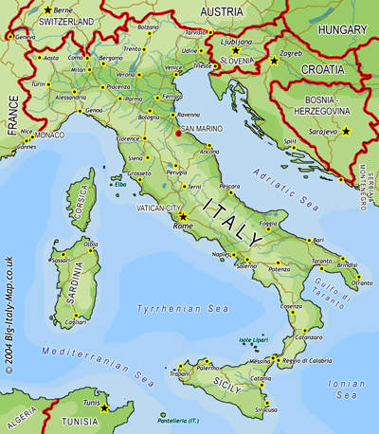

- Medici Family- A powerful _______________________ who ruled Florence, Italy during the 1400’s.
  - Acting as ____________ they encouraged the _____ during the Renaissance

Classical and Worldly Values (pg. 472-473)

Influences of Classical Art
Humanism- Movement that focused on _______ ________________ and _____________ | - Secular-  Worldly outlook on _____ and _____ rather than spiritual | Patrons- People who ____________ ________________  ________________ ________________ ________________

Renaissance Man- | Renaissance Woman-
- Renaissance Man- A man well versed in __________________ and ______________________  - The Courtier-Book which taught young men how to become Renaissance men | - Renaissance Woman-  - Encouraged to be ________ and know the classics, as well as ______________  - Not encouraged to ______________ or ___________ art

The Renaissance Revolutionizes Art (pg. 474-475)

- Perspective-Artistic technique that shows __________________________ on a flat surface

Renaissance Artists
- Donatello-Artist, _______, sculpture, ___________, painter  - Statue of David the boy  - 1st free standing nude male sculpture since ancient times | - ________________-Painter, __________, inventor, scientist  - Best known for painting the __________ and _____________ | - Raphael-Painted the _________________  - Showed _____________ ____________ on the Renaissance

Renaissance Writers Change Literature (pg. 475-476)

- Vernacular- _________________________________ (language of the time)

- Niccolo Machiavelli-  - Wrote __________ in 1513 A.D.  - In it he explains how a ruler can ______ and ________ power through ______________ and _________ his opponents | 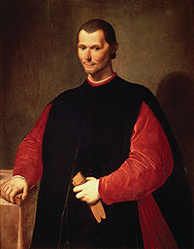

Chapter 17-European Renaissance and Reformation-Guided Notes
Section 1-Italy: Birthplace of the Renaissance

Italy’s Advantage (pg. 471-472)

- Renaissance-Term meaning “rebirth or revival” of the arts and learning (1300 A.D. to 1600 A.D.)
  - Italians wanted to revive the culture of classical Greeks and Romans

Italy the Birthplace of the Renaissance
Three advantages that made Italy the birthplace of the Renaissance: | - Thriving cities  - Wealthy merchant class  - Classical heritage of Greece and Rome

- Medici Family- A powerful banking family who ruled Florence, Italy during the 1400’s.
  - Acting as patrons they encouraged the arts during the Renaissance

Classical and Worldly Values (pg. 472-473)

Influences of Classical Art
Humanism- Movement that focused on human potential and achievement | - Secular-  - Worldly outlook on life and art rather than spiritual | Patrons- People who financially supported the arts or artistic movements

Sculpted

Renaissance Man- | Renaissance Woman-
- Renaissance Man- A man well versed in many areas of art and education  - The Courtier-Book which taught young men how to become Renaissance men | - Renaissance Woman-  - Encouraged to be charming and know the classics, as well as Not encouraged to seek fame, or create art

The Renaissance Revolutionizes Art (pg. 474-475)

- Perspective-Artistic technique that shows three dimensional designs on a flat surface

Renaissance Artists
- Donatello-Artist, poet, sculpture, architect, painter  - Statue of David the boy  - 1st free standing nude male sculpture since ancient times | - Leonardo da Vinci-Painter, sculpture, inventor, scientist  - Best known for painting the Mona Lisa and The Last Supper | - Raphael-Painted the School of Athens  - Showed classical influence on the Renaissance

Renaissance Writers Change Literature (pg. 475-476)

- Vernacular-Writing in ones native language (language of the time)

- Niccolo Machiavelli-
  - Wrote The Prince in 1513 A.D.
  - In it he explains how a ruler can gain and keep power through misleading and deceive his opponents

