Chapter 13-European Middle Ages
Guided Notes-Section 3

Knights: Warriors on Horseback (pg. 364 and 365)

Technology of Warfare Changes | Knights: Warriors on Horseback
- Leather __________ and __________ allowed warriors to handle heavy weapons while fighting  - __________________________ = most important part of the army | - Feudal lords hired private armies of _________ to protect their land  - ____ days of service a year  - Traded protection for fiefs (land grants)  - Wealth allowed the knights to  - Devote ____________________  - Buy __________, armor and ____________________.

Knighthood and the Code of Chivalry (pg.365-367)

Knighthood and the Code of Chivalry | A knights Training
- Chivalry-  - _____________ lord  - _____________ Lord  - His chosen ______ | - Qualities of an Ideal Knight-  - ______________  - ______________  - ______________

Knighthood and the Code of Chivalry (pg 365 and 367)

Knights Training
- Age 7- Sent off to a castle became a ______________.  - There he would wait on his host and practice _______________. | - Age 14- The young man became a _________ (knights servant) | - Age ____ -Finally became a full-fledged knight | - Tournaments-Staged battles for practice that combined ______________ and _______________ | 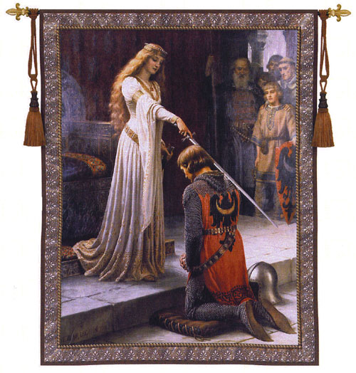
Literature of Chivalry (pg. 367)

- Epic Poems-  - They recounted a hero’s _______ and _______________________.  - ______________________-Earliest and most famous epic poem | - Troubadours-Traveling Poet-musicians  - Composed poems about the joys and _______________________.  - They always viewed noble women as ________________________.

Women’s Role in Feudal Society (pg. 368)
- Women were seen as _____________________ to men.

Noble Women
- Could inherit an estate from ____________ | - Send her husbands _________ into _____ | - Acted as ______________ __________________ when her husband was away  - Hurled _______ and shot ____________ at attackers | - They were most often limited to activities _________ _______________ or _________________

Peasant Women
- Performed ____________ ___________ in the home and fields.  - Raised children  - Took care of families | - Young peasant girls learned _____________ _____________ skills | - Females in peasant families remained _______ and ____________ | - Rich girls were educated

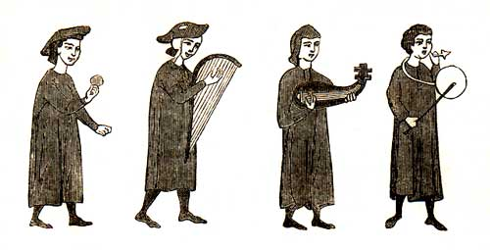

Chapter 13-European Middle Ages
Guided Notes-Section 3

Knights: Warriors on Horseback (pg. 364 and 365)

Technology of Warfare Changes | Knights: Warriors on Horseback
- Leather saddles and stirrups allowed warriors to handle heavy weapons while fighting  - Mounted knights = most important part of the army | - Feudal lords hired private armies of knights to protect their land  - 40 days of service a year  - Traded protection for fiefs (land grants)  - Wealth allowed the knights to  - Devote their lives to war  - Buy weapons, armor, warhorses

Knighthood and the Code of Chivalry (pg.365-367)

Knighthood and the Code of Chivalry | A knights Training
- Chivalry-A complex set of ideals, in which a knight would fight bravely for three masters  - Earthly feudal lord  - Heavenly Lord  - His chosen lady | - Qualities of an Ideal Knight-  - Loyal  - Brave  - Courteous

Knights Training
- Age 7- Sent off to a castle became a page.  - There he would wait on his host and practice fighting skills | - Age 14- The young man became a squire (knights servant) | - Age 21-Finally became a full-fledged knight | - Tournaments-Staged battles for practice that combined recreation and combat training

Literature of Chivalry (pg. 367)

- Epic Poems-  - They recounted a hero’s deeds and adventures  - Song of Roland-Earliest and most famous epic poem | - Troubadours-Traveling Poet-Musicians  - Composed poems about the joys and sorrows of love  - They always viewed noble women as beautiful and pure

Women’s Role in Feudal Society (pg. 368)
- Women were seen as inferior to men.

Noble Women
- Could inherit an estate from her husband | - Send her husbands knights into war | - Acted as military commander when her husband was away  - Hurled rocks and shot arrows at attackers | - They were most often limited to activities around the home or convent

Peasant Women
- Performed endless labor in the home and fields  - Raised children  - Took care of families | - Young peasant girls learned house hold skills | - Females in peasant families remained poor and powerless | - Rich girls were educated

