**Chapter 2-Origins of American Government (pg. 30)**

**Packet Check List #3**

**(The Entire Packet is due at the End of the Hour)**

Chapter 2-Multi-Flow Map



Chapter 2- Section 2-Review Questions (pg. 42) #1-5



Chapter 2- Section 3-Review Questions (pg. 50) #1-5



Chapter 2- Section 4-Review Questions (pg. 58) #1-5



Chapter 2- Section 5-Review Questions (pg. 62) #1-5



--------------------------------------------------------------------------------------------

Name __________________________________ Date ______________________ Hour _________________

Using the multi-flow map bleow please record the details regarding the Framer’s Constitutionsal compermise

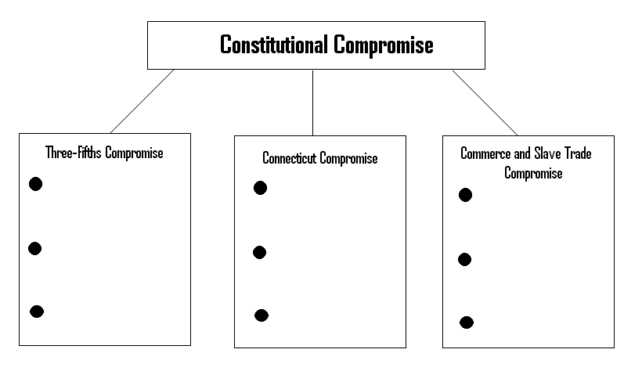

Chapter 2-Section 2 Review Questions-Pg. 42 #1-5

Please answer questions 1-5 on this sheet

*Don’t forget to draw out the bubble map at the top of this sheet to help you answer #1

1.

2.

a.

b.

3.

4.

5.

a.

b.

Chapter 2-Section 3 Review Questions-Pg. 50 #1-5

Please answer questions 1-5 on this sheet

1.

2.

3.

a.

b.

4.

a.

b.

5.

a.

b.

Chapter 2-Section 4 Review Questions-Pg. 58 #1-5

Please answer questions 1-5 on this sheet

1.

2.

a.

b.

3.

4.

5.

Chapter 2-Section 5 Review Questions-Pg. 62 #1-5

Please answer questions 1-5 on this sheet

1.

2.

3.

4.

5.