**Chapter 2-Origins of American Government (pg. 30)**

**Packet Check List #1**

**(The Entire Packet is due at the End of the Hour)**

Chapter 2–Basic Concepts of Government-Bubble Map



Chapter 2-Names and Terms



Chapter 2-American Beginings: Practice Quiz



Chapter 2-Big Concept Questions



Chapter 2- Section 1-Review Questions (pg. 17) #1-6



--------------------------------------------------------------------------------------------

Using the bubble map bleow please list the basic concepts of government that helped shaped America

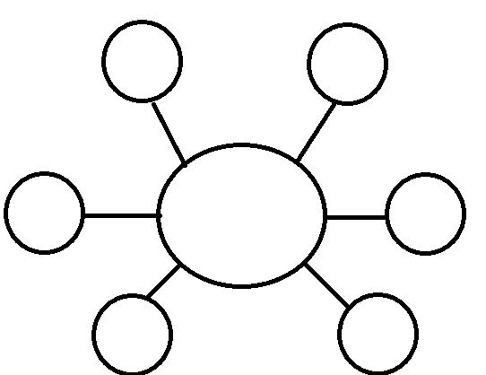

**Chapter 2-Origins of American Government-**

**Names and Terms**

**Section 1: Our Political Beginnings-**

1. Limited Government-
2. Representative Government-
3. Magna Carta-
4. Due Process-
5. Petition of Right-
6. English Bill of Rights-
7. Charter-
8. Bicameral-
9. Proprietary-
10. Unicameral-

**Section 2: The Coming of Independence-**

1. Confederation-
2. Albany Plan of Union-
3. Delegate-
4. Popular Sovereignty-

**Section 3: The Critical Period-**

1. Articles of Confederation-
2. Ratification-

**Section 4: Creating the Constitution-**

1. Framers-
2. Virginia Plan-
3. New Jersey Plan-
4. Connecticut Compromise-
5. Three-Fifths Compromise-
6. Commerce and Trade Compromise-

**Section 5: Ratifying the Constitution-**

1. Federalist-
2. Anti- Federalist-

**American Beginnings**

**Practice Quiz**

**1. The American ideas of government were radical and without any influence from other countries or the past.**

A. true

B. false

**2. What positive things did John Smith do for Jamestown?**

A. He ignited the Native Americans to attack French settlements.

B. He rejected strict rules and laws so that people could do what they wanted.

C. He established the triangular trade route, which allowed Jamestown to trade with the West Indies.

D. He established a trading system with the Native Americans, encouraged farming, and strengthened the colony's defenses.

**3. What is true about Plymouth Rock?**

A. It is a large coastal point where the Pilgrims landed.

B. It is a coastal and rocky area in Plymouth, Massachusetts.

C. The Puritans did not land on Plymouth Rock, or even in Plymouth, Massachusetts.

D. The Pilgrims actually landed at Plymouth Rock before they reached Jamestown.

**4. Why do you think the myth about Plymouth Rock continues?**

A. People do not want to believe that the Puritans landed in Delaware.

B. The recollections of a very old and respected man in regard to Plymouth Rock have not been disproved.

C. Presidents have visited and honored Plymouth Rock as a national shrine.

D. The Puritans landed at Plymouth Rock to escape religious persecution.

**5. How has Plymouth Rock changed over the years?**

A. The rock is smoother because so many people have touched it.

B. The rock had broken into pieces and was replaced with another rock.

C. The rock has been moved so many times that it looks larger than it originally was.

D. The rock has been moved so many times that it began to break into pieces.

**6. What was the name of the colonial protest against the unfair British tax on tea?**

A. Boston Tea Party

B. Boston Massacre

C. Second Colonial Congress

D. The Stamp and Trade Tax Act

Chapter 2-Section 2-Big Concept Questions

Please use section two to help elaborate on the following topics.

1. The Albany Plan-
   1. Please list the rules and regulations set under this plan
2. The Stamp Act-
   1. What was it?
   2. Did it last?
3. New Restrictive Laws-
   1. How did the colonists react to the new taxes and restrictions?
4. First Continental Congress-
   1. What prompted it to occur and what resulted?
5. Second Continental Congress-
   1. What resulted
6. Declaration of Independence-
   1. Who wrote it and what were its main ideas?

Chapter 2-Section 1 Review Questions-Pg. 34 #1-6

Please answer questions 1-6 on this sheet

*Don’t forget to draw out the bubble map at the top of this sheet to help you answer #1