**Economics-Chapter 1- Fundamental Economic Concepts (pg.4) Packet #1**

**Packet Check List**

**(The Entire Packet is due at the End of the Hour)**

Chapter 1-Economic Growth-Bubble Map



Chapter 1-Names and Terms



Chapter 1-Section 1-Guided Reading



Chapter 1-Section 2 Review Questions-Pg. 17 #1-9



--------------------------------------------------------------------------------------------

Name __________________________________ Date ______________________ Hour _________________

**Using the information we have covered in section 1 please fill in the bubble map describing the Factors of Economic Growth**

**Economic Growth**

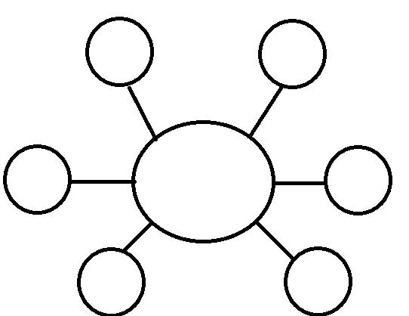

**Chapter 1-Fundimental Economic Concepts**

**Names and Terms**

**Section 1: Scarcity and the Science of Economics-**

1. Scarcity-
2. Economics-
3. Need-
4. Want-
5. Factors of Production-
6. Land-
7. Capital-
8. Capital Good-
9. Labor-
10. Entrepreneur-
11. Gross Domestic Product (GDP)-

**Section 2: Basic Economic Concepts-**

1. Good-
2. Consumer Good-
3. Durable Good-
4. Nondurable Good-
5. Service-
6. Value-
7. Paradox of Value-

**Section 2: Basic Economic Concepts-continued**

1. Utility-
2. Wealth-
3. Market-
4. Factor Market-
5. Economic Growth-
6. Productivity-
7. Human Capital-
8. Division of Labor-
9. Specialization-
10. Economic Independence-

**Section 3: Economic Choices and Decision Making-**

1. Trade-off-
2. Opportunity Cost-
3. Production Possibilities Frontier-
4. Economic Model-
5. Cost Benefit Analysis-
6. Free Enterprise Economy-.
7. Standard of Living-



Chapter 1-Section 2 Review Questions-Pg. 17 #1-9

Please answer questions 1-9 on this sheet

*Don’t forget to draw out the graphic organizer for #3