The Zimmerman Note

On January 19, 1917, Arthur Zimmerman, the German foreign minister, sent the following coded telegram to the German Ambassador in Mexico. British intelligence agents decoded the telegram and pass it to the U.S. government. Read the telegram and answer the questions below?

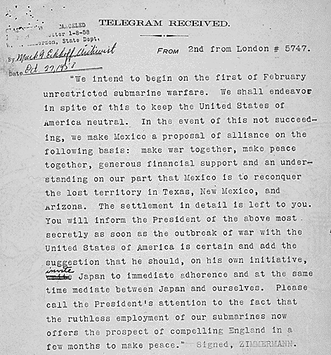

- According to this telegram, what did the German government decide to begin on February 1st, 1917?

- What did Zimmerman propose if the United States went to war with Germany during WWI?

- If this telegram had not been intercepted by British agents, what do you think might have happened? Use evidence to support your answer?

