Chapter 29-The Great War-Guided Notes
Section 4-A Flawed Peace

The Allies Meet and Debate (pg. 858-859)

The Allies Meet and Debate | Wilson’s Plan for Peace
- January 18th,1919 delegates representing _____ nations met to discuss the terms of peace at the __________ of _____________  - The Big Four held most of the decision making power  - ________________ of the U.S., Georges Clemenceau of France, David Lloyd George of _____________, and _______________ of Italy | - Fourteen Points-

Wilson’s Fourteen Points
- No ______________________  - Freedom of Seas  - Lower ________ to increase _______  - Reduce ___________________  - No more __________________  - New boundaries for countries | - League of Nations  - All countries could peacefully settle ____________________  - Like a modern UN  - Many countries not happy because did not punish ___________________

The Allies Meet and Debate (pg. 858-859) continued…..

Wilson’s Plan for Peace | The Versailles Treaty
- Self-Determination- | - The Treaty of Versailles-  - As a result Germany lost all of it’s ________________ powers  - Wilson’s __________________ were adopted  - The ______________________ was created  - It’s goal was to keep peace among the nations

A Troubled Treaty (pg. 859-861)

- A total of __________ treaties were signed by the allied powers
  - This created feelings of ____________and _______________ among the losing nations

- New Nations Created After WWI-
  - Austria, __________, _________________, and ___________ were recognized as independent nations
  - The _________________ lost all of their territory except modern day Turkey

A Troubled Treaty (pg. 859-861) Continued…

- End Results of WWI-
  - The Treaty of Versailles could not guarantee ____________________________
    - The U.S. ultimately rejected the Treaty of Versailles in favor of an __________________
  - The __________________________ left Germany extremely bitter
    - Germany received the harshest punishment including ______________ dollars in reparations owed to the allied powers
  - __________ and Asia were upset with the way the Allies disregarded their calls for ________________

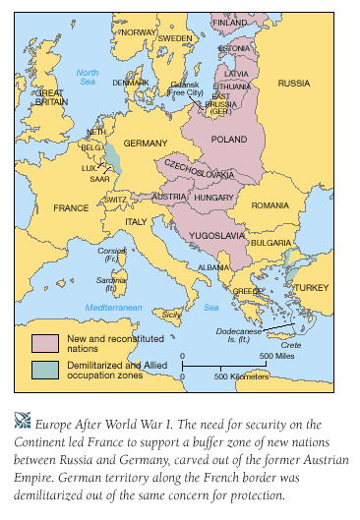

Chapter 29-The Great War-Guided Notes
Section 4-A Flawed Peace

The Allies Meet and Debate (pg. 858-859)

The Allies Meet and Debate | Wilson’s Plan for Peace
- January 18th,1919 delegates representing 32 nations met to discuss the terms of peace at the Palace of Versailles  - The Big Four held most of the decision making power  - Woodrow Wilson of the U.S., Georges Clemenceau of France, David Lloyd George of Great Britain, and Vittorio Orlando of Italy | - Fourteen Points-A series of proposals drawn up by Woodrow Wilson in order to outline long lasting peace with Europe

Wilson’s Fourteen Points
- No secret treaties  - Freedom of Seas  - Lower tariffs to increase trade  - Reduce militaries  - No more colonizing  - New boundaries for countries | - League of Nations  - All countries could peacefully settle disagreements  - Like a modern UN  - Many countries not happy because did not punish Germany

The Allies Meet and Debate (pg. 858-859) continued…..

Wilson’s Plan for Peace | The Versailles Treaty
- Self-Determination-The people could decide for themselves what kind of government they wanted to live under | - The Treaty of Versailles-An agreement designed to bring peace among the nations, and punish Germany  - As a result Germany lost all of it’s war making powers  - Wilson’s 14 points were adopted  - The League of Nations was  created  - It’s goal was to keep peace among the nations

A Troubled Treaty (pg. 859-861) Continued…

- A total of five treaties were signed by the allied powers
  - This created feelings of bitterness and betrayal among the losing nations

- New Nations Created After WWI-
  - Austria, Hungary, Czechoslovakia, and Yugoslavia were recognized as independent nations
  - The Ottomans lost all of their territory except modern day Turkey

A Troubled Treaty (pg. 859-861) Continued…

- End Results of WWI-
  - The Treaty of Versailles could not guarantee lasting peace
    - The U.S. ultimately rejected the Treaty of Versailles in favor of an isolationist approach
  - The War Guilt Clause left Germany extremely bitter
    - Germany received the harshest punishment including 33 billion dollars in reparations owed to the allied powers
  - Africa and Asia were upset with the way the Allies disregarded their calls for independence

