Chapter 29-The Great War-Guided Notes
Section 1-Marching Towards War

Rising Tensions in Europe (pg. 841-842)

The Rise of Nationalism | Imperialism and Militarism
- Nationalism-  - It can serve as a _____________ force or the catalyst for fierce ____________ among others  - Ex. By the turn of the 20th century Great Britain, Germany, Russia, Italy, France and the Austria-Hungarian empire were engaged in a fierce rivalry | - Militarism-

Tangled Alliances (pg. 842-843)

Bismarck Forges Early Pacts | Shifting Alliances Threaten Peace
- Triple Alliance-  - Otto von Bismarck felt that “As long as it is without allies, France poses no danger to us (Triple Alliance)” | - Triple Entente-  - This did not mean that Britain would fight with them but it did ensure they _________________________________ _________________________________.  - By 1907 the _____________________ and ____________________ were the strongest powers in Europe and would soon lead them into war
Crisis in the Balkans (pg. 843-844)

A Shot Rings Throughout Europe
- In 1908, Austria-Hungary annexed _____________ and _______________ thus creating tension in the region.
- June 28th, 1914 _________________________ assassinated the Archduke _____________________ and his wife in Sarajevo, Bosnia.
  - Princip was Serbian so the Austrians sought to punish Serbia
    - Harsh demands were placed on Serbia
- __________________ soon sided with Serbia and soon the rest of Europe began to take sides as well

Critical Thinning and Writing (MME Content) pg. 844
6. Analyzing Causes: Which of the forces at work in Europe played the greatest role in helping to prevent the outbreak of war?

7. Analyzing Issues: Was the description of the Balkans as the “powder keg” of Europe justified? Please explain your reasoning.

8. Forming and Supporting Opinions: Do you think WWI was avoidable? Please us information from the text to support your answer.

Chapter 29-The Great War-Guided Notes
Section 1-Marching Towards War

Rising Tensions in Europe (pg. 841-842)

The Rise of Nationalism | Imperialism and Militarism
- Nationalism-A deep devotion to one’s own nation  - It can serve as a unifying force or the catalyst for fierce competition among others  - Ex. By the turn of the 20th century Great Britain, Germany, Russia, Italy, France and the Austria-Hungarian empire were engaged in a fierce rivalry | - Militarism-The policy of glorifying military power and keeping an army prepared for war

Tangled Alliances (pg. 842-843)

Bismarck Forges Early Pacts | Shifting Alliances Threaten Peace
- Triple Alliance- Alliance between Germany, Austria-Hungary and Italy whose goal was to isolate France  - Otto von Bismarck felt that “As long as it is without allies, France poses no danger to us (Triple Alliance)” | - Triple Entente-Britain’s alliance with France and Russia  - Did not mean that Britain would fight with them but it did ensure they would not fight against them  - By 1907 the Triple Alliance and Triple Entente were the strongest powers in Europe and would soon lead them into war

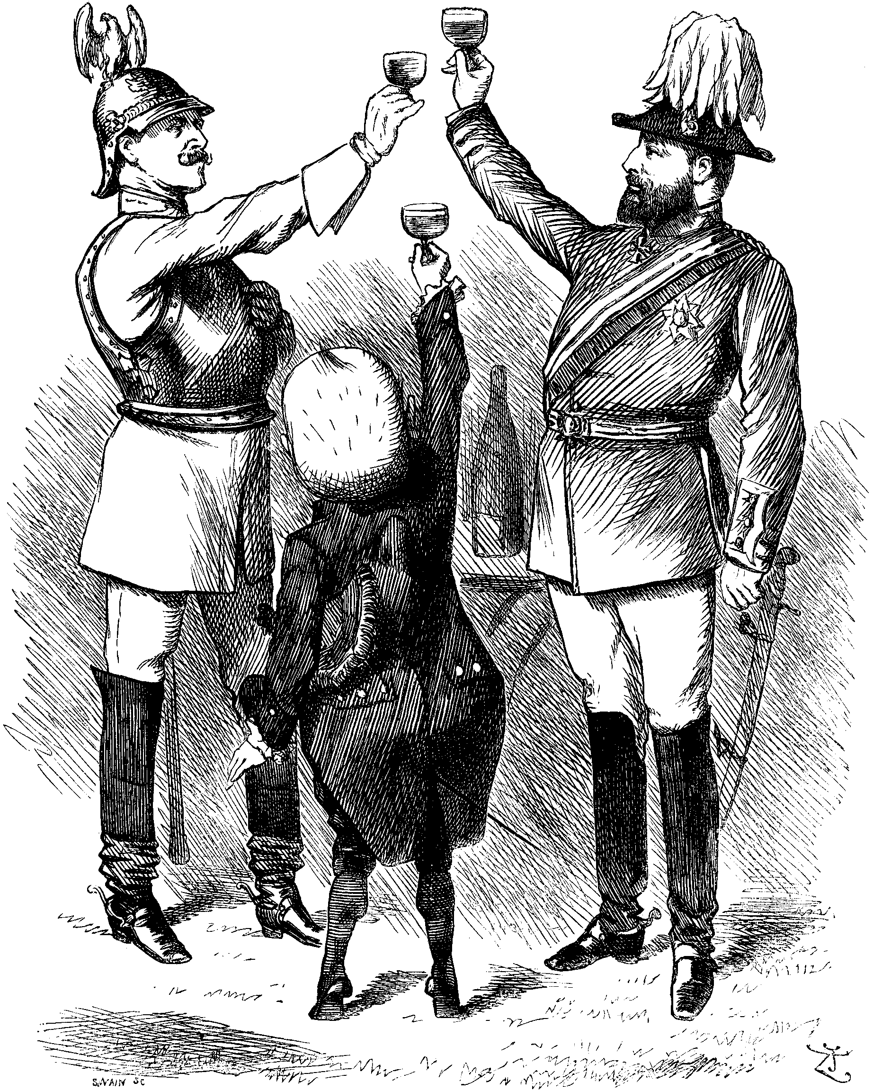
Crisis in the Balkans (pg. 843-844)

A Shot Rings Throughout Europe
- In 1908 Austria-Hungary annexed Bosnia and Herzegovina thus creating tension in the region
- June 28th, 1914 Gavrilo Princip assassinated the Archduke Franz Ferdinand and his wife in Sarajevo, Bosnia.
  - Princip was Serbian so the Austrians sought to punish Serbia
    - Harsh demands were placed on Serbia
- Russia soon sided with Serbia and soon the rest of Europe began to take sides as well

Critical Thinning and Writing (MME Content) pg. 844
6. Analyzing Causes: Which of the forces at work in Europe played the greatest role in helping to prevent the outbreak of war?

7. Analyzing Issues: Was the description of the Balkans as the “powder keg” of Europe justified? Please explain your reasoning.

8. Forming and Supporting Opinions: Do you think WWI was avoidable? Please us information from the text to support your answer.

