Chapter 30-Revolution and Nationalism-Guided Notes
Section 2-Totalilarianism

A Government of Total Control (pg. 874-876)

Totalitarianism = Total Government Control
- Totalitarianism-  - To achieve this control leaders often use terror, indoctrination, _______________, _____________, and religious/ethnic persecution | 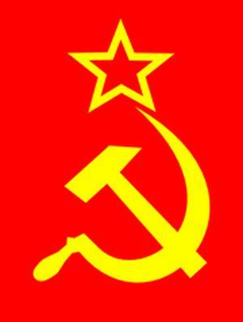

Analyzing Key Concepts: Totalitarianism (pg. 875)

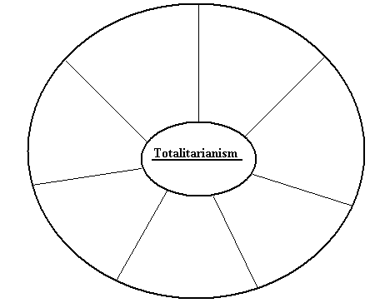
Stalin Builds a Totalitarian State (pg. 876-877)

Police State and Stalin’s Great Purge
- Police State-  - Stalin used a police state to maintain his power  - They used ______ and armored cars to stop riots, tapped phone lines, ________, and encouraged kids to tell the gov. if ___________ _____________________________ | - Great Purge-  - Historians estimate Stalin killed ___ to ___ million people during the Great Purge

Stalin Seizes Control of the Economy (pg. 877-878)

Russia Industrializes
- Command Economy- | - Five Year Plans-  - Set impossibly high goals for steel, ______, oil and __________________ production  - Limited production of _____________ to achieve this

Crises at Home and Abroad (pg. 878-879)

- An Agricultural Revolution-
  - Collective Farms- __________________________________ __________________________________________________
    - 1928 the gov. confiscated nearly 25 million ___________________________________
    - ____ to ____ million people died as a result of protests or persecution
    - By 1938 ____% of all Russian ______________ lived on __________________________

Daily Life Under Stalin (pg. 878-879)

Life Under Stalin Where Women Gain Rights
- The Good:  - Soviet society saw:  - _________ roles expand  - People becoming better ___________  - People mastered new ____________________ | - The Bad:  - Soviet society saw:  - Personal freedoms ______  - _____________________ _____________________  - ___________ (complaining) was prohibited

- Women achieved equal rights and saw social advances under Stalin’s Five-Year Plans.
  - By 1950 women made up ___% of the doctors in the Soviet Union
    - However they were also expected to take ____________________ and raise loyal ____________________

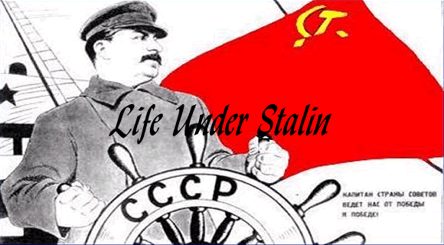

Chapter 30-Revolution and Nationalism-Guided Notes
Section 2-Totalilarianism

A Government of Total Control (pg. 874-876)

Totalitarianism = Total Government Control
- Totalitarianism- Describes a government that takes total, centralized, state control over every aspect of public and private life
  - To achieve this control leaders often use terror, indoctrination, propaganda, censorship, and religious/ethnic persecution

Analyzing Key Concepts: Totalitarianism (pg. 875)

Stalin Builds a Totalitarian State (pg. 876-877)

Police State and Stalin’s Great Purge
- Police State-  - Stalin used a police state to maintain his power  - They used tanks and armored cars to stop riots, tapped phone lines, read mail, and encouraged kids to tell the gov. if their parents made disloyal remarks | - Great Purge- A campaign of terror designed to eliminate anyone who threatened Stalin’s power  - Historians estimate Stalin killed  - 8 to 13 million people during the Great Purge

Stalin Seizes Control of the Economy (pg. 877-878)

Russia Industrializes
- Command Economy-A system where the gov. made all the economic decisions | - Five Year Plans-  - Stalin’s plans for the development of the Soviet Union’s Economy  - Set impossibly high goals for steel, coal, oil and electricity production  - Limited production of consumer goods to achieve this

Crises at Home and Abroad (pg. 868-869)

- An Agricultural Revolution-
  - Collective Farms-Large government owned farms which produced food for the state
    - 1928 the gov. confiscated nearly 25 million privately owned farms
    - 5 to 10 million people died as a result of protests or persecution
    - By 1938 90% of all Russian peasants lived on collective farms
Daily Life Under Stalin (pg. 878-879)

Life Under Stalin Where Women Gain Rights
- The Good:  - Soviet society saw:  - Women’s roles expand  - People becoming better educated  - People mastered new technical skills | - The Bad:  - Soviet society saw:  - Personal freedoms limited  - Consumer goods in short supply  - Dissent (complaining) was prohibited

- Women achieved equal rights and saw social advances under Stalin’s Five-Year Plans.
  - By 1950 women made up 75% of the doctors in the Soviet Union
    - However they were also expected to take care of the home and raise loyal Soviet citizens

