Chapter 25-The Industrial Revolution -Guided Notes
Section 1-The Beginnings of Industrialization

Industrial Revolution Begins in Britain (pg. 717-718)

The Agricultural; Revolution-Paves the Way
- The Industrial Revolution- | - Enclosures-

Rotating Crops
- Seed Drill-  - Invented by _____________ in 1701 that allowed farmers to plant seeds in ______________________ ____________________________. | - Crop Rotation-  - Designed to _____________ that ________ nutrients from the soil (ex. Wheat) with crops that ________ them (ex. Turnips)

Why the Industrial Revolution Began in England
- Industrialization-  - Natural Resources used for Industrialization  - ________ and coal power  - __________ to construct tools, machines and buildings  - ___________________________  - Harbors for _________________ | - Factors of Production-  - Ex. Land, labor and capital (a.k.a wealth)  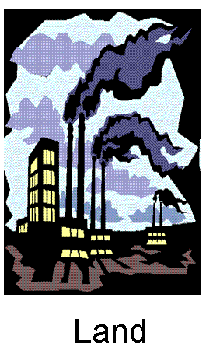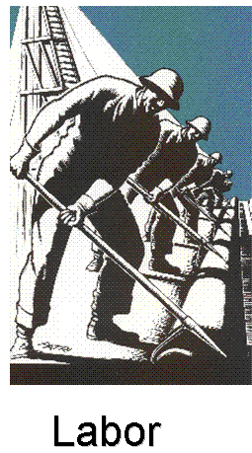
Improvements in Transportation (pg.721)

Watt’s Steam Engine
- Entrepreneur- | - The ______________ was modified by James Watt for increased efficiency.  - Ex. Robert Fulton's ___________ was a steam ship that ferried passengers up and down the ______________

The Railway Age Begins (pg. 721-722)

- The __________________________________________ was the driving force behind English industry after 1820

- Steam-Driven Locomotives-
  - 1804 ____________________ won several thousand dollars on a bet that he could haul _______ of iron ore nearly ____ miles with a ________________

- The Liverpool-Manchester Railroad-  - English entrepreneurs wanted a rail line to connect the cities of ________ and _________.  - A contest was held to see which train would run on the line  - George Stephenson’s Rocket won by hauling __________ _________________ per hour | - Railroads Revolutionize Life in Britain-  - The Four Major Effects of the Locomotive-  - __________ and _________ products were cheap to transport  - The new rail lines created _______________ of new jobs  - __________ and ___________ saw a boost b/c of new transportation opportunities  - ________ became easier and people could now live farther from their jobs
Chapter 25-The Industrial Revolution -Guided Notes
Section 1-The Beginnings of Industrialization

Industrial Revolution Begins in Britain (pg. 717-718)

The Agricultural; Revolution-Paves the Way
- The Industrial Revolution-  - The increased output of machine-made goods beginning in England in the mid 1700’s | - Enclosures-  - Large fenced in fields in which landowners experimented with productive seeding and harvesting methods to boost crop harvests

Rotating Crops
- Seed Drill-  - Invented by Jethro Tull in 1701 that allowed farmers to plant seeds in well-spaced rows at specific depths. | - Crop Rotation-  - Designed to rotate crops that drained nutrients from the soil (ex. Wheat) with crops that replenish them (ex. Turnips)

Why the Industrial Revolution Began in England
- Industrialization- The process of developing the machine production of goods through the use of natural resources.  - Natural Resources used for Industrialization  - Water and coal power  - Iron Ore to construct tools, machines and buildings  - Rivers for inland transportation  - Harbors for the ships to set sail | - Factors of Production-The resources needed to produce goods and services that the Industrial Revolution required.  - Ex. Land, labor and capital (a.k.a wealth)
Improvements in Transportation (pg.721)

Watt’s Steam Engine
- Entrepreneur-Someone who organizes, manages, and takes on the risks of a business. | - The steam engine was modified by James Watt for increased efficiency.  - Ex. Robert Fulton's Clermont was a steam ship that ferried passengers up and down the Hudson River

The Railway Age Begins (pg. 721-722)

- The steam powered railroad locomotive was the driving force behind English industry after 1820

- Steam-Driven Locomotives-
  - 1804 Richard Trevithick won several thousand dollars on a bet that he could haul 10 tons of iron ore nearly 10 miles with a steam engine

- The Liverpool-Manchester Railroad-  - English entrepreneurs wanted a rail line to connect the cities of Liverpool and Manchester.  - A contest was held to see which train would run on the line  - George Stephenson’s Rocket won by hauling 13 tons at nearly 24 miles per hour | - Railroads Revolutionize Life in Britain-  - The Four Major Effects of the Locomotive-  - Materials and finished products were cheap to transport  - The new rail lines created thousands of new jobs  - Agricultural and fishing industries saw a boost b/c of new transportation opportunities  - Travel became easier and people could now live farther from their jobs

