Chapter 24-Nationalist Revolutions Sweep the West-Guided Notes
Section 2-Europe Faces Revolutions

Clash of Philosophies (pg. 687)

Philosophies, Goals and Followers
- Conservative-  - Usually made up of wealthy land owners  - Liberal-Wanted to give more power to elect parliament (only landowners could vote)  - Made up of ____________________ leaders and ____________________ | - Radical-  - Believed that gov. should practice liberty, equality and brotherhood

Nationalism Develops (pg. 687-689)

What’s the Difference Between Nationalism and Nation States?
- Nationalism-  - Most who supported this were __________ or ___________ | - Nation-State-  - In 1815 only France, _______ and ___________ could be considered nation states

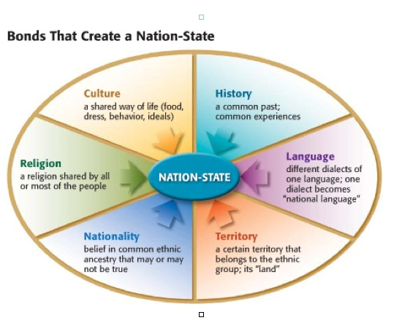
Nationalists Challenge Conservative Power (pg. 689-690)

- Greeks Gain Independence-
  - 1st people to win self-rule from the ______________________
    - 1827 _________, ____________ and ________ helped the Greeks defeat the Ottomans in the Battle of Navarino
    - 1830 France, Britain and Russia signed a treaty guaranteeing the ________________________ _____________________

Radicals Change France (pg. 690)

- The Third Republic-  - After _______________ was removed from power in 1848 the new republican gov. was split into factions  - One side wanted _________ ______________ the other social and ______________ | - Dec 1848- ______________________ was elected president  - He rebuilt __________, encouraged ________________________, and ambitious public works programs

Reform in Russia (pg. 690-691)

Defeat Brings Change- | Reform and Reaction-
- As the 1850’s approached Russia still was behind _____________________  - Alexander II moved the country towards ___________________and social change  - He felt this would allow Russia to ____________________________ ____________________________ | - Alexander II abolished __________ in 1861  - Gave ________ half the land and made the ________ buy theirs  - Nationalism under Alexander III encouraged ____________________ of Russia

Chapter 24-Nationalist Revolutions Sweep the West-Guided Notes
Section 2-Europe Faces Revolutions

Clash of Philosophies (pg. 687)

Philosophies, Goals and Followers
- Conservative-Argued for the protection of the traditional monarchies  - Usually made up of wealthy land owners  - Liberal-Wanted to give more power to elect parliament (only landowners could vote)  - Made up of middle-class business leaders and merchants | - Radical-Favored drastic changes to extend democracy to all people  - Believed that gov. should practice liberty, equality and brotherhood

Nationalism Develops (pg. 687-689)

What’s the Difference Between Nationalism and Nation States?
- Nationalism-A belief that a persons greatest loyalty should be to a nation of people who share a common culture and history, not to a king  - Most who supported this were liberals or radicals | - Nation-State-A nation with it’s own independent government  - In 1815 only France, England and Spain could be considered nation states

Nationalists Challenge Conservative Power (pg. 689-690)

- Greeks Gain Independence-
  - 1st people to win self-rule from the Ottoman Empire
    - 1827 France, Britain and Russia helped the Greeks defeat the Ottomans in the Battle of Navarino
    - 1830 France, Britain and Russia signed a treaty guaranteeing the independent kingdom of Greece

Radicals Change France (pg. 690)

- The Third Republic-  - After Louis-Philippe was removed from power in 1848 the new republican gov. was split into factions  - One side wanted political reform the other social and economic | - Dec 1848-Louis-Napoleon was elected president  - He rebuilt roads, encouraged industrialization, and ambitious public works programs

Reform in Russia (pg. 690-691)

Defeat Brings Change- | Reform and Reaction-
- As the 1850’s approached Russia still was behind industrially  - Alexander II moved the country towards modernization and social change  - He felt this would allow Russia to compete as a world power | - Alexander II abolished serfdom in 1861  - Gave nobles half the land made the serfs buy theirs  - Nationalism under Alexander III encouraged industrial development of Russia

