Chapter 24-Nationalist Revolutions Sweep the West-Guided Notes
Section 1-Latin American Peoples Win Independence
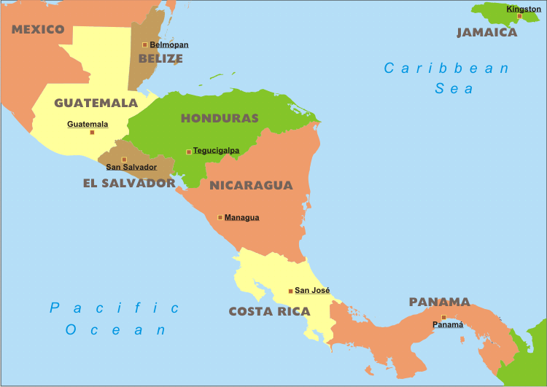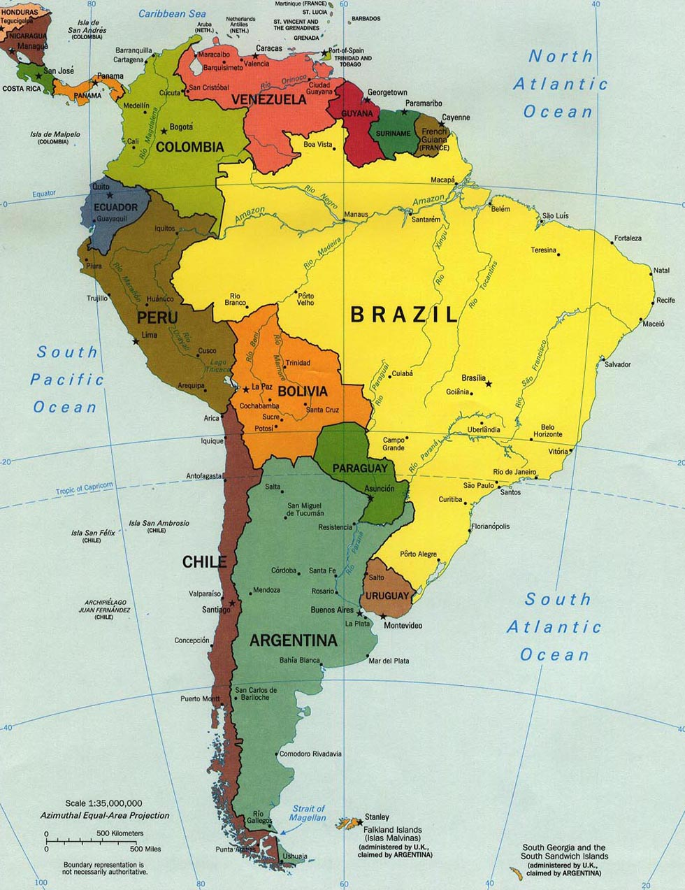
Central America South America

Colonial Society Divided (pg. 681-682)

In Latin American Society, Class Dictated People’s Place in Society
- Peninsulares–  - Creoles-Spaniards born _____________  - Could not hold high-level office but could rise in rank in the army | - Mestizos-People of mixed _________ and _________ ancestry  - Mulattos-People of __________ and ____________ ancestry

Revolutions in America (pg. 682)

Revolution in Haiti
- Saint Domingue (Haiti) was the 1st Latin territory to _______________________ ___________________________________.
  - _______________________ led the revolution until he was sent to a French prison
  - Jean-Jacques Dessalines declared them independent on _________________
    - Haiti means “__________________________”

Creoles Lead Independence (pg. 682-683)

- Creoles-  - ________ oppressed of those in Latin American and the _________ educated  - Brought ideas of the _______________back from Europe  - The South American Wars of independence rested on the achievements of ______________ and _______________________ | - Simon Bolivar-  - August 1819-Bolivar led __________ soldiers through the ____________ and won a surprise victory  - 1821-Bolivar won _______________’s independence and marched into __________ where he met _______________________  - Jose de San Martin-  - 1817-San Martin helped free _______

- Grand Colombia-The future countries of _______________, _________________, _____________, and ______________ that united to form one country

Mexico Ends Spanish Rule (pg. 685-686)

A Cry for Freedom | Mexico’s Independence
- Miguel Hidalgo-  - A priest from Dolores who took the first step towards _____________ independence  - Poor but ____________ man who supported the _______________________  - ________, 1810-Hidalgo rang the bells from his church and _______________________  - He and his 80,000 man army were defeated | - Mexico’s Independence-  - 1820-Mexico’s creoles feared _________________________  - They united in their support of Mexico’s independence and in ________ gained it  - Central America’s Independence-  - 1823-Central America declared their independence from __________, taking the name the ______________________ America

Brazil’s Royal Liberator (pg. 655)

- Brazil’s Quest for Independence-
  - Brazil declared their independence without ________________.
    - They also had help from ________________'s royal family
  - 1822-______________ Brazilians signed a petition to have _______________________ rule Brazil
    - He agreed and ____________________________ ________________________________________

Chapter 24-Nationalist Revolutions Sweep the West-Guided Notes
Section 1-Latin American Peoples Win Independence
Central America South America

Colonial Society Divided (pg. 681-682)

In Latin American Society, Class Dictated People’s Place in Society
- Peninsulares –Spaniards born on the Iberian peninsula, they were the only ones able to hold high office in the colonial government  - Creoles-Spaniards born in Latin America  - Could not hold high-level office but could rise in rank in the army | - Mestizos-People of mixed European and Italian ancestry  - Mulattos-People of European and African ancestry

Revolutions in America (pg. 682)

Revolution in Haiti
- Saint Domingue (Haiti) was the 1st Latin territory to free itself from European rule
  - Toussaint L’Ouverture led the revolution until he was sent to a French prison
  - Jean-Jacques Dessalines declared them independent on January 1, 1804
    - Haiti means “mountainous land”

Creoles Lead Independence (pg. 682-683)

- Creoles-  - Least oppressed of those in Latin American and the best educated  - Brought ideas of the enlightenment back from Europe  - The South American Wars of independence rested on the achievements of Simon Bolivar and Jose de San Martin | - Simon Bolivar-  - August 1819-Bolivar led 2,000 soldiers through the Andes and won a surprise victory  - 1821-Bolivar won Venezuela’s independence and marched into Ecuador where he met San Martin  - Jose de San Martin-  - 1817-San Martin helped free Chile

- Grand Colombia-The future countries of Venezuela, Colombia, Panama, and Ecuador united to form one country

Mexico Ends Spanish Rule (pg. 685-686)

A Cry for Freedom | Mexico’s Independence
- Miguel Hidalgo-  - A priest from Dolores who took the first step towards Mexico’s independence  - Poor but well educated man who supported the enlightenment  - Sept. 16th, 1810-Hidalgo rang the bells from his church and called for the rebellion  - He and his 80,000 man army were defeated | - Mexico’s Independence-  - 1820-Mexico’s creoles feared the loss of their privileges  - They united in their support of Mexico’s independence and in 1821 gained it  - Central America’s Independence-  - 1823-Central America declared their independence from Mexico, taking the name the United Provinces of Central America

Brazil’s Royal Liberator (pg. 686)

- Brazil’s Quest for Independence-
  - Brazil declared their independence without blood shed
    - They also had help from Portugal's royal family
  - 1822-8,000 Brazilians signed a petition to have Dom Pedro rule Brazil
    - He agreed and Brazil received their independence

