Chapter 23-The French Revolution and Napoleon-Guided Notes
Section 3-Napoleon Forges an Empire

Napoleon Seizes Power (pg. 663-664)

Napoleon Bonaparte (1769 A.D. to A.D.)
- Born in 1769  - Sent to __________________ at 9 years old  - He became a ____________________________ at 16  - Upon his return from Egypt he led a ______________  - When the council dissolved he ___________________  - His first goal was to restore _____________ in France | 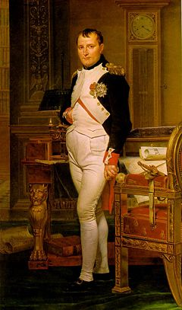

Napoleon Rules France (pg. 664-665)

Restoring Order at Home
- The Plebiscite-  - Napoleon Supported  - Changes from the revolution  - Laws that would strengthen the central gov. and achieve the goals of the revolution | - Napoleon also:  - Set up an effective _________________  - Tried to end to gov. corruption  - Set up Lycees- ______________________ __________________________________  - Students came from all backgrounds  - Relived jobs based on ___________  - Napoleonic Code-  - Promoted order over individual rights

Napoleon Creates an Empire (pg.665-667)

- 1804-Napoleon crowned himself emperor
  - This symbolized his ____________________________

Napoleon Creates an Empire (pg.666-667)

Loss of American Territories
- Napoleon's Goals-  - Wanted to control ____________  - Re-establish French dominance in the Americas  - He thought the key was the _________ producing colony of _____________ _____________________ | - The people of Saint Domingue led by ____________________ demanded the same rights as ___________________  - Napoleon failed to overtake them  - 1803-Napoleon offers to sell the _______________________________ for $ ___ million

Conquering Europe
- Napoleon was extremely successful in battle during the early part of his reign  - _________, Russia, _________, and Sweden joined forces against France but could not beat them  - His victories allowed him to build the __________ _________________________________  - His only real challenge was __________ navy | 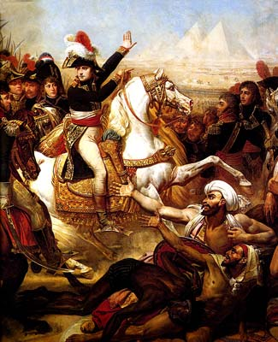

Napoleon Creates an Empire (pg.667) continued

The Battle of Trafalgar | The French Empire
- The only major battle Napoleon lost  - This naval defeat had two lasting effects:  - It assured ___________ naval supremacy for the next ____ years  - Napoleon abandoned his plans ____________________ | - By 1812 the only countries in Europe not controlled by Napoleon were:  - __________, __________, _______________ and the Ottoman Empire  - His empire existed at it’s greatest extent from 1807 to 1812  - Napoleon’s _________ ____________ became his undoing

Chapter 23-The French Revolution and Napoleon-Guided Notes
Section 3-Napoleon Forges an Empire

Napoleon Seizes Power (pg. 663-664)

Napoleon Bonaparte (1769 A.D. to A.D.)
- Born in 1769
- Sent to military school at 9 years old
- He became a lieutenant in the French artillery at 16
- Upon his return from Egypt he led a coup d’ etat
- When the council dissolved he named himself dictator
- His first goal was to restore order in France

Napoleon Rules France (pg. 664-665)

Restoring Order at Home
- The Plebiscite-  - A vote of the people that gave Napoleon all real power  - Napoleon Supported  - Changes from the revolution  - Laws that would strengthen the central gov. and achieve the goals of the revolution | - Napoleon also:  - Set up an effective banking system  - Tried to end to gov. corruption  - Set up Lycees-Gov. ran public schools  - Students came from all backgrounds  - Relived jobs based on performance  - Napoleonic Code-A uniform set of laws that ended many injustices  - Promoted order over individual rights

Napoleon Creates an Empire (pg.665-666)

- 1804-Napoleon crowned himself emperor
  - This symbolized his power over the church

Napoleon Creates an Empire (pg.666-667) continued

Loss of American Territories
- Napoleon's Goals-  - Wanted to control all of Europe  - Re-establish French dominance in the Americas  - He thought the key was the sugar producing colony of Saint Domingue | - Napoleon Supported  - Changes from the revolution  - Laws that would strengthen the central gov. and achieve the goals of the revolution

Loss of American Territories
- The people of Saint Domingue led by Toussaint L’Ouverture demanded the same rights as French citizens  - Napoleon failed to overtake them  - 1803-Napoleon offers to sell the Louisiana Territory for $15 million | 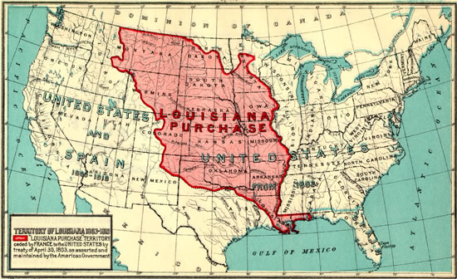

Conquering Europe
- Napoleon was extremely successful in battle during the early part of his reign
- Britain, Russia, Austria, and Sweden joined forces against France but could not beat them
- His victories allowed him to build the largest empire since the Romans
  - His only real challenge was Britain's navy

Napoleon Creates an Empire (pg.667) continued

The Battle of Trafalgar | The French Empire
- The only major battle Napoleon lost  - This naval defeat had two lasting effects:  - It assured Britain naval supremacy for the next 100 years  - Napoleon abandoned his plans of invading Britain | - By 1812 the only countries in Europe not controlled by Napoleon were:  - Britain, Portugal, Sweden and the Ottoman Empire  - His empire existed at it’s greatest extent from 1807 to 1812  - Napoleon’s grand ambitions became his undoing

