Chapter 22-Enlightenment and Revolution-Guided Notes
Section 3-The Enlightenment Spreads

A World of Ideas (pg. 636)

Diderot’s Encyclopedia
- ___________________ began publishing the 1st volumes in 1751  - They were a series of _________ and ______________ by the leading scholars in Europe | - The ____________________ and _____________________ banned the books  - ___________________________ ___________________________ ___________________________

New Artistic Styles (pg. 637)

Neoclassical Style Emerges (along with Baroque)
- Baroque Art- | - Neoclassical Art- A simple and elegant style of art that _____________________ classical Greek and _____________.

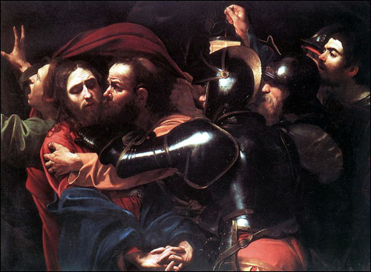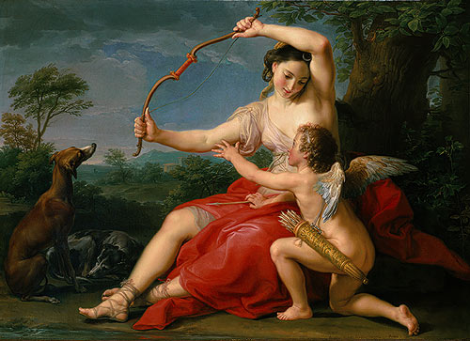
Baroque Style Art Neoclassical Art

- Classical Music- __________________________________
  - Famous classical composers
    - Franz Joseph Haydn, Wolfgang Amadeus Mozart, ___________________________
Enlightenment and Monarchy (pg. 638-639)

- Enlightened Despots- ___________________________ ____________________________________________________________________________________________

Frederick II (1712 A.D. to 1786 A.D.) | Joseph II (1741 A.D. to 1790 A.D.)
- Frederick II-  - a.k.a. ____________________  - Persian king who ruled from 1740-1786  - Enlightened Accomplishments:  - _______________________  - Reduced ________________  - _______________________  - _______________________ | - Joseph II-  - Ruled Austria from 1780 to 1790  - The most radical of the reformers  - Enlightened Accomplishments:  - _____________________________  - Allowed freedom of press  - _____________________________  - Abolished ___________ and ordered that peasants be ______ for their labor

Catherine the Great (1729 A.D. to 1796 A.D.)
- Ruled __________ from 1762 to 1796  - Read the works of the philosophes and corresponded with _________________  - Enlightened Accomplishments:  - _____________________________ Russia's laws  - She was not able to accomplish her major reforms so she instituted more __________ reforms | - Following the _________________ in 1773, she gave the nobles in Russia ________________________ ______________________________  - Serfs lost all traces of _________________

Chapter 22-Enlightenment and Revolution-Guided Notes
Section 3-The Enlightenment Spreads

A World of Ideas (pg. 636)

Diderot’s Encyclopedia
- Dennis Diderot began publishing the 1st volumes in 1751  - They were a series of essays and article by the leading scholars in Europe | - The French government and Catholic Church banned the books  - Helped spread ideas during the Enlightenment throughout Europe

New Artistic Styles (pg. 637)

Neoclassical Style Emerges (along with Baroque)
- Baroque Art- European art during the 1600s and early 1700s which was characterized by a grand ornate design | - Neoclassical Art- A simple and elegant style of art that barrowed themes from classical Greek and Rome

Baroque Style Art Neoclassical Art

- Classical Music-Lighter elegant style of music
  - Famous classical composers
    - Franz Joseph Haydn, Wolfgang Amadeus Mozart, Ludwig van Beethoven

Enlightenment and Monarchy (pg. 638-639)

- Enlightened Despots-“Absolute rulers” that embraced new ideas and made reforms that reflected the Enlightenment

Frederick II (1712 A.D. to 1786 A.D.) | Joseph II (1741 A.D. to 1790 A.D.)
- Frederick II-  - a.k.a. Frederick the Great  - Persian king who ruled from 1740-1786  - Enlightened Accomplishments:  - Granted religious freedom  - Reduced censorship  - Improved education  - Abolished torture | - Joseph II-  - Ruled Austria from 1780 to 1790  - The most radical of the reformers  - Enlightened Accomplishments:  - Introduced legal reform  - Allowed freedom of press  - Supported freedom of worship  - Abolished serfdom and ordered that peasants be paid for their labor

Catherine the Great (1729 A.D. to 1796 A.D.)
- Ruled Russia from 1762 to 1796  - Read the works of the philosophes and corresponded with Voltaire  - Enlightened Accomplishments:  - Formed a commission to review Russia's laws  - She was not able to accomplish her major reforms so she instituted more limited reforms | - Following the serf uprising in 1773, she gave the nobles in Russia absolute control over the serfs  - Serfs lost all traces of freedom  - Her armies gained control of the northern shore of the Black Sea and expanded westward into Poland

