Chapter 22-Enlightenment and Revolution-Guided Notes
Section 2-The Enlightenment in Europe

Setting the Stage (pg. 629)
- The Enlightenment-________________________________ _________________________________________________ _________________________.

Two Views on Government (pg. 629-630)

Hobbes’s Social Contract | Locke’s Natural Rights
- Social Contract-Thomas Hobbes theory that __________________ ___________________________ ___________________________  - Ideally an ______________ that could impose order and demand obedience | - John Locke’s Natural Rights-  - He believed that people were born ____ and _______ with ________ ____________________________  - Life, ________ and ________  - The purpose of government was to __________ these rights  - If the government fails the people have ________ _____________________

The Philosophes Advocate Reason (pg. 630-632)

Philosophes in France | Voltaire (1694 A.D. to 1778 A.D.)
- Philosophes-Social critics in France during the mid-1700’s  - They had five core beliefs  - _________________  - _________________  - _________________  - _________________  - _________________ | - Voltaire-  - Born François-Marie Arouet  - Published more than ____________ in his life  - Used satire against his enemies  - Targeted the _______________, ___________, and ___________
The Philosophes Advocate Reason (pg. 630-632) continued…

Montesquieu (1689 A.D. to 1755 A.D)
- Montesquieu-A French baron who _____________ __________________________________________  - His ideas about separation of power, ___________ and _______________ became the basis for the ________________________ | 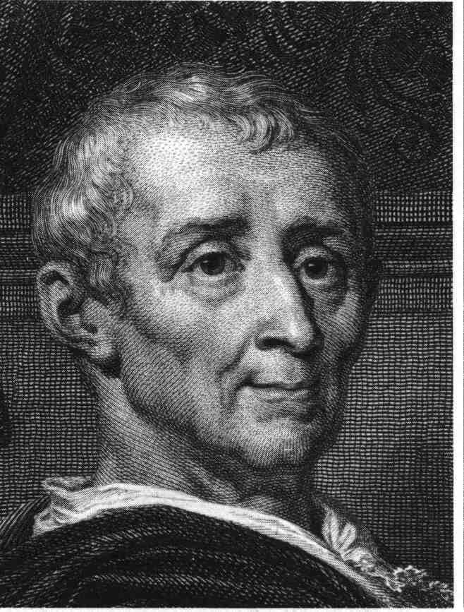

Women and the Enlightenment (pg.633)

Mary Wollstonecraft- (1759 A.D. to 1797 A.D)
- Mary Wollstonecraft-  - Wrote A Vindication of the Rights of Women  - Felt that women _______________________ ________________ to be virtuous and useful  - Her daughter Mary Shelly wrote ___________________________ | 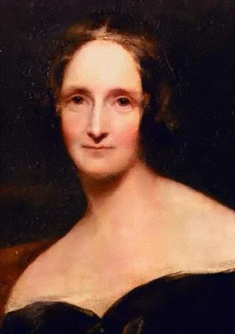

Legacy of the Enlightenment (pg.633-634)

A More Secular Outlook and the Important of the Individual
- People became more accepting of _______________________ beliefs  - ________________________  - New discoveries were made in __________, physics, _________, and ___________ | - ______________________ were questioned and people developed more of a _______________ on life  - More emphasis was placed on the _________________ within a society
Chapter 22-Enlightenment and Revolution-Guided Notes
Section 2-The Enlightenment in Europe

Setting the Stage (pg. 629)
- The Enlightenment-A new intellectual movement that stressed reason, thought and the power of individuals to solve problems

Two Views on Government (pg. 629-630)

Hobbes’s Social Contract | Locke’s Natural Rights
- Social Contract-Thomas Hobbes theory that if people hand their rights to a strong ruler that they would receive law and order  - Ideally an absolute monarchy that could impose order and demand obedience | - John Locke’s Natural Rights-  - He believed that people were born free and equal with three main rights  - Life, Liberty and Property  - The purpose of government was to protect these rights  - If the government fails the people have the right to overthrow it

The Philosophes Advocate Reason (pg. 630-632)

Philosophes in France | Voltaire (1694 A.D. to 1778 A.D.)
- Philosophes-Social critics in France during the mid-1700’s  - They had five core beliefs  - Reason  - Nature  - Happiness  - Progress  - Liberty | - Voltaire-  - Born François-Marie Arouet  - Published more than 70 books in his life  - Used satire against his enemies  - Targeted the government, clergy, and aristocracy

The Philosophes Advocate Reason (pg. 630-632) continued…

Montesquieu (1689 A.D. to 1755 A.D)
- Montesquieu-A French baron who devoted himself to the study of political liberty
  - His ideas about separation of power and checks and balances became the basis for the U.S. Constitution

Women and the Enlightenment (pg.633)

Mary Wollstonecraft- (1759 A.D. to 1797 A.D)
- Mary Wollstonecraft-
  - Wrote A Vindication of the Rights of Women
  - Felt that women just like men needed education to be virtuous and useful
  - Her daughter Mary Shelly wrote Frankenstein

Legacy of the Enlightenment (pg.633-634)

A More Secular Outlook and the Important of the Individual
- People became more accepting of progressive beliefs  - Mainly scientific knowledge  - New discoveries were made in chemistry, physics, biology, and mechanics | - Religious beliefs were questioned and people developed more of a secular outlook on life  - More emphasis was placed on the individual within a society

