Chapter 14-The Formation of Western Europe-Guided Notes-Section 2-Changes in Medieval Society

A Growing Food Supply (pg. 387)
- Expanding civilization = need for more food
- Switch to horse power
  - Horses required _________________ but could do three times the work
  - They began to use better ____________ that fit around the horses chest

The Three-Field System (pg.387)
You divide your land into three parts

The Guilds (pg.388)
- Guild-An organization of individuals in the same business striving to improve the economic and social conditions for its members.  - Both _______ and _________ joined | 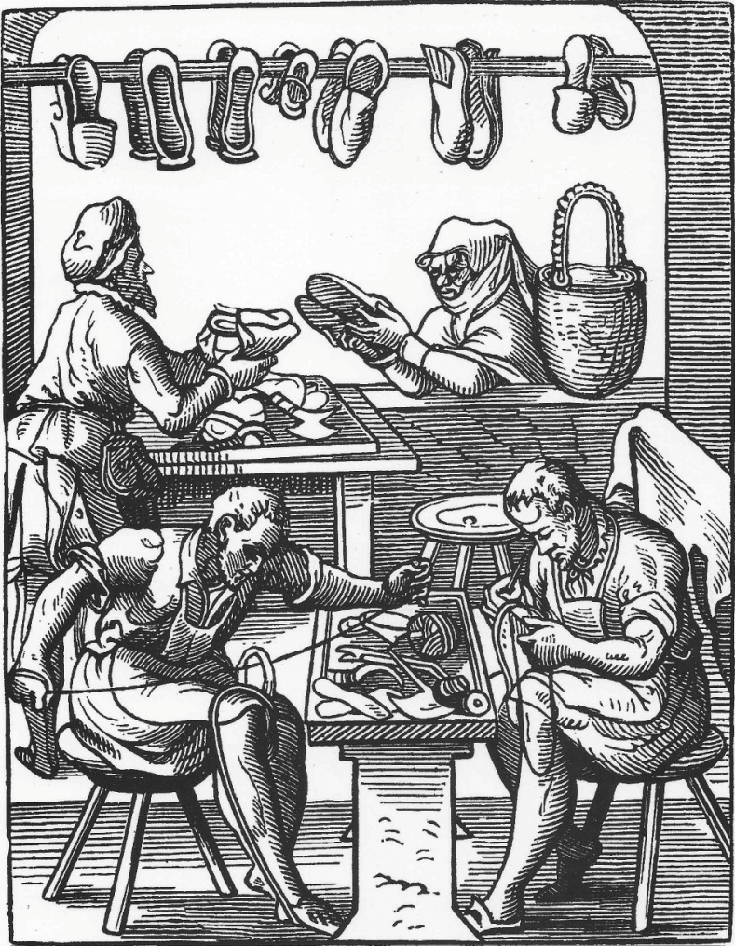 | - Set standards for quality of work, ___________, and working conditions, supervised training of new workers

Commercial Revolution (pg.389)

Fairs and Trades
- Merchants traded cloth, __________, salt, ________, cheese, wine, __________, knives

Commercial Revolution continued… (pg.389)

- Business and Banking-
  - _________________________ eliminated the need for traders to carry ___________________________________________
    - Exchange rates established
  - Usury- ____________________________________________
___________________________________________________

The Revival of Learning (pg.391)

The Crusades-300 Years of Religious Wars
- Scholars and Universities-
  - University-___________________________________
  - Most students were ___________________
  - _____________________________________________
  - Bachelors in theology – ___ to ____ years
  - _____________________________________-12 years
  - Vernacular- Lively everyday language of one’s homeland
    - This brought ____________________________

Aquinas and Medieval Philosophy (pg. 392)

- Scholastics- _________________________________________

Thomas Aquinas (January 1225–March 1274 A.D.)
- Thomas Aquinas argued that religious truths could be proved by logic  - Wrote the Summa Theologicate  - Combined ____________ thought with modern _____________________ | 