Chapter 14-The Formation of Western Europe-Guided Notes-Section 1

Section 1-Church Reform and the Crusades (pg. 379)

- The “_________________”-Period of time in Western Europe between 500-1000 A.D.

The Age of Faith (pg. 379)

Problems with the Catholic Church During the Dark Ages
- Village priests were getting _____________  - Against the rules | ___________ -Bishops were selling positions within the church | - _______________-Kings and nobles were appointing ________

- Reform and Church Organization-
  - (Pope) Gregory VII and Leo IX began to enforce laws against __________ and ___________________________
  - Restructured Catholic leadership to resemble a _____________ by making the pope the ________ of the Catholic Church
  - Cannon Law (Law of the Church) was developed to deal with _______________, divorce and ____________________

Cathedrals-Cities of God (pg. 380)

- Cathedrals-Large __________________ built in major cities designed to be a representation of the “______________________”

The Concept of Government Changes
_______________ Style-  - Built between 800 and 1100 A.D.  - _____________________  - Heavy roof held up by thick ______ and ___________  - ________________ made them extremely dark | Gothic Architecture-  - Began being built around the 1100’s A.D.  - Built ___________ towards the ____________________  - Large stained glass windows  - Designed to ____________ _________________ with the magnificence of God

The Crusades (pg. 382-383)
- Crusade- “________________” to gain control of the Holy Land (Jerusalem)
  - Issued by Pope Urban II

The Crusades-300 Years of Religious Wars
Goals of the Crusades-  - ____________, social, _________ and political goals  - Some sought to regain ________, Jerusalem and ___________ Christendom  - Others were looking for _______________________ | 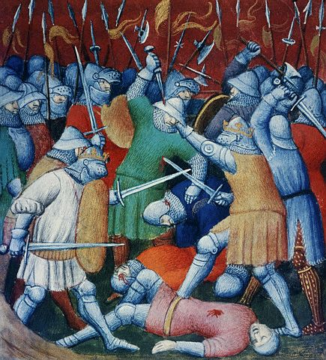

The First and Second Crusades (1096-1149 A.D.)
- 1st Crusade-  - ________ men approached Jerusalem  - In ________ Crusaders capture the city of Jerusalem | - 2nd Crusade-  - Organized to recapture ___________  - 1187-Jerusalem fell to the ___________ warrior ___________ | - Pope said “those who _____ on _________, have a place in _________”  - Crusaders wore a ___________ on their tunic and shouted “God wills it!”

The Third Crusade (1189-1191 A.D.)
- Organized to help Christian Crusaders recapture _________________________

- Led by _____________ of Europe’s most powerful monarchs  - Philip II, _________, Richard the ________-Hearted  - Philip went _________, Fredrick ___________ on the journey, so Richard was left alone | - 1192-Richard and ________ agreed to a ___________  - Muslims kept the ___________  - Christian pilgrims could enter ______________
The Crusading Sprit Dwindles (pg 383-384)

The Children’s Crusade (1212 A.D.)
1212-Thousands of ___________ set out to overtake Jerusalem  - Led by Stephen of Cloyes (He was only 12 Years old)  - ________ kids under the age of 18 joined the Crusade because they believed ________________ __________________ Jerusalem  - Many died on the way, drowned or were ____________________ | 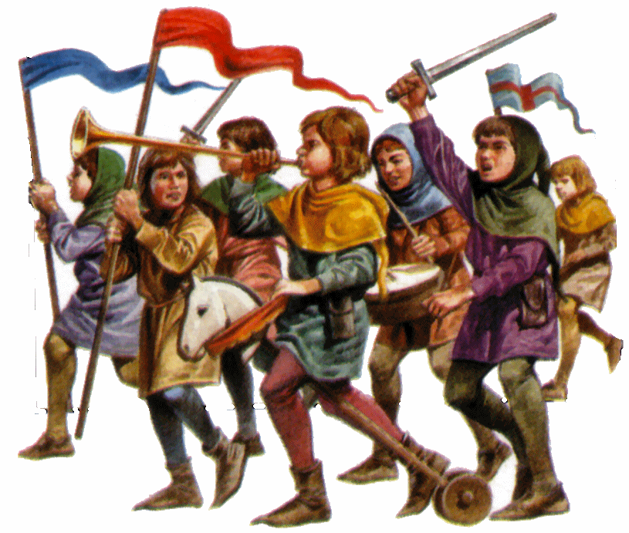

A Spanish Crusade (pg. 384) –

Spanish Crusades (Late 1400’s)-
- Reconquista-  - Long fought effort to get the _________ (Muslims) out of _________  - 1492-Granada fell to the Christian army | - Inquisition-  - Christian ________ used by Isabella and Ferdinand of Spain to ___________ heresy  - Heretic-  - Someone who’s beliefs ___________ from those of the Catholic Church  - Suspects many be __________ for weeks or __________

The Effects of the Crusades (pg. 385)

Effects of the Crusades
- Thousands _________ their _________ and fought for the church | - Women managed affairs of the home along with opening ___________ and _______ | - Trade expanded between _______ and South West _________  - Popular products traded were _________, fruit, and _________ | - _________ of later Crusades weakened the power of the ________ | - _________ and ________ hated each other  - Jews during this time were heavily ____________

Chapter 14-The Formation of Western Europe-Guided Notes-Section 1

Section 1-Church Reform and the Crusades (pg. 373)

- The “Dark Ages”-Period of time in Western Europe between 500 and 1000 A.D.

The Age of Faith (pg. 373)

Problems with the Catholic Church During the Dark Ages
- Village priests were getting married  - Against the rules | - Simony-Bishops selling positions within the church | - Lay Investiture-Kings and nobles were appointing Bishops

- Reform and Church Organization-
  - Gregory VII and Leo IX enforced laws against simony and priests marrying
  - Restructured to make the pope the head of the church
  - Cannon Law was developed

Cathedrals-Cities of God (pg. 380)

- Cathedrals-Large churches built in major cities

The Concept of Government Changes
Romanesque Style-  - Built between 800 and 1100 A.D.  - Round heavy arches  - Heavy roof held up by thick walls and pillars  - Small windows | Gothic Architecture-  - Began being built around the 1100’s A.D.  - Built upward towards the heavens  - Large stained glass windows  - Designed to inspire worshipers with the magnificence of God
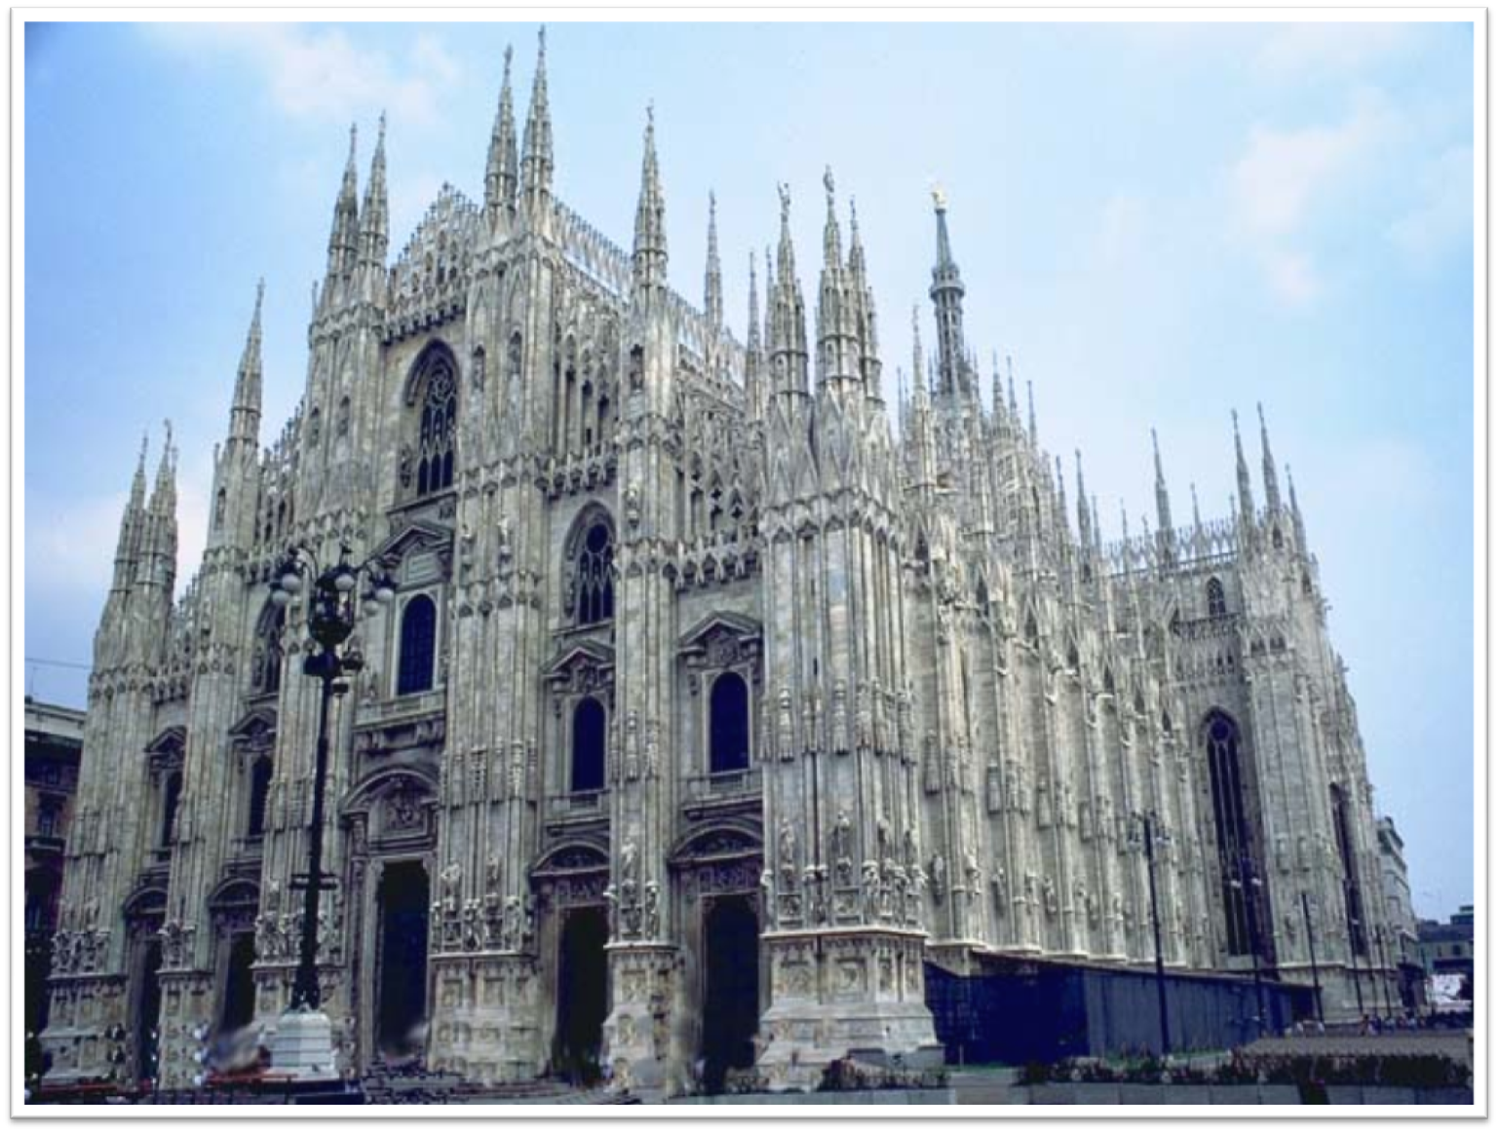

The Crusades (pg. 382-383)
- Crusade- “Holy War” to gain control of the Holy Land (Jerusalem)
  - Issued by Pope Urban II

The Crusades-300 Years of Religious Wars
Goals of the Crusades-
- Religious, social, economic and political goals
- Some sought to regain Palestine, Jerusalem and reunite Christendom
- Others were looking for land of their own

The First and Second Crusades (1096-1149 A.D.)
- 1st Crusade-  - 12,000 men approached Jerusalem  - In 1099 Crusaders capture the city of Jerusalem | - 2nd Crusade-  - Organized to recapture Edessa  - 1187-Jerusalem fell to the Kurdish warrior Saladin | - Pope said “those who die on crusade, have a place in heaven”  - Crusaders wore a red cross on their tunic and shouted “God wills it!”

The Third Crusade (1189-1191 A.D.)
- Organized to help Christian Crusaders recapture Jerusalem

- Led by three of Europe’s most powerful monarchs  - Philip II, Fredrick I, Richard the Lion-Hearted  - Philip went home, Fredrick drowned on the journey, so Richard was left alone | - 1192-Richard and Saladin agreed to a truce  - Muslims kept the holy city  - Christian pilgrims could enter freely

The Crusading Sprit Dwindles (pg 383-384)

The Children’s Crusade (1212 A.D.)
1212-Thousands of children set out to overtake Jerusalem
- Led by Stephen of Cloyes (He was only 12 Years old)
- 30,000 kids under the age of 18 joined the Crusade because they believed God would give them Jerusalem
- Many died on the way, drowned or were sold into slavery

A Spanish Crusade (pg. 384) –

Spanish Crusades (Late 1400’s)-
- Reconquista-  - Long fought effort to get the Moors (Muslims) out of Spain  - 1492-Granada fell to the Christian army | - Inquisition-  - Christian court used by Isabella and Ferdinand of Spain to suppress heresy  - Heretic-  - Someone who’s beliefs differed from those of the Catholic Church  - Suspects many be questioned for weeks or tortured

The Effects of the Crusades (pg. 385)

Effects of the Crusades
- Thousands left their homes and fought for the church | - Women managed affairs of the home along with opening shops and inns | - Trade expanded between Europe and South West Asia  - Popular products traded were spices, fruit, and cloth | - Failure of later Crusades weakened the power of the pope | - Muslims and Christians hated each other  - Jews during this time were heavily persecuted

