World Religions-Guided Notes
Chapter 10-The Muslim World

Section 1: The Rise of Islam (pg. 263)
Mecca | Ka’aba | Monotheism
- During __________ months __________ stopped in Mecca in western Arabia | - An ancient _______________ _______________ _______________  - Contained over ________ idols | - Belief in ____ god  - Islam = _________

The Prophet Muhammad (pg. 264)
The Prophet Muhammad (570-632 A.D.)
Early Life: | - Born to ___________________________________  - Orphaned at _______________________________  - Raised by _________________________________
Age 25: | - Became ___________________________________  __________________________________________.  - Married _____________________________.
Took a Great Interest In:
Age 40: | - The voice of ________________________________  ___________________________________________.
The Angel Gabriel Told Him:

(pg. 265)
Islam | Muslim | 613 A.D
- “ _______________  _______________  _______________  ______________” | - “ _______________  _______________  _______________  ______________”

- The Hijrah-
  - Muhammad’s journey to ______________ (200 miles north of Mecca)
  - _________ A.D. Muhammad and _________ followers returned to Mecca
    - Mecca’s leaders surrendered
  - Destroyed the idols in the Ka’aba and made the call to prayer
    - Most Meccans converted to Islam
- The Prophet Muhammad ____________________. at the age of ______
  - Incredibly he was able to unify a majority of the ___________________________

Beliefs and Practices of Islam (pg 267)

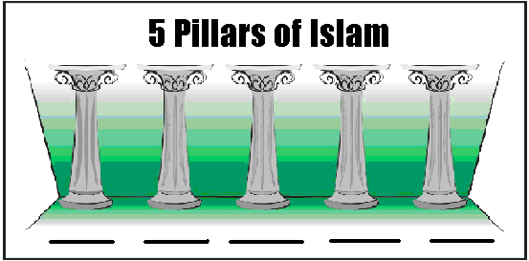

Sources of Authority (pg.267)-The Qur’an
- __________-Islamic holy book containing the word of Allah as revealed to the Prophet Muhammad
  - Written in _______________
    - Only the Qur’an written in Arabic is considered _____________ ____________________________________________________.
- Muslims believe that Muhammad’s mission was to ___________________ and _____________ it’s application

(Pg. 268)

Sunna
Shari’a | -Regulated family life,  moral conduct, and  business and community  life

Section 2: Islam Expands (pg. 269)
- Muslims wanted to carry on Islam but Muhammad had not named a successor
  - They were not sure how to choose a new leader
  - After the prophets death many Muslims ____________ others ________

The “Four Rightly Guided” Caliphs
“Caliph”-A successor or Deputy
Abu-Bakr | Umar | Uthman and Ali

- Jihad- Term meaning “_____________” (or an inner struggle against evil)

- Reasons for the early success of Islam- (pg 269-270)
  - The four “Rightly Guided” Caliphs saw their ____________ as a sign of Allah’s support
  - By the time Muslim armies arrived the _______________ and _________ armies were exhausted
  - _______________________ welcomed the Muslims as “____________”
  - Islam was attractive and offered ____________ and ____________
    - Also Muslims did not have to pay a poll tax

Internal Conflict Creates a Crisis (pg.270-271)

Shi’a and Sunni Split
Shi’a | Sunni | Sufi
 |  | - Rejected the luxury of the Umayyad’s life style instead they pursued poverty and spirituality

Section 3: Muslim Culture (pg. 273)

Four Social Classes in Early Islamic Society
Upper Class | Second Class | Third Class | Lower Class

Role of Women (pg. 274)
- The Quran says “Men are the managers of the affairs of women” and “Righteous Women are Obedient”
- Men and women as _____________________________
- Shari’a granted rights
  - ___________________
  - ___________________
  - ___________________

Muslim Scholarship Extends Knowledge (pg. 274)

Reasons for Supporting Science and Knowledge
Wanted skilled ________________ to treat their ills | Used _____ and ________ to calculate times of prayer | Even _________________  ______________________ revered the power of learning

Muslim Literature
- The Qur’an is the most beautiful form of Arabic ____________ and __________.
- Muslims also believed that only Allah could create _____________ so they perfected ______________ (hand drawings)
    - Also used ________________, glass, and ceramics

