Chapter 11-The Byzantines, Russians and Turks Interact Guided Notes-Section 1 (Part 2)

Section 1:The Byzantine Empire-Notes (continued) (pg. 303)

- Hippodrome-A massive stadium that held ______________ spectators and offered free _____________ and ___________.  - The site of the Nika Rebellion | 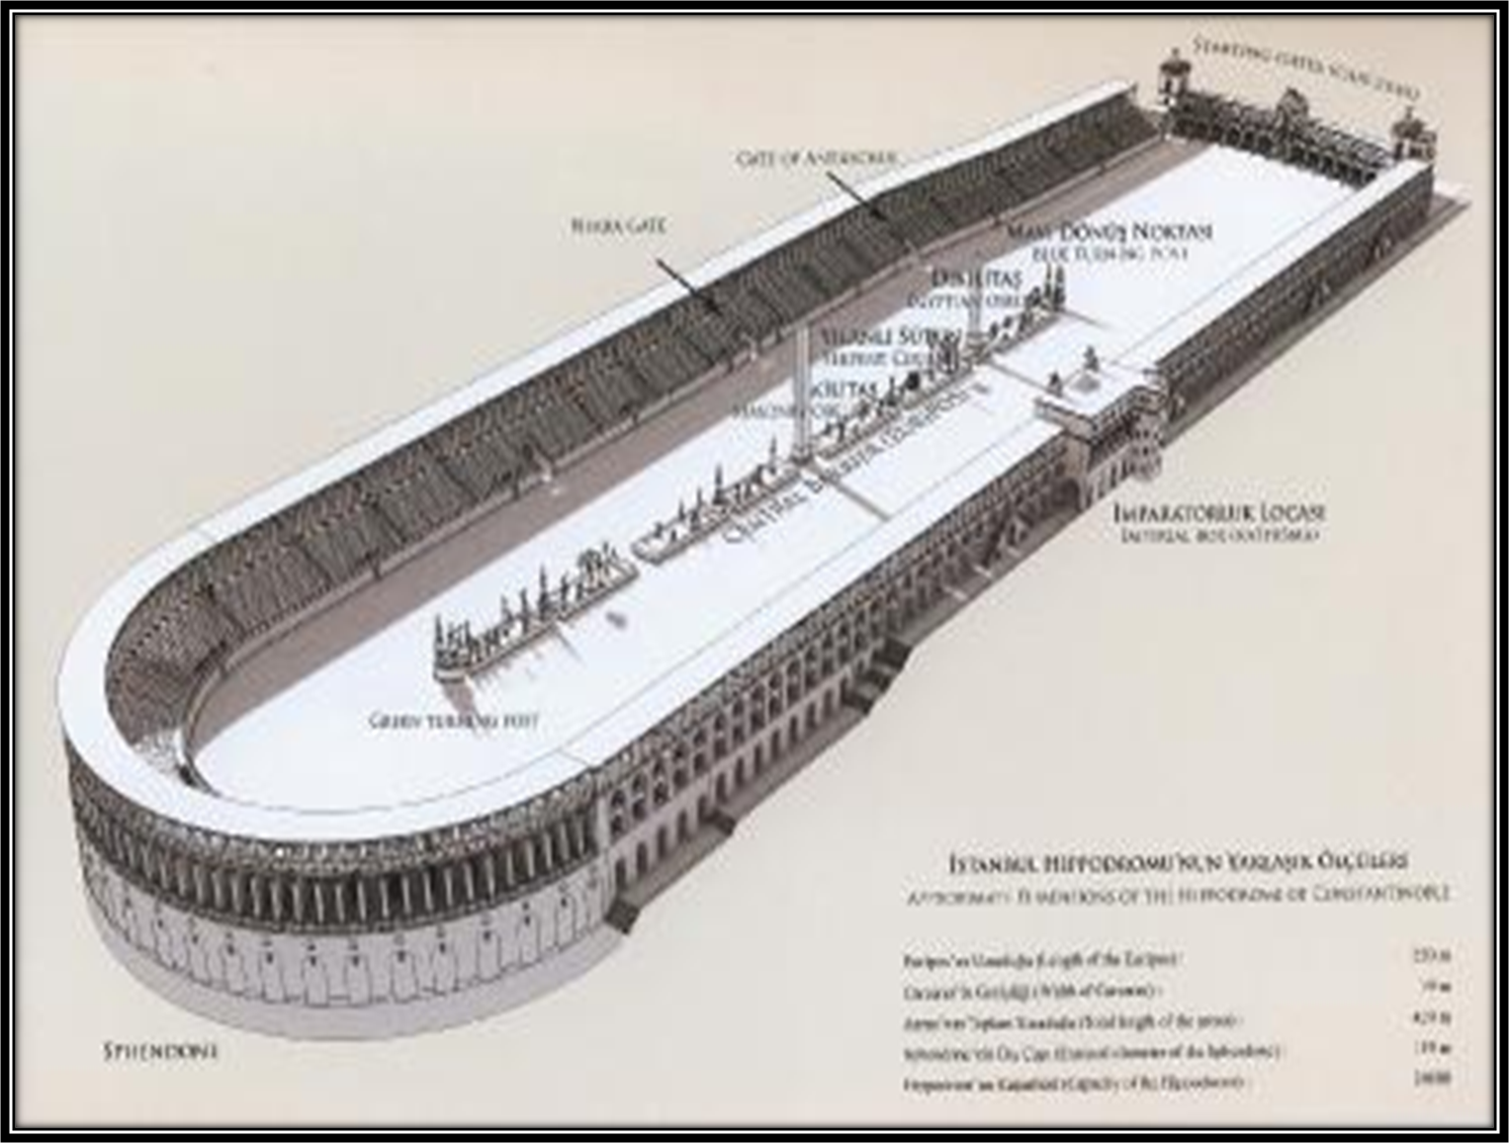

- Nika Rebellion-532 A.D. Two groups of angry protestors sparked ________________________ shouting “________” (meaning “Victory”) while also calling for the overthrow of _____________ and his ______________.
  - Justinian sent in his troops and slaughtered all _________ protestors inside of the ____________.

History Makers-Empress Theodora (pg. 303)

Empress Theodora (500-548 A.D.) | Married _________________ in 525 A.D.
Empress Theodora (500-548 A.D.) | Former _________________ dancer
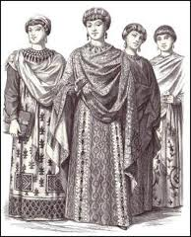 | Most _____________ woman in Byzantine history.
 | Theodora’s Political Responsibilities as Co-Empress

The Empire Falls-(pg. 304)
- The Plague of Justinian-542 A.D. The _____________ plague swept through ______________________ killing nearly __________ people a day.

Attacks from East and West-(pg. 304)
- Byzantium faced constant attacks

In order to keep their enemies at bay the Byzantines used:

The Church Divides-(pg. 306)

The Church Divides-A Religious Split
Eastern Orthodox Christianity |  | Roman Catholicism
Patriarch | Icons | Pope | Excommunication
- Leading _______ of the __________.  -Still under the authority of the _____________. | -Religious _______  ________________  ____________ in the Orthodox Faith. | - Head of the ___________ Church  -Answers to God alone | -Means you are _________________  _________________  _________________.

Byzantine Missionaries Convert the Slavs-(pg. 306)

- Cyrillic Alphabet-  - Since many of the people spoke _________ languages or _________ an alphabet was created in which the Slavic people could read the ________________. | 