9th Grade Social Studies MEAP Prep-The Battle of Saratoga

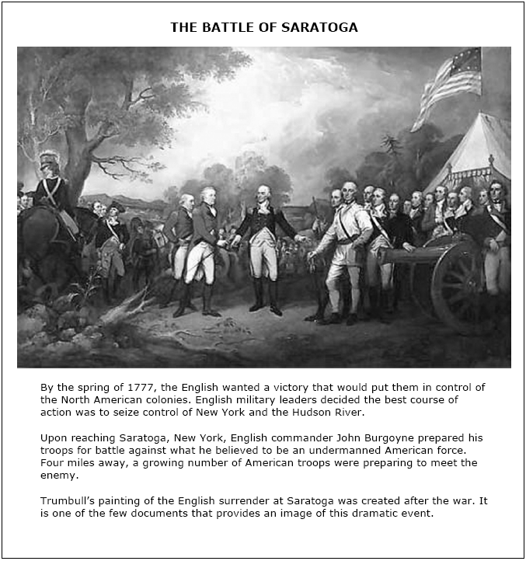

- Based on the images in the painting what might lead you to believe that the United States was victorious in the Battle of Saratoga?

- What is symbolic about the English Commander John Burgoyne surrendering his sward to George Washington?

