9th Grade Social Studies MEAP Prep-Analyzing Maps

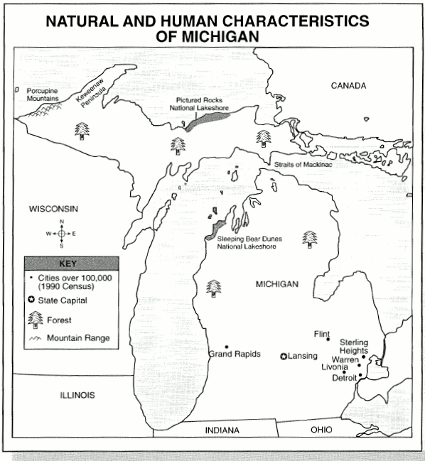

54.) What natural characteristic is found on the shores of Lake Michigan?
- Lansing
- Mountain Ranges
- Sand Dunes
- Water Sports

55.) The people in the Upper Peninsula use natural resources in what major
economic activity?
- Cutting trees for lumber and pulp
- Growing vegetables for other states
- Playing hockey and other sports
- Starting churches and schools

56.) People in the southern part of Michigan have changed their environment the
MOST by?
- Building many large cities
- Creating art and music
- Visiting other states
- Taking boat rides on the lakes

57.) Which of the following is an example of human characteristics shown on the
map?
- Cities
- Lakes
- Peninsulas
- Straits

58.) People have changed the natural environment of our state the MOST by?
- Farming new land
- Learning new languages
- Playing new sports
- Watching new TV shows

