Name _______________________________________ Date __________ Hour _______Number

**Sep Natural Selection Review and Extra Credit(25points)**

**Directions**

1. Go to the link . <https://sepuplhs.org/high/sgi/teachers/evolution_act11_sim.html>

** NOTE: If you cannot see the entire window of the simulation on your computer, grab the lower right corner of the screen and drag it until the entire window is visible.

**Part A:** This simulation represents 500,000 years. A bird population exists in the southwestern portion of the island. During this time, mutations may alter the ability of some birds and their descendants to thrive in the environment. Birds with traits that enhance their fitness are more likely to survive and reproduce. In the southwest, your birds will encounter the environmental conditions listed in the table below. Fill in the second column of the chart with the bird phenotypes that are best suited for each of the conditions. (1)

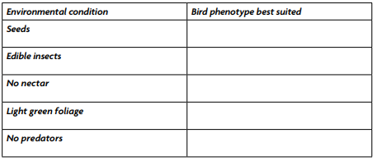

1. Of the phenotypes you selected for the three birds, how fit do you think each phenotype is in the current environment? Explain your reasoning. (2)

2. Select one of the populations of birds to observe. Record the population you have been assigned. (.5)

Watch the animation. Record in the chart for your assigned population what changes occur (including mutations, mutation effects, and population numbers) in each population, and how many years have passed when the change occurs. (4.5)

|  |  |  |  |
| --- | --- | --- | --- |
| Years passed | Mutation | Mutation effect | Population number |
| 50,000 |  |  |  |
| 150,000 |  |  |  |
| 250,000 |  |  |  |
| 350,000 |  |  |  |
| 450,000 |  |  |  |
| 500, 000 |  |  |  |

4. How has the bird populations changed over the course of the 500,000 years. For example, what types of mutations occurred? Under what circumstances were the offspring more or less fit as a result of the mutation? (3)

5. Were your ideas about the fitness of each phenotype you selected correct? Explain why or why not. (2)

**Part B:** A hurricane has hit the island, and some of the birds have been blown to three new areas! Each area has a unique environment. Select and observe one of the three areas.(.5)

6. Record in the chart below the environment that exists in each of the three new areas when each bird population arrives. Circle in the first column the name of the area that you have been selected. (1)

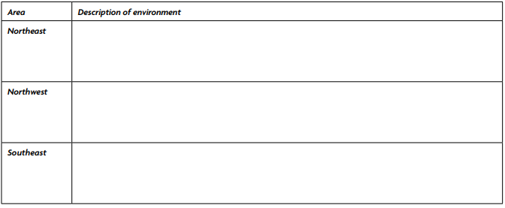

7. Which birds you think will be most fit in each new environment and which will be less fit. Record in the space below your ideas, and explain your reasoning. (2)

8.Watch the animation for your assigned area. Record in the chart below the phenotypes of the birds in each population and their environment (food, foliage, predators) each time there is a change in the area during 500,000 years of evolution. (4)

|  |  |  |  |  |
| --- | --- | --- | --- | --- |
| Years Passed | Mutation | Mutation Effect | Environment | Population Number |
| 550,000 |  |  |  |  |
| 650,000 |  |  |  |  |
| 700,000 |  |  |  |  |
| 800,000 |  |  |  |  |
| 900,000 |  |  |  |  |
| 1,000,000 |  |  |  |  |

9. What changes that occurred in each of the three areas over 500,000 years. (.5)

10. Explain how much the recent birds vary from the original birds after 1 million years of natural selection. How does evolution explain the changes? Use the following terms or phrases in your explanation: natural selection, random mutation, nonrandom selection of favorable traits, reproduction, genetic variation, and extinction. (2)

11.In this activity you worked with a model to simulate natural selection. In what ways did this activity model natural selection well? What aspects of natural selection did the simulation not include?(2)