Plants in a time of drought

Populations of organisms adapt to their environment over many generations. The longer the generation, the longer it takes the populations to adapt. So what happens to these populations if their environment changes suddenly?

Scientists had the opportunity to study rapid environmental changes when California experienced a drought from 1997-2004. This ecosystem typically has a wet and dry season each year. During the years of the drought, the wet season was shorter than normal.

The scientists studied a plant called field mustard, a wild relative of Fast Plants. Field mustard plants that sprout, grow, and make their seeds during the rainy season have the best chance to survive and reproduce. Because California only has one rainy season per year, the scientists knew the field mustard only had about 7 generations to adapt to the drought. Was this enough generations to adapt?

Scientists grew two groups of plants: one group from seeds collected before the drought, and the other group from seeds collected after the drought. They recorded how long it took each group of plants to produce flowers. Only plants that flower during the Wet Season have enough water to successfully reproduce.

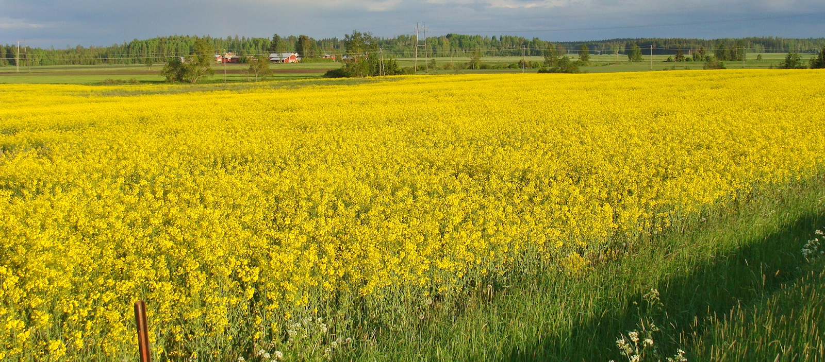

“[Field Mustard in Southern Finland](https://commons.wikimedia.org/wiki/File:Rypsipelto_Field_Mustard.jpg)” by Paasikivi is licensed under CC BY-SA 4.0

Comparison of Plants Flowering from seeds collected before the drought

versus

 Plants Flowering from seeds collected after the drought

