|  |
| --- |
| **Dog Traits** |

**Artificial Selection**

Artificial selection happens when people select individuals to mate that have features they hope the offspring will inherit. This is also called slective breeding.

Here is what is needed..

***1. Variation*** the differences that exist among individuals. Many of these differences are determined by their genes.

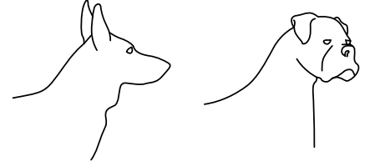

2***. Inheritance:*** Genetic traits are inherited from parents and are passed to offspring.

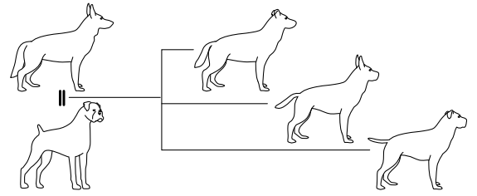

***3. Selection:*** In artificial selection, individuals with favorable traits are bred in hopes that those traits will be passed on to the next generation.

***4. Time:*** Getting the desirable features does not usually happen in just one try. Often, you have to breed many generations to get a new breed established.

**The traits**

|  |  |
| --- | --- |
| **Physical Traits** | **Function/Significance** |
| 1. Smell | Above average olfactory receptors (very good smellers) |
| 2. Sight | Above average number of rods (very good sight) |
| 3. Hearing | Long pointed ears (very good hearing) |
| 4. Speed | Long legs (fast runner) |
| 5. Endurance | Large heart means more oxygen which means good endurance (can work/run for a long time) |
| 6. Strength | Large muscles (very strong) |
| 7. Coat color | Color can camouflage with its environment (You will have to choose this as a trait as well) |
| 8. Hair Length (pick either long or short hair) | Long hair = the dogs stays warm but is heavy when wet  Short hair= the dog stays cool; does not get heavy when wet. |

|  |  |
| --- | --- |
| **Behavioral Traits** | **Function/significance** |
| 1. trainability (pick high or low trainability) | High trainability= learn quickly ; follows directions; does not get distracted  Low trainability= easily distracted; have to keep on a leash most times; crazy |
| 2. Disposition (pick either vicious or compatible) | Vicious= will attack if commanded; is not afraid of other dogs or people  Compatible= friendly; likes to help others; very social |
| 3. Bark (pick either loud or quiet) | Loud bark= can be used as a warning  Quiet bark= won’t scare others |