**Name ________________________ Date ___________ Hour _______**

**Good Grades!(5points)**

**Directions:**  Examine the data table and graph below to help answer the questions.

|  |  |
| --- | --- |
| **TV time**  **(hours per week)** | **Grade Point Average** |
| 0 | 3.50 |
| 5 | 3.25 |
| 10 | 3.00 |
| 15 | 2.75 |
| 20 | 2.50 |

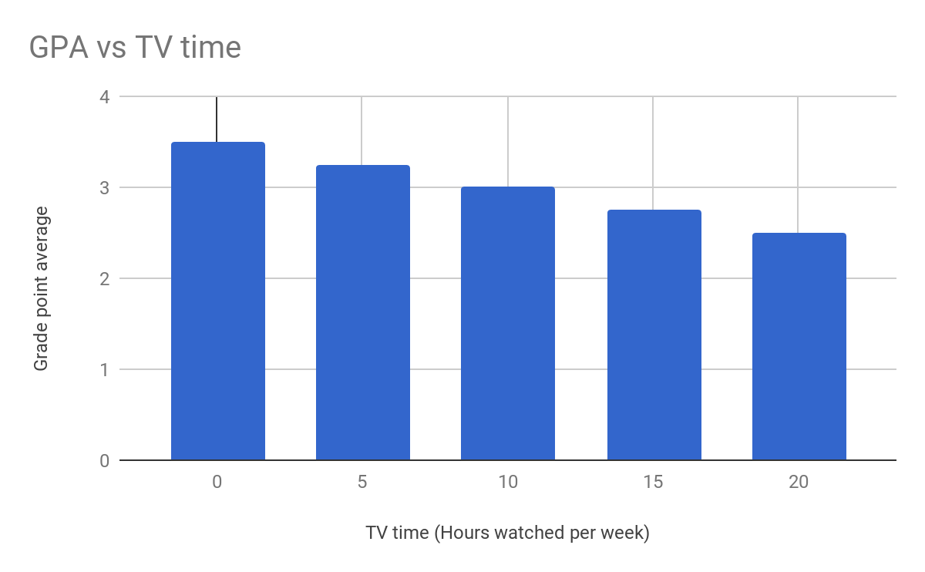

Directions: Answer the following questions using complete sentences with a restate.

1. What patterns or trends can you see in the data?

2. What would you predict would happen to a student’s grade point average if they watched more than 20 hours per week of TV?

3. What kind of relationship is being shown between grades and TV time?

4. What was the other relationship similar to this one in our stations?

5. Give an example of a cause and effect relationship outside of the classroom?