Patterns Graphs and Data May
Data Table 1
Average Daily Temperature Lansing, MI - May 2017
Date | Average Temperature | Date | Average Temperature | Date | Average Temperature
05/01/2017 | 55 | 05/12/2017 | 55 | 05/23/2017 | 63
05/02/2017 | 45 | 05/13/2017 | 61 | 05/24/2017 | 62
05/03/2017 | 48 | 05/14/2017 | 61 | 05/25/2017 | 61
05/04/2017 | 47 | 05/15/2017 | 70 | 05/26/2017 | 63
05/05/2017 | 50 | 05/16/2017 | 70 | 05/27/2017 | 65
05/06/2017 | 50 | 05/17/2017 | 78 | 05/28/2017 | 70
05/07/2017 | 45 | 05/18/2017 | 67 | 05/29/2017 | 67
05/08/2017 | 44 | 05/19/2017 | 48 | 05/30/2017 | 62
05/09/2017 | 48 | 05/20/2017 | 55 | 05/31/2017 | 59
05/10/2017 | 58 | 05/21/2017 | 64
05/11/2017 | 57 | 05/22/2017 | 59

Graph 1

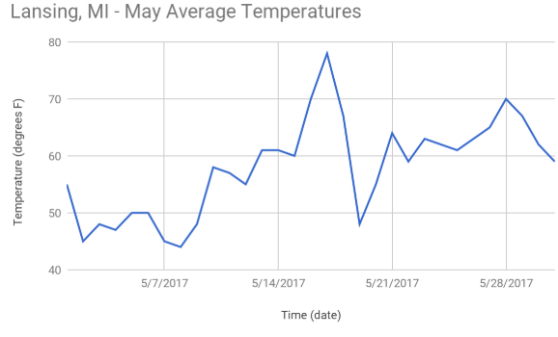

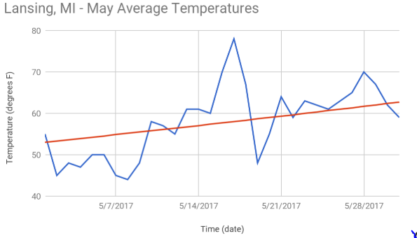

Patterns Graphs and Data June

Graph 3

