Name____________________________________ Date _________________ Hour _________
Station 6: Visible Light Spectrum
Pre-activity questions:
1. What does the color of a light tell us about a wave?

2. How does amplitude affect a wave?

Part 1: Read the following article.
-While reading the article please answer the questions using complete sentences and a restate.
Visible Light Spectrum
Focus Question: What does the color of a visible light wave tell us?
Electromagnetic Radiation  Radiation is energy that comes from a source and travels through a medium or through space. Mechanical waves like water, seismic, and sound waves radiate energy. All electromagnetic waves like radio, visible light, and x-rays are also various forms of radiation. The section of the electromagnetic spectrum that can be seen and detected by the human eye is the visible light spectrum. The longer the wavelength, the lower the energy, the shorter the wavelength, the higher the energy (see FIGURE 1). | Is visible light a form of radiation? Explain.
FIGURE 1 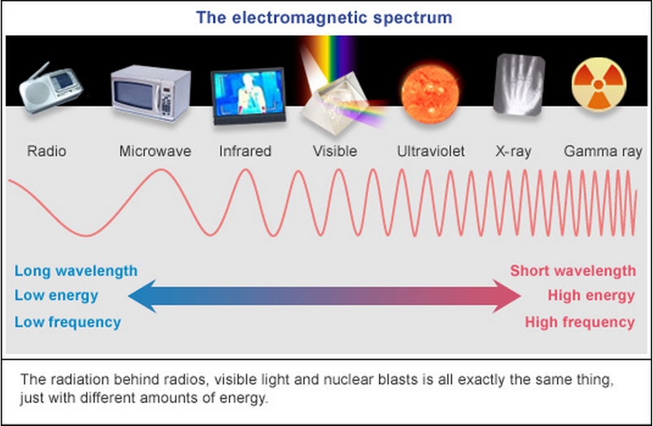 | Do you believe all forms of radiation are safe for humans?
White Light  White light is the name given to what the human eye sees when all the colors that make up the visible spectrum are combined. The visible light spectrum is made up of red, orange, yellow, green, blue, indigo, and violet light, and these colors combine to make white light. In 1665, Isaac Newton discovered that a prism bends white light into the separate colors of the visible light spectrum. (See FIGURE 2). | What is white light?
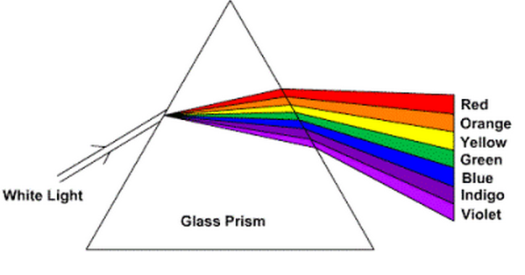  FIGURE 2 | What scientific concept is being illustrated in this model?
The Color of Light  Each color of the rainbow bends at a slightly different angle depending on its unique wavelength. The longer the wavelength, the lower the energy, the shorter the wavelength, the higher the energy. Violet light has the shortest wavelength, high energy, and bends at the greatest angle. Red light has the longest wavelength, low energy, and bends at the smallest angle. | What makes each light color bend differently? Explain.
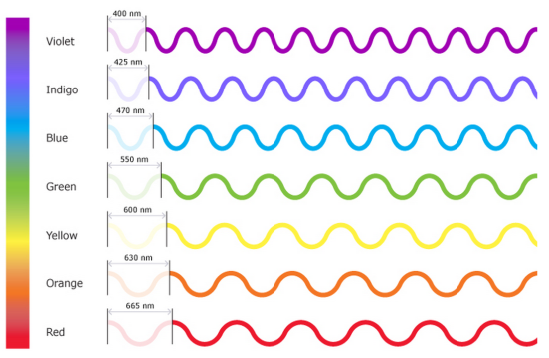 figure 3 | What scientific concepts are being illustrated through this model? Explain.
Color = Energy  As objects grow hotter, they gain energy and radiate shorter, more energetic wavelengths, changing color before your eyes. The flame color on a gas stove shifts from red to blue in color as it is adjusted to burn hotter. Study FIGURE 4 to see how temperature is related to color. | How is color related to energy?
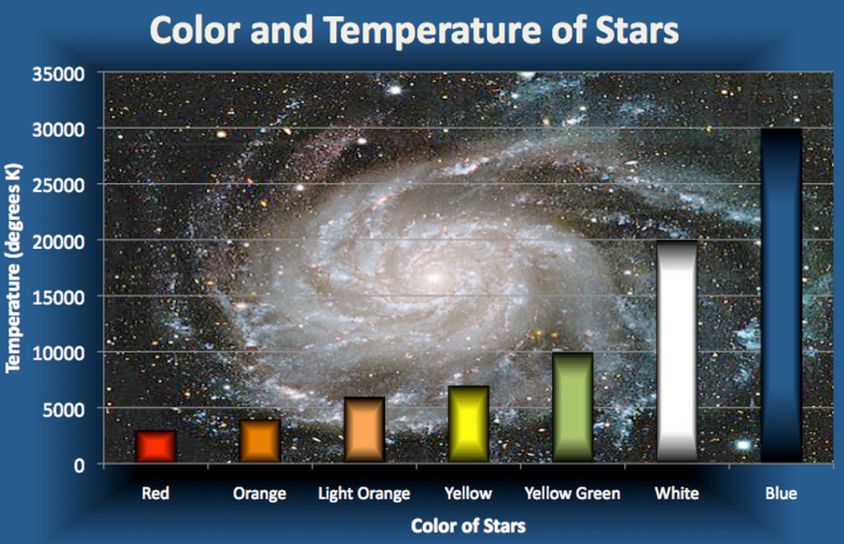  FIGURE 4 | What are the highest energy colors? What are the lowest energy colors?
What can a star’s color teach us?  The color of stars tells scientists about their temperature. Our Sun produces more yellow light than any other color because its surface temperature is 5,500°C. If the Sun's surface were cooler, 3,000°C, it would look reddish, like the star Betelgeuse. If the Sun were hotter, 12,000°C, it would look blue, like the star Spica. | What can a star’s color teach us?
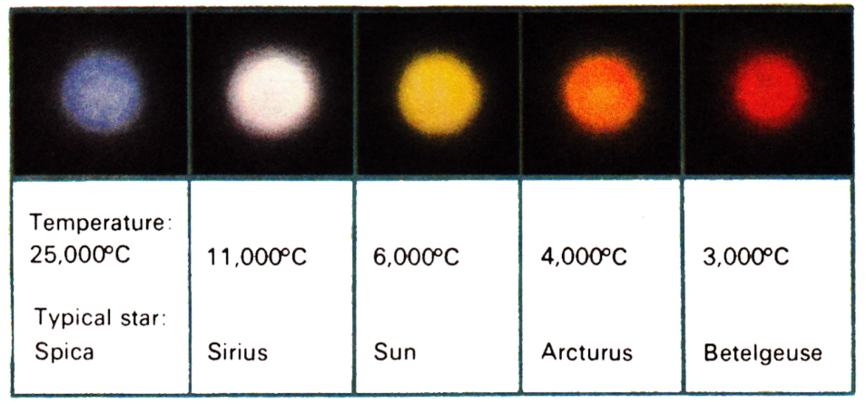  FIGURE 5 | Is the sun the hottest star in the universe? Explain.

(Purple) Answer the following questions using complete sentences with a restate.

1. Review FIGURE 1. What radiation waves are you exposed to on a daily basis, and do you believe this level of radiation is safe? Explain your reasoning.

2. Create an annotated model comparing the energy, wavelength, and frequencies of x-rays and radio waves.

Part 2: (Have all the following documents open and ready when you show Ms. Murphy)
1. Show Ms. Murphy your student record keeping
X__________________________________________________
2. Show Ms. Murphy your student connect
X _________________________________________________
3. Show Ms. Murphy your started Laser Alarm System KWL
4. Select something from the “What to do when you’re done list”

