Name _______________________________ Date_______________ Hour _________________

**Sound Vibrations Station 1: Tuning Forks**

**Pre-lab questions:**

1. Touch the front of your throat as you hum a high note and a low note. How is what your feeling related to sound? (I should HEAR humming!)

2. How do your vocal chords feel as you change the pitch from a high note to a low note?

**Tuning Forks Lab**: Once you have answered your pre-lab questions raise your hand for your lab supplies. You will be working with you table partner.

**Part 1:** Initial Observations

1. Take a tuning fork and hit it with your pencil. Bring it near your ear. What do you observe?

2. Practice hitting the tuning forks with different strengths. Notice the measurement on each tuning fork in Hz (Hertz). Hit and compare the sounds of two different tuning forks. Observation questions:

|  |  |
| --- | --- |
| Tuning fork ____Hz  Observations | Tuning fork _________Hz  Observations |

1. What observations can you make about the sound of the tuning fork? (How does it start? How does it end? Is it high or low pitched?)

2. How does the strength of the hit affect the sound of the tuning fork?

3. What do you feel when you touch the prongs of the tuning fork?

**Part 2:**

1. Pick up the ping pong ball attached to the string. Let the ball hang from the string and hold the string very still.

2. Hit the tuning fork with your pencil. Touch the tuning fork gently against the motionless ball

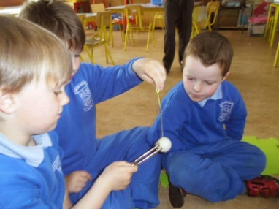

3. Take turns exploring this and record observations. I would like you to record your observations by

Drawing a labeled model illustrating and explaining what you observe happening. Label each part of the

Diagram and explain what is happening.

|  |
| --- |
| Picture:  How do the tuning fork and ping pong ball interact?  What do you notice about the ping pong ball when it first touches the tuning fork? After a few seconds pass?  How is the tuning fork able to move the ball? |

**Part 3: Sound Waves and Water**

1. Fill a cup with water (to the top).

2. Strongly hit a tuning fork with your pencil.

3. Gently touch the water surface with one of the prongs of the tuning fork (see picture)

4. Hit the tuning fork strongly again and dip the prongs of the tuning fork down into the water (see picture).

5. Take turns and let different group members conduct these tests.

6. Below record your observations by constructing a model illustrating and explaining what you observe happening. Label each part of the diagram and describe/explain what is happening.

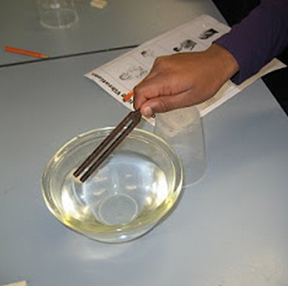 

|  |
| --- |
| Picture:  I observed…  In my observations I saw…  Why do you think this happened? |

**Part 4:** Answer the following questions using complete sentences and support your answers with evidence. (Be sure to include the source of your evidence)

1. How is sound created?

2. How does sound travel?

3. What **patterns** can we observe about sound?