Name __________________________________________ Date ________________ Hour __________  
 **Sound Vibration Station 3: What Makes Your Ears Ring**

**Pre-lab Question**

1. What effects can very loud music have on your hearing?

**Task:**

A. Watch Video #1 “What Makes Your Ears Ring” (found on my blog) and answer the following questions.

[https://drive.google.com/file/d/0B7lVLuFpIHGJVUY5dUFPNzJZM0E/view](https://drive.google.com/file/d/0B7lVLuFpIHGJVUY5dUFPNzJZM0E/view  https://www.youtube.com/watch?v=U0SGBN8LAVU&t=1s1)

[https://www.youtube.com/watch?v=U0SGBN8LAVU&t=1s](https://drive.google.com/file/d/0B7lVLuFpIHGJVUY5dUFPNzJZM0E/view  https://www.youtube.com/watch?v=U0SGBN8LAVU&t=1s1)

[1](https://drive.google.com/file/d/0B7lVLuFpIHGJVUY5dUFPNzJZM0E/view  https://www.youtube.com/watch?v=U0SGBN8LAVU&t=1s1). What is the scientific word for ringing in the ears?

2. What causes ringing in the ears?

3. Sound waves maker your ear drum ______________________.

4. How much do the hairs in your ear move when there is a loud noise?

5. What do the broken hairs in your ears cause?

C. Read and annotate the article “The Middle Ear: Good Vibration”. Raise your hand and Ms. Murphy will give you the article. Be sure to talk to the text when reading the article.

D. Create an informational flier that includes a labeled, detailed, colored picture. Three important details about your topic and one important warning related to your topic. (You are making your own fliers) You can use the back of this paper.

Topics:

Yellow and blue: How sound travels.

Purple and green: The parts of the ear

Orange and red: Does loud music affect your ears?

8.3.1 - Resource Sheet

**The Middle Ear: Good Vibrations**

Focus Question: What effect can very loud music have on your hearing?

**Directions:** Read the article closely and follow the instructions on your [Talking to the Text Annotating Rubric](https://docs.google.com/document/d/1ioQJVaK2ippXnLRp-zK4q9StGW9_jvxtEXInOHbH4_4/edit?usp=sharing).

After sound waves enter the outer ear, they travel through the ear canal and make their way to the middle ear. The middle ear's main job is to take those sound waves and turn them into vibrations that are delivered to the inner ear. To do this, it needs the eardrum, which is a thin piece of skin stretched tight like a drum. The eardrum separates the outer ear from the middle ear. In the middle ear, you can find the three tiniest, most delicate bones in your body. They include: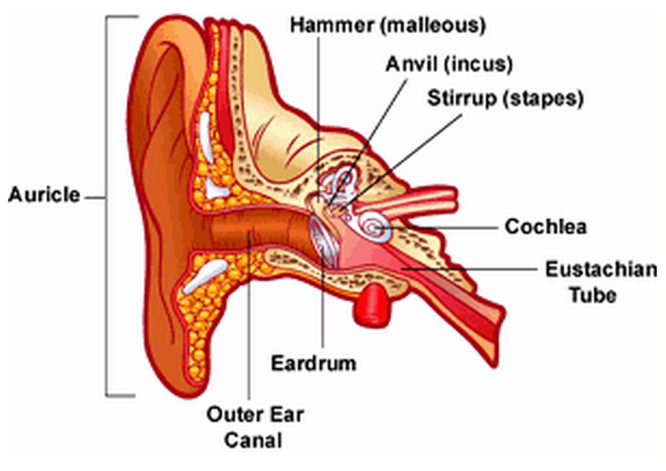

* the **hammer** which is attached to the eardrum
* the **anvil** which is attached to the hammer
* the **stirrup** which is the smallest bone in the body, and is attached to the anvil

When sound waves reach the eardrum, they cause the eardrum to vibrate. When the eardrum vibrates, it moves the tiny bones — from the hammer to the anvil and then to the stirrup. These tiny bones help sound move along on its journey into the inner ear. Really loud noises, like an explosion, can produce sound waves that are strong enough to damage the eardrum. 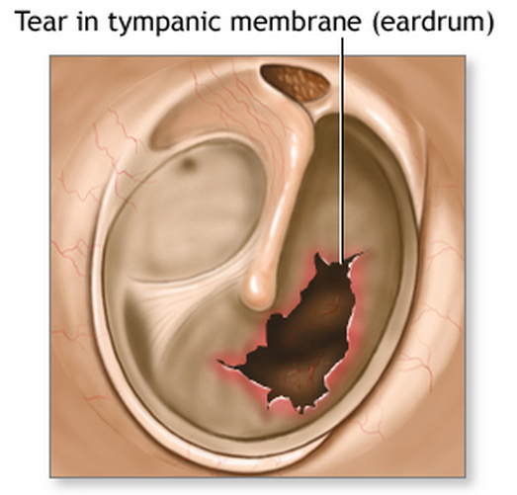

**The Inner Ear: Nerve Signals Start Here**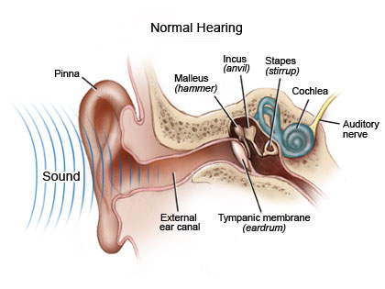

Sound comes into the inner ear as vibrations and enters the **cochlea** (say: KAH-klee-uh), a small, curled tube in the inner ear. The cochlea is filled with liquid, which is set into motion, like a wave, when the small bones vibrate.

The cochlea is also lined with tiny cells covered in tiny hairs that are so small you would need a microscope to see them. They may be small, but they're awfully important. When sound reaches the cochlea, the vibrations (sound) cause the hairs on the cells to move, creating nerve signals that the brain understands as sound. The brain puts it together and hooray! You hear your favorite song on the radio.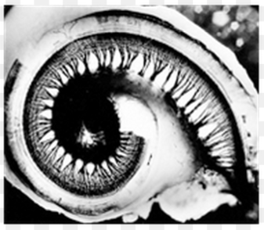

**Can Music in Your Headphones be TOO Loud?**

Pictured is an electron micrograph image from both a normal, undamaged cochlea and one that has experienced extreme noise exposure and hair cell loss.  The hair cells are connected to nerves which send messages to the brain and the brain “hears” sound. But as you can see, many of the hairs have been destroyed by exposure to extremely powerful noises. What effect could this have on your hearing?